Public Housing Committee Staff
Audrey Son, Senior Counsel
Jose Conde, Senior Policy Analyst
Ricky Chawla, Senior Policy Analyst
Dan Kroop, Senior Financial Analyst
Rose Martinez, Assistant Deputy Director & Data Scientist
James Wu, Data Analyst

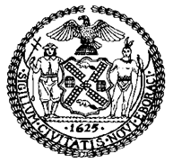

THE NEW YORK CITY COUNCIL

BRIEFING PAPER OF THE INFRASTRUCTURE DIVISION
Andrea Vazquez, Legislative Director
Bradley Reid, Deputy Director, Infrastructure

COMMITTEE ON PUBLIC HOUSING
Hon. Alexa Avilés, Chair

December 14, 2022

Oversight: Winter Preparedness Across NYCHA Developments

Introduction
On December 14, 2022, the Committee on Public Housing, chaired by Council Member Alexa Avilés, will hold an oversight hearing entitled “Winter Preparedness Across NYCHA Developments.” The Committee expects to hear testimony from officials of the New York City Housing Authority (“NYCHA”) regarding what steps it has taken to maintain its boilers, prevent heating and utility outages, and respond to heat and hot water service disruptions when they occur. The Committee has also invited to testify NYCHA tenants, resident associations, and advocacy groups, regarding the impact of NYCHA’s heat and utility policies and management on residents.
Background on NYCHA and Public Housing
Former New York City Mayor Fiorello La Guardia created NYCHA in 1934 to replace dilapidated tenements using funds from The New Deal, three years before the Housing Act of 1937 established public housing nationwide. NYCHA originally served two purposes: (1) to provide low-cost housing for middle-class, working families temporarily unemployed because of the Great Depression and (2) to bolster the lagging economy by creating jobs for the building trades. Later, NYCHA’s purpose evolved into providing safe, decent housing for families with the lowest incomes.
Today, NYCHA has 335 developments, and 177,569 units home to 525,686 authorized residents, through the conventional public housing program, the Housing Choice Voucher program created by the United States Housing and Community Development Act of 1978 (“Section 8”), and through the Permanent Affordability Commitment Together Program (“PACT”), which is NYCHA’s implementation of the federal Rental Assistance Demonstration (“RAD”) program.
Heat Season in New York City
Building owners in New York City are legally required to provide heat and hot water to tenants. Hot water must be provided 365 days per year at a consistent minimum temperature of 120 degrees Fahrenheit. From October 1 through May 31 (i.e. “heat season”), between the hours of 6:00 AM and 10:00 PM, if the outdoor temperature falls below 55 degrees Fahrenheit, all residential building owners must provide tenants with heat so that the indoor temperature is at least 68 degrees Fahrenheit. Between 10:00 PM and 6:00AM, the indoor temperature must be at least 62 degrees Fahrenheit, regardless of the outdoor temperature.
Background on NYCHA’s Heating Systems and the Heating Management Service Department
Heating for NYCHA housing is provided through a “heating plant” in each building or development. Each plant typically includes at least one boiler and a system of pipes and radiators. Heating plants are maintained by NYCHA staff, vendors, and private management. NYCHA’s systemwide heating operation uses 1,713 boilers, 1,492 vacuum tanks, and 847 instantaneous water heaters.
NYCHA’s heating operation is managed by the Heating Management Service Department (“HMSD”). HMSD uses federal operating dollars and City funding to manage and repair boiler plants, tank rooms, and ancillary equipment. The department’s total FY22 operating expense budget is $85.13 million. HMSD employed 549 full time staff as of October 31, 2019. The majority of HMSD’s frontline staff are organized into thirteen geographic clusters: three in the Bronx, four in Brooklyn, three in Manhattan, two in Queens, and one in Staten Island.
HUD/NYCHA Agreement
Chronic heat and hot water outages were among the many catalysts that led to the HUD/NYCHA Agreement (“Agreement” or “HUD Agreement”) and the appointment of the Federal Monitor. In recent years, NYCHA has been subjected to oversight and investigations by the United States Department of Housing and Urban Development (“HUD”), federal prosecutors, state lawmakers, the City Council, and others about alleged mismanagement. On January 31, 2019, HUD entered into an agreement with NYCHA and the City of New York. The purpose of the Agreement was to remedy NYCHA’s physical conditions, make sure NYCHA complies with its obligations, reform NYCHA’s management structure, and help with cooperation and coordination between HUD, NYCHA, and the City. The Agreement was made under HUD’s authority and, unlike the consent decree that preceded it, was not subject to court approval. The Agreement recognized the existence of a “substantial default” but did not impose a receivership or take possession of NYCHA. It required NYCHA to prepare “Action Plans” setting forth policies in several “pillar areas”: elevators, mold, pests and waste management, lead, and heating. The Agreement also scheduled milestones and established other requirements to identify and respond to NYCHA’s physical deficiencies. To help NYCHA in its compliance with the Agreement, the City will provide $1 billion in financial support for capital expenses provided in the Action Plan, including the replacement of about 500 boilers by 2026 and the replacement of at least 425 elevators by 2024.
The Agreement prescribed that by March 31, 2019, NYCHA would create a 24/7 Heat Desk which would monitor heating metrics and dispatch staff to correct deficiencies during heat season. Under the Agreement, NYCHA is also required to:
- Restore heat to units affected by a heating shortage within an average 12 hours
- Restore heat to 85% of affected units within 24 hours
- Investigate the root cause of heat outages that exceeded 12 hours
Independent Monitor
On February 21, 2019, HUD selected Bart Schwartz to be NYCHA’s new Federal Monitor (“Monitor”) under the HUD Agreement. According to the HUD/NYCHA Agreement, the Monitor is not responsible for the day-to-day operations of NYCHA but will have full access to all information in NYCHA’s possession and all programs, services, facilities, and premises under NYCHA’s control. HUD, The United States Attorney for the Southern District of New York (“SDNY”), and the United States Environmental Protection Agency (“EPA”) are required to receive quarterly reports from the Monitor on the work performed, data showing NYCHA’s progress, and any other information the Monitor considers appropriate. These reports are publicly available on NYCHA’s website.
The Action Plans required by the Agreement are subject to Monitor approval. If the Monitor finds that an Action Plan is unacceptable, and NYCHA cannot revise it in an acceptable way, then the Monitor has the authority to submit a revised Action Plan to NYCHA, HUD, and SDNY. Each approved Action Plan will be posted on NYCHA’s website. The Monitor may direct NYCHA to select an independent contractor to perform work called for by an Action Plan or revisions made by the Monitor. NYCHA’s Heating Action Plan has been approved by the Monitor and is available online.
Heat Outages
To understand the impact of heat outages, this section uses data from NYCHA’s outage website for analysis. The dataset was limited to Heating Seasons starting from October 1, 2019 to the time the data was pulled, November 22, 2022. For this analysis, “sectional outages” (which impact only a certain section of a development) and “entire development outages” were all counted as a singular instance of an outage. Under that analysis, the total count of heating outages for that period was 2,253.
Table A
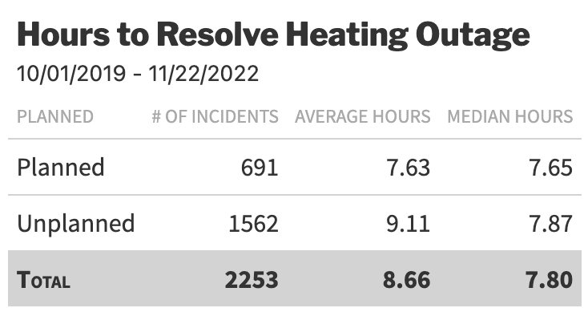
Table A shows the hours it took to resolve a heating outage, broken down by planned and unplanned outages.

Of the 2,253 heating outage incidents from October 1, 2019 to November 22, 2022, 691 incidents were planned and 1562 incidents were unplanned. These outages usually took 7.8 hours to resolve, with certain catastrophic incidents skewing the average to 8.66 hours. One of the incidents that significantly impacted the data was the unplanned 53 hours-long entire development outage at Fort Independence Street Heath Avenue on November 6, 2021. Planned outages generally took less time to resolve than unplanned outages.
Table B
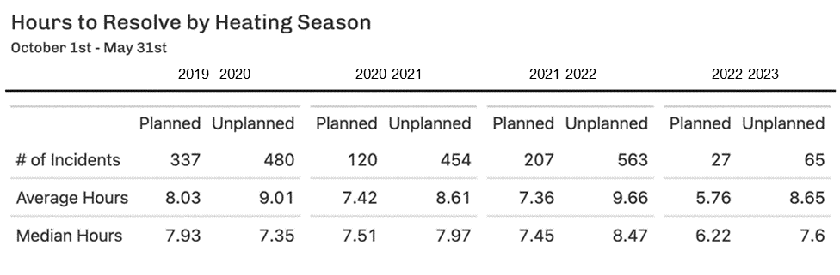
Table B shows the hours it took to resolve a heating outage, broken down by heat season from 2019-2020 through present.

As noted, the data for the 2022-2023 heat season is only for 53 days. If that data is omitted, then for the three heat seasons from 2019 to 2022, there is a slight increasing trend for the median hours it took per heat season to resolve an unplanned outage, and a slight decreasing trend for the time to resolve a planned outage.
Heat Outages Lasting Over Twelve Hours

Table C below shows the top 15 developments with the highest number of outages that took 12 or more hours to resolve. Bay View had the most frequent number of 12-hour or more outages, but many were planned. In contrast, many, if not all, of the 12-hour or more outages at WSUR, Williamsburg, Wagner and other NYCHA developments were unplanned.
Table C

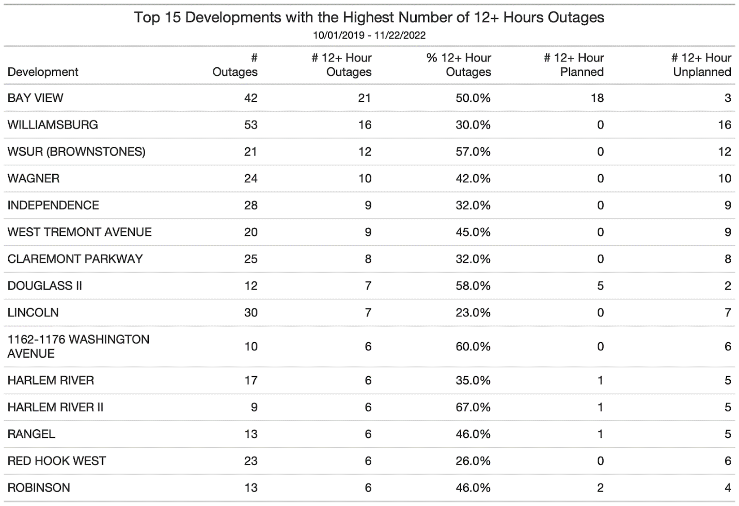
Table C shows the 15 NYCHA developments with the highest number of 12+ hours-long heating outages during heat season from October 1, 2019, through present.

For most of the developments listed in Table C, the outages happened in one given heat season. For example, Bay View is not in the top 20 for 2022, since it had most of its 12+ hour outages in Heating Season 2019-2020. Williamsburg had some of the highest numbers of 12+ hour outages in both Heating Season 2019-2020 and Heating Season 2020-2021, but has not had a heating outage in Heating Season 2021-2022 and onwards.
Table D
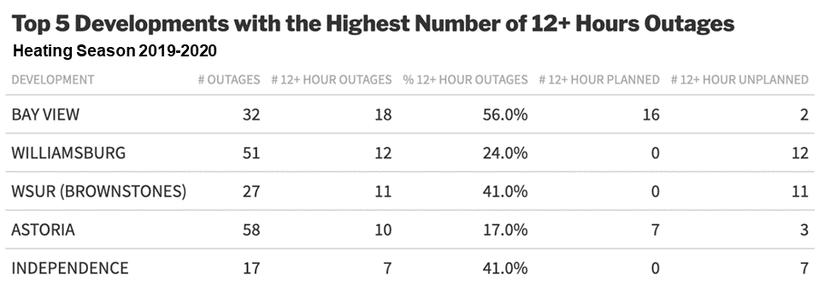
Table D shows the top five developments with the highest number of 12+ hours-long outages for the 2019-2020 heat season: Bay View, Williamsburg, WSUR, Astoria, and Independence.

Table E
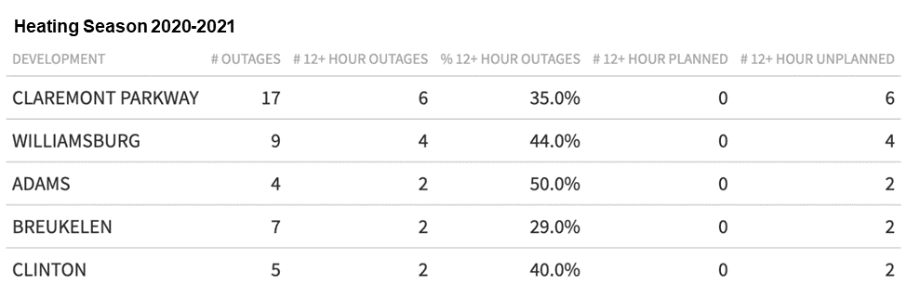
Table E shows the top five developments with the highest number of 12+ hours-long outages for the 2020-2021 heat season: Claremont-Parkway, Williamsburg, Adams, Breukelen, and Clinton.

Table F
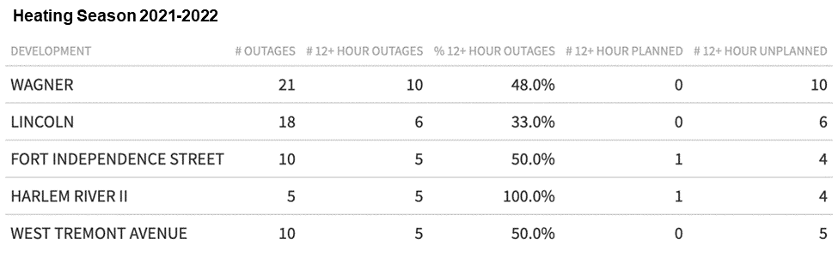
Table F shows the top five developments with the highest number of 12+ hours-long outages for the 2020-2021 heat season: Wagner, Lincoln, Fort Independence Street, Harlem River II, and West Tremont Avenue.

Table G
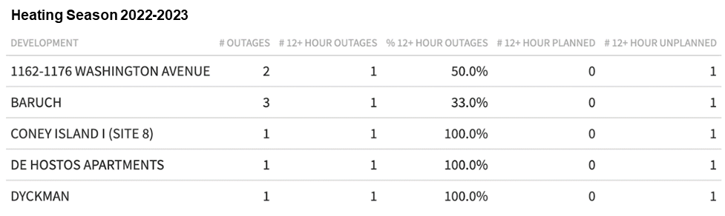
Table G shows the top five developments with the highest number of 12+ hours-long outages for the 2022-2023 heat season: 1162-1176 Washington Ave, Baruch, Coney Island Site 8, De Hostos Apartments, and Dyckman. Because the 2022-2023 heat season is ongoing, the data depicted is limited to outages from October 1, 2022 through November 22, 2022.

Compliance with HUD/NYCHA Agreement
During 2021-2022 heat season, (October 1, 2021 through May 31, 2022) the Monitor evaluated the performance of NYCHA’s HMSD and NYCHA’s compliance with the HUD Agreement. The Monitor analyzed NYCHA’s work orders utilizing data from Maximo (NYCHA’s work order database), inspected NYCHA’s boiler rooms, and interviewed NYCHA’s heating staff. NYCHA’s Environmental Health & Safety Heat Oversight Team (“EHS”) also conducted analysis for heat outages greater than 12 hours for the past three heat seasons. In 2021-2022, there were 352 boiler outages, 204 for the 2020-2021 season, and 153 for the 2019-2020 season. Boiler mechanical failures accounted for 62.4 percent of NYCHA’s heat outages in the 2021-2022 heating season. The leading cause of boiler related outages was boiler controls and burners. Boiler control outages have gone up by 300% since the 2019-2020 heating season, while burner outages have gone up by 312% since the 2019-2020 heating season. However, the Monitor raised concerns that the Maximo database, which is important for determining the root cause of heating outages, did not have quality data when a significant problem impacts NYCHA’s heating services, particularly given the importance of Maximo data in determining the root causes for the outages, identifying problematic assets, developing mitigation strategies, and analyzing the annual maintenance program.
The Monitor noted that NYCHA’s failure to properly execute and complete its summer 2021 preventive maintenance program (“PM”) contributed in part to the increase in heating failures during the 2021-2022 heat season. The Monitor concluded there were several reasons HMSD did not complete the PM. First, the HMSD is understaffed, including insufficient line workers, or Heating Plant Technicians (“HPT”), supervisors, and staff to properly maintain and repair boilers and to supervise this work. Second, NYCHA has not replaced the worst performing boilers, which could alleviate staff burden in keeping the boilers operational. Third, the Monitor noted that the HMSD unit was not effectively using its staff. For instance, staff routinely failed to comply with established procedures for scheduling and completing daily, weekly, monthly, and annual maintenance work orders, while managers failed to perform regular, comprehensive inspections of such work. Staff also failed to properly record their maintenance, repair, and inspection work. The Monitor further noted a need to overhaul HMSD training. For instance, HPTs currently wait an average of over a year before there is space and training staff to take a class, and there is no effective structure to provide field training. The Monitor additionally identified a failure to manage parts and equipment storerooms, affecting NYCHA’s ability to respond to emergencies.
In January 2022, the Monitor issued a comprehensive report to NYCHA that made these recommendations to improve their heating services:
1. adding staff to HMSD;
2. improving staff training at HMSD;
3. updating the heating operation procedures;
4. making sure staff are capturing key data in Maximo; and
5. improving management and supervision at HMSD to ensure staff are following procedures and completing the master plan.
Since the Monitor’s comprehensive January 2022 report, NYCHA has purportedly taken the following steps to improve its PM performance and to improve HMSD more generally:
- Providing better oversight and support of HMSD by having a new Chief Operating Officer and Senior Vice President;
- Increasing the use of vendors to help with PM work to ensure completion;
- Improving coordination and collaboration between HMSD, EHS, HUD and the Monitor to oversee and assess both vendors and HMSD staff as work is done during the summer preventive maintenance program;
- Beginning comprehensive staff trainings including both in-class and field training, and setting up a new NYCHA heating lab;
- Establishing a working group to update its heating standard operating procedures;
- Increasing HMSD staffing levels for more front-line and management personnel; and
- Restructuring HMSD in coordination with NYCHA’s new organizational plan known as the Neighborhood Model.
The Monitor noted NYCHA’s ongoing struggles to complete capital projects in a timely manner, with schedules for new heating systems approximately 10 months behind schedule. However, progress is being made in replacing boilers. Under the HUD Agreement, NYCHA must replace 297 building heating systems (mainly boilers) within the next few years. NYCHA has already met its Agreement obligation to replace at least 70 heating systems by the end of 2022, and is on track to complete as many as 90 by the end of the year.
Looking forward, there is a risk that NYCHA will experience setbacks in its efforts to meet its obligations under the HUD Agreement. NYCHA has reportedly informed the Monitor, HUD, and the U.S. Attorney that it will be difficult to meet some of the Agreement deadlines due to a drop in rental revenue. NYCHA’s rental income pays for about one-third of NYCHA’s operating budget. NYCHA’s Interim CEO Lisa Bova-Hiatt has stated in an interview that “the annual operating costs, have increased steadily over the last three years and without additional revenue, we are going to be unable to continue the pace of investment to address these requirements.” Many NYCHA tenants have submitted applications to the Emergency Rental Assistance Program (“ERAP”), but no money has been spent on NYCHA tenants’ rent arrears. According to the New York State Office of Temporary and Disability Assistance, public housing, Section 8 and FHEPS currently cannot be paid ERAP benefits because State law requires such subsidized housing tenants to be paid only after all other eligible applicants have been reviewed and paid.
Conclusion
New York City public housing residents have experienced significant gaps in the provision of heat and hot water services, endangering their health and wellbeing. NYCHA has an obligation to provide tenants with homes where they can live safely and with dignity. This hearing is to conduct oversight and hold NYCHA accountable, and will provide NYCHA a forum through which to provide the Committee with an update on its ability to provide services to its residents as required by law.

Ferre-Sadurni, Luis, “The Rise and Fall of New York Public Housing: An Oral History,” The New York Times, available at https://www.nytimes.com/interactive/2018/06/25/nyregion/new-york-city-public-housing-history.html.
Housing Act of 1937, available at https://www.gpo.gov/fdsys/pkg/USCODE-2009-title42/pdf/USCODE-2009-title42-chap8.pdf.
Marcuse, 353-54; J.A. Stoloff, A Brief History of Public Housing, Paper presented at August 14 meeting of the American Sociological Association, at 3 (2004).
Marcuse, 354; Stoloff, 1; see also Judith D. Feins, et al., Revised Methods of Providing Federal Funds for Public Housing Agencies, US Department of Housing and Urban Development, at 9 (1994).
See NYCHA Fact Sheet, available at https://www1.nyc.gov/assets/nycha/downloads/pdf/NYCHA_Fact_Sheet_2022.pdf.
New York City Department of Housing and Preservation, Conditions: Heat and Hot Water, https://www1.nyc.gov/site/hpd/services-and-information/heat-and-hot-water-information.page (last accessed Dec. 9, 2022).
Id.
Id.
Heat Action Plan, NYCHA Monitor, available at https://nychamonitor.com/.
Id. Instantaneous water heaters, also known as demand-type or tankless water heaters, provide hot water only as needed and do not produce the standby energy losses associated with storage water heaters.
NYCHA Adopted Budget for FY 2022, available at https://www.nyc.gov/assets/nycha/downloads/pdf/nycha-2022-budget-book.pdf.
Supra note 9.
Id.
United States Department of Housing and Urban Development, Agreement, p.1, filed 1/31/19, available at https://www.hud.gov/sites/dfiles/PA/documents/HUD-NYCHA-Agreement013119.pdf
Id. at 2–3.
Id.
Id. at 4.
Id. at 4, 8.
Id. at 2.
Id.
Id.
Amy Plitt, HUD Reportedly Selects Ex-Prosecutor As NYCHA’s New Federal Monitor, Curbed New York, (Feb. 21, 2019 11:45 a.m.) available at https://ny.curbed.com/2019/2/21/18234731/nycha-hud-federal-monitor-selection.
Supra note 14 at 6.
See NYCHA, Transparency and Reports, https://www1.nyc.gov/site/nycha/about/reports.page (last accessed Dec. 12, 2022).
Supra note 14 at 7.
New York City Housing Authority, Action Plan – Heating, available at https://nychamonitor.com/wp-content/uploads/2019/12/Heating-Action-Plan-12.4.19.pdf.
New York City Housing Authority, Service Interruptions, available at https://my.nycha.info/Outages/Outages.aspx.
Id.
Id.
Id.
Id.
Id.
Id.
Id
Id.
Id.
Id.
Id.
Id.
Id.
Id.
Bart Schwartz, Twelfth Monitor Quarterly Report, available at https://nychamonitor.com/wp-content/uploads/2022/09/Twelfth-Monitor-Quarterly-Report-9.7.22.pdf.
Supra note 42 at 7.
Id. at 8.
Id. at 9.
Id. at 11.
Id.
Id. at 2.
Id. at 13
Id.
Id. at 14.
Id.
Id.
Id.
Id. at 15.
Id. at 4.
Id.
Id.
Bart Schwartz, Monitor Report Measuring NYCHA’s Compliance with The HUD Agreement, p. 57, available at https://nychamonitor.com/wp-content/uploads/2022/11/Monitor-Metrics-Report-11.29.22.pdf.
Id.
Greg B. Smith, NYCHA tells Feds Housing Fixes Delayed by Massive Shortfall in Rent Collection, The City, (Nov. 29,, 2022, 9:47 p.m.) https://www.thecity.nyc/2022/11/29/23485246/nycha-fix-delayed-rent-collection-shortfall#:~:text=The%20New%20York%20City%20Housing,agreement%2C%20THE%20CITY%20has%20learned.
Id.
Id.
Id.
Emergency Rental Assistance Program, New York State Office of Temporary and Disability Assistance, https://otda.ny.gov/programs/emergency-rental-assistance/ (last accessed Dec. 12, 2022).
Kevin Rincon, Lawmakers, NYCHA tenants demand agency do more to improve living conditions, CBS New York, (Nov. 22, 2022, 5:51 p.m.) https://www.cbsnews.com/newyork/news/nycha-city-hall-living-conditions-rally/; Kevin Rincon, “No heat, no hot water, no rent:: Astoria Houses residents frustrated by recurring heat, hot water outages, CBS New York, (Nov. 21, 2022, 12:13 a.m.) https://www.cbsnews.com/newyork/news/astoria-houses-no-heat-hot-water/.

