Public Housing Committee Staff
Connor Mealey, Counsel
Jose Conde, Senior Policy Analyst
Ricky Chawla, Senior Policy Analyst
Dan Kroop, Senior Financial Analyst
Rose Martinez, Assistant Deputy Director & Data Scientist
Julia Fredenburg, Senior Data Analyst
James Wu, Data Scientist
Rachel Avram, Data Scientist



THE NEW YORK CITY COUNCIL

BRIEFING PAPER OF THE INFRASTRUCTURE DIVISION
Andrea Vazquez, Legislative Director
Bradley Reid, Deputy Director, Infrastructure

COMMITTEE ON PUBLIC HOUSING
Hon. Alexa Avilés, Chair

January 31, 2023

Oversight – Examining Causes of Vacancies
In New York City Housing Authority Properties

Introduction
On January 31, 2023, the Committee on Public Housing, chaired by Council Member Alexa Avilés, will hold an oversight hearing entitled “Oversight – Examining Causes of Vacancies in New York City Housing Authority Properties.” The Committee expects to hear testimony from officials of the New York City Housing Authority (“NYCHA”) regarding the increase in vacancies across NYCHA properties, the underlying reasons for why more apartments are empty for longer and what NYCHA is currently doing to bring down vacancies. The Committee has also invited NYCHA tenants, resident associations, and advocacy groups to testify on the impact of vacancies on the tenants of NYCHA living in buildings with vacant apartments, current tenants waiting for transfers, and finally on persons on the waitlist.
Background on NYCHA and Public Housing
Former New York City Mayor Fiorello La Guardia created NYCHA in 1934 to replace dilapidated tenements using funds from The New Deal, three years before the Housing Act of 1937 established public housing nationwide. NYCHA originally served two purposes: (1) to provide low-cost housing for middle-class, working families temporarily unemployed because of the Great Depression and (2) to bolster the lagging economy by creating jobs for the building trades. Later, NYCHA’s purpose evolved into providing safe, decent housing for families with the lowest incomes.
Today, NYCHA has 335 developments, and 177,569 units home to 525,686 authorized residents, through the conventional public housing program, the Housing Choice Voucher program created by the United States Housing and Community Development Act of 1978 (“Section 8”), and through the Permanent Affordability Commitment Together Program (“PACT”), which is NYCHA’s implementation of the federal Rental Assistance Demonstration (“RAD”) program.
Historical Vacancies and Waiting Lists in NYCHA
The need for housing in New York City is ever present. Every day someone begins a search for a new home to fit a growing family, to be closer to their job or school, or to simply have a roof over their head. This constant need creates a serious demand for apartments and any apartment sitting vacant for any length of time increases the stress, time and cost on all New Yorkers looking for housing. One indication of this demand, particularly for low-income housing, has been the waitlist for a New York City Housing Authority apartment. As of February 28, 2022, the Public Housing Waitlist had 254,827 families on it. Although this number has fluctuated over time, it regularly shows that hundreds of thousands of New Yorkers are waiting for an apartment that fits their family and their income.
The intense and unending demand for a NYCHA apartment makes it imperative that NYCHA quickly and efficiently turnover vacant apartments and get them ready to have new tenants move in. This requires there be processes in place to identify any renovation work that needs to be done, for that work to be promptly completed, and for an efficient system for placing tenants into renovated apartments. As NYCHA deals with an ongoing funding crisis, the need to keep vacancies as low as possible is vital. For the past two decades NYCHA has had an over 99% occupancy rate, but in recent years the rate has dipped below 99% and in 2022 was at 97.53%. While that percentage of the whole is low, NYCHA has so many units that the number of actual vacant apartments went from less than 500 units in December 2021 to 3,300 units in December 2022. The impact of these apartments remaining empty is quite simply that fewer New Yorkers are being placed in the stable and long term housing that NYCHA represents.
In the past, even with a low vacancy rate, NYCHA sometimes struggled to restore vacant apartments back onto the rent rolls. On June 24, 2015, the New York City Comptroller released an audit examining NYCHA’s management of vacant apartments. In this audit, the Comptroller’s office found NYCHA had “inadequate controls…over the monitoring and tracking of its vacant apartments.” The audit team found that in the developments they examined it took an average of 116 days to fill apartments with new tenants. NYCHA pointed out in response that the average turnover time across NYCHA at the time of the audit was 57 days. The auditors found that the delays were caused by the need for repairs inside the vacant apartments, as well as long term elevator repairs which required elderly tenants to be moved while the work was being completed. The audit also found some apartments classified as vacant were in use in some other capacity, had inadequate safeguards and seemed to have been used by unauthorized individuals, or in some cases were occupied by transfer tenants. The audit team provided NYCHA with a number of recommendations on how to improve the management of vacant apartments, most of which NYCHA agreed with and pledged to implement changes to address the issues.
Recent Spike in Vacancies
In the last year, there has been a marked uptick in vacant apartments and accordingly an increase in the average number of turnaround days to re-occupy vacant apartments, according to NYCHA’s own data. On the NYCHA Metrics page of NYCHA.info, NYCHA provides unoccupied apartments as broken down into three categories: vacant, move-in/selected and non-dwelling. ‘Move-in/selected’ is defined as an apartment which has “been chosen for a family to move into.” ‘Non-dwelling’ is defined as apartments “being renovated or are not for residential use.” Vacant is not given a more elaborate definition and so a reader can only assume NYCHA uses the term in its common understanding, or any unoccupied apartment which does not fall into the other two categories. NYCHA’s data shows an overall growth from December 2021 to December 2022 in the total unoccupied apartments from 4,172 to 6,985 with the largest increase coming from the growth in vacant apartments from 490 to over 3,300.

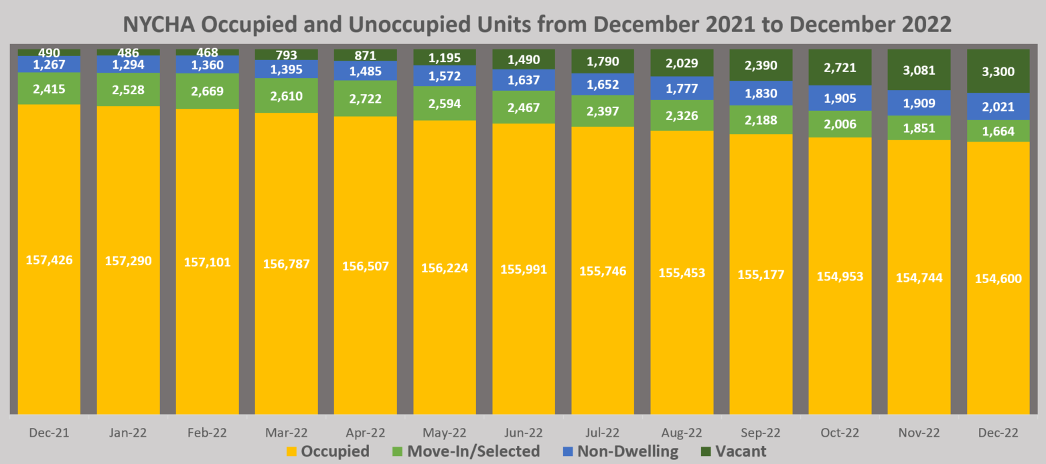
ALT= Bar chart showing occupied and unoccupied units from December 2021 to December 2021 with unoccupied units broken down into three categories: Move-in/Selected, Non-Dwelling, and Vacant. See table below for data.
Data from https://eapps.nycha.info/NychaMetrics/Charts/PublicHousingChartsTabs/?section=public_housing&tab=tab_repairs.

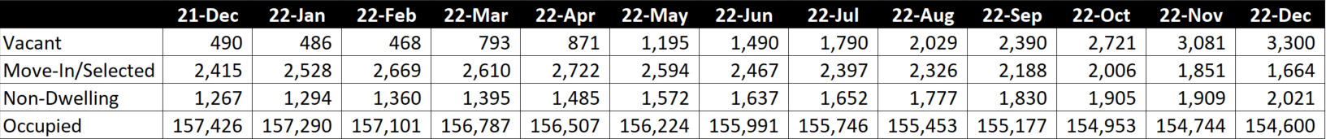

The initial increase in vacancies occurred in February 2022 with an increase of 325 vacancies and continued for the rest of the year growing by an average of 286 apartments per month for the next 8 months. From the publicly available data, there is no single development or set of developments, or some change in a borough policy, that can account for the growth. From a review of the data at the development level, there are some developments that saw larger increases than others, but no one development or set of developments saw such a rapid growth in vacancies as to cause the overall increase. As such there was no outlier development but rather the growth in vacancies is portfolio wide. For example, in December 2021 there were 151 developments with no vacancies and only 36 developments with no vacancies in December 2022.
These increases are also spread across the boroughs. All five boroughs saw large increases in vacant units with each borough maintaining a somewhat similar percentage of the vacant units across the city. Again, this lack of growth in one borough points to the issue of vacancies as a portfolio wide issue.
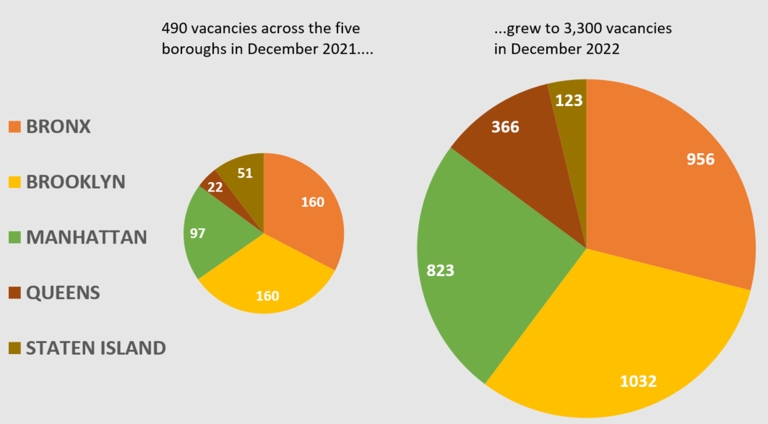
ALT= Two pie charts showing the number of vacant units in NYCHA developments broken down by borough in December 2021 (Bronx with 160, Brooklyn with 160, Manhattan with 97, Queens with 22, and Staten Island with 51) and December 2022 (Bronx with 956, Brooklyn with 1032, Manhattan with 823, Queens with 366 and Staten Island with 123). Data from https://eapps.nycha.info/NychaMetrics/Charts/PublicHousingChartsTabs/?section=public_housing&tab=tab_repairs.

These numbers track closely with the drop in occupancy rate and the drop in the total number of applicants placed in public housing in the last year as reported in the Mayor’s Management Report (“MMR”) and as evidenced by the data available on NYCHA’s website. In the MMR, NYCHA described several contributing factors in their comments. First, that some vacant units are being used in the relocation of residents due to lead abatement. It is unclear from any NYCHA public documents or information how many vacant apartments are being used in this manner. The other factor NYCHA has cited is a policy of holding open apartments in developments set to be converted into the RAD/PACT program in anticipation of the modernization that will happen upon the conversion. While this number could account for some of the ongoing vacancies, out of the 3,300 vacant apartments in December 2022, only 412 of those were in a development currently in the RAD/PACT program. The remaining 2,888 vacancies were in non-RAD/PACT developments.
As would be expected, the growth in vacant apartments coincided with a growth in the average number of turnaround days to reoccupy vacant apartments from 120 days in December 2021 to 260 in December 2022. This increase continues a trend that was highlighted in the 2022 Mayor’s Management Report, which saw the turnaround time increase from 114 days on average in Fiscal Year 2021 to 160 on average across the 2022 Fiscal Year. NYCHA cited increased testing and abatement requirements for lead and asbestos as one reason for the longer turnaround time.
This growth in vacancies and turnaround times comes as NYCHA is experiencing a budget shortfall which is exacerbated by a drop in rent collections due to the pandemic and the exclusion of NYCHA residents from the Emergency Rental Assistance Program, which cut off a needed source for tenants to pay arrears. NYCHA has testified that this continued budget crisis will impact their operations if not remedied. At the same time the Program to Eliminate the Gap in the Mayor’s Fiscal Year 2023 November Plan included a reduction of approximately $31 million dollars over four years to the NYCHA Vacant Unit Readiness Program, which helps prepare and rehabilitate units for tenants to move back into. This reduced spending on the program may be reflected in the growth in vacant units. Additionally, the vacant units represent a loss in rental income for NYCHA, further exacerbating its ongoing budget crisis.
Conclusion
With the immense demand for housing, all available NYCHA apartments should be turned over and filled with tenants as soon as possible. The Committee expects to hear from tenants who on the waitlist, in shelters, or awaiting a transfer, on how the extended time to get into an apartments has effected them. The Committee also expects to hear testimony from NYCHA providing context and explanation about what is causing more apartments to stay empty for longer. The Committee is interested to learn what steps NYCHA is taking to quickly and efficiently transfer tenants or place new tenants from the waiting list into units. Finally, the Committee will look to understand what policies and procedures will be in place for vacancies in developments going through the PACT Program or, in the future, into the Public Housing Preservation Trust.

Ferre-Sadurni, Luis, “The Rise and Fall of New York Public Housing: An Oral History,” The New York Times, available at https://www.nytimes.com/interactive/2018/06/25/nyregion/new-york-city-public-housing-history.html.
Housing Act of 1937, available at https://www.gpo.gov/fdsys/pkg/USCODE-2009-title42/pdf/USCODE-2009-title42-chap8.pdf. Last accessed on 01/25/2023.
Marcuse, 353-54; J.A. Stoloff, A Brief History of Public Housing, Paper presented at August 14 meeting of the American Sociological Association, at 3 (2004).
Marcuse, 354; Stoloff, 1; see also Judith D. Feins, et al., Revised Methods of Providing Federal Funds for Public Housing Agencies, US Department of Housing and Urban Development, at 9 (1994).
See NYCHA Fact Sheet, available at https://www1.nyc.gov/assets/nycha/downloads/pdf/NYCHA_Fact_Sheet_2022.pdf. Last accessed on 01/25/2023.
NYCHA Fact Sheet, available at https://www1.nyc.gov/assets/nycha/downloads/pdf/NYCHA_Fact_Sheet_2022.pdf. Last accessed on 01/25/2023.
Mayor’s Management Report, NYCHA Occupancy Rate. Available at https://dmmr.nyc.gov/city-services/promoting-viable-communities-and-neighborhoods/new-york-city-housing-authority/3177. Last accessed on 01/25/2023.
NYCHA Vacancy data available at https://eapps.nycha.info/NychaMetrics/Charts/PublicHousingChartsTabs/?section=public_housing&tab=tab_repairs. Last accessed on 01/25/2023.
The number of applicants placed in public housing dropped below 3,000 for the first time for which data in the Mayor’s Management Report are available.
City of New York Office of the Comptroller, Audit Report on the New York City Housing Authority’s Management of Vacant Apartments, June 24, 2015. Available at https://comptroller.nyc.gov/reports/audit-report-on-the-new-york-city-housing-authoritys-management-of-vacant-apartments/. Last accessed on 01/25/2025.
Id. Pg. 5
Id. Pg. 5
Id. Pg. 12
Id. Pg. 8
Id. Pg. 15
Id. Pg. 15
Id. Pg. 16
NYCHA’s Letter to NYC Comptroller attached as an addendum to Audit Report on the New York City Housing Authority’s Management of Vacant Apartments, June 24, 2015. Available at https://comptroller.nyc.gov/reports/audit-report-on-the-new-york-city-housing-authoritys-management-of-vacant-apartments/. Last accessed on 01/25/2023.
NYCHA Metrics, https://eapps.nycha.info/NychaMetrics/Charts/PublicHousingChartsTabs/?section=public_housing&tab=tab_repairs. Last accessed on 01/25/2023.
Id.
Id.
Mayor’s Management Report FY2022, pg. 377-379.
Id. Pg. 379
Id. Pg. 379
Data analysis done by Council staff using data from https://eapps.nycha.info/NychaMetrics/Charts/PublicHousingChartsTabs/?section=public_housing&tab=tab_repairs. Last accessed on 01/25/2023.
Id.
Mayor’s Management Report FY2022, pg. 377.
Id.
See NYCHA Testimony from Committee on Public Housing hearing on 12/14/2022 from timestamp 2:20-2:22, available at https://legistar.council.nyc.gov/MeetingDetail.aspx?ID=1059338&GUID=2C23DEDB-0391-434A-B86B-5ABAC5C50010&Options=&Search=.
Budget analysis provided by NYC Council Finance Division using Office of Management and Budget information.

