Committee Counsel:
Jeffrey Campagna

THE COUNCIL OF THE CITY OF NEW YORK

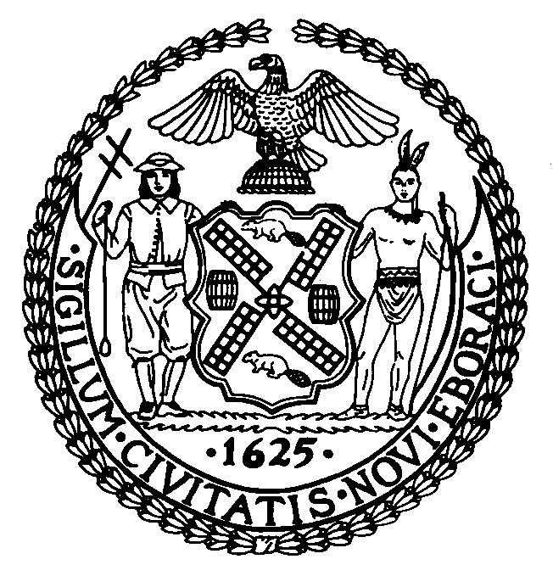

OFFICE OF THE GENERAL COUNSEL
Jason Adolfo Otaño, General Counsel

COMMITTEE REPORT OF THE
COMMITTEE ON RULES, PRIVILEGES AND ELECTIONS

Hon. Keith Powers

March 2, 2023

SUBJECT: Preconsidered Resolution making certain amendments to Rule 7.00(a) of the Rules of the Council in relation to the Standing Committees, Sub-Committees, and Special Committees of the Council.

ANALYSIS: Before the Committee, for its consideration, are proposed changes to the list of standing committees of the Council

SUBJECT: Preconsidered Resolution pursuant to Rule 7.00 making changes to the membership of certain committees of the Council.

ANALYSIS: Before the Committee, for its consideration, are proposed changes to membership of certain standing committees of the Council

