Committee on Women & Gender Equity Staff
Julia Goldsmith-Pinkham, Senior Legislative Counsel
Katie Salina, Legislative Policy Analyst
Allie Stofer, Financial Analyst



The Council of the City of New York

Committee Report of the Legislative Division
Andrea Vazquez, Director
Smita Deshmukh, Deputy Director, Human and Social Services

Committee on Women and Gender Equity

Hon. Amanda Farías, Chair

January 28, 2026

Introduction No. 1297-2025-A: By Council Members Brooks-Powers, Louis, Hanif, Banks, Restler, Brewer, Stevens, Avilés, Joseph, De La Rosa, Sanchez, Krishnan, Abreu, Farías, Hudson, Powers, Cabán, Nurse, Schulman, Hanks, Brannan, Riley, Gutiérrez, Moya, Ayala, Marte, Won, Narcisse, Salaam, Lee, Bottcher, Ung, Ossé, Williams, Menin, Gennaro, Feliz, Salamanca, Dinowitz, Holden, and Public Advocate Jumaane Williams
Title: A Local Law to amend the administrative code of the city of New York, in relation to the gender-motivated violence protection law

- Introduction
On January 28, 2026, the Committee on Women and Gender Equity (“the Committee”), chaired by Council Member Amanda Farías, will consider whether to recommend the override of the Mayor’s veto of Introduction Number 1297-2025-A (“Int. No. 1297-A”), sponsored by Council Member Brooks-Powers, relating to the gender-motivated violence protection law; and whether to recommend that veto message M-0014-2026 be filed.
On May 28, 2025, Int. No. 1297 was introduced and referred to the Committee on Women and Gender Equity. The Committee considered testimony on Int. No. 1297 on October 16, 2025. Witnesses who testified included the Mayor’s Office to End Domestic and Gender-based Violence (ENDGBV), survivors of gender-based violence, representatives from community-based organizations, and other interested members of the community.
On November 25, 2025, the Committee considered Int. No. 1297-A and passed the legislation by a vote of 5 in the affirmative and zero in the negative, with zero abstentions. The bill was then sent for approval by the full Council. At the Stated Meeting of November 25, 2025, the Council approved the bill by a vote of 48 in the affirmative and zero in the negative, with zero abstentions.
On December 24, 2025, the Mayor issued a message of disapproval for Int. No. 1279-A. Pursuant to Section 37(b) of the Charter, the clerk presented the Mayor’s veto message, M-0014-2026 at the next Stated Meeting on January 7, 2026, and the message was referred to the Committee on Women and Gender Equity. The Mayor’s veto message is appended hereto as Appendix A.
The question before the Committee on Women and Gender Equity today is whether to recommend that Int. No. 1279-A be re-passed notwithstanding the objections of the Mayor, and whether to recommend that the Mayor’s veto message, M-0014-2026, be filed.
- Background
Int. No. 1297-A
In 2000, the Council passed the Victims of Gender-Motivated Violence Protection Law (“GMVA”) creating a civil cause of action against individuals who committed a crime of violence motivated by gender. The cause of action was in section 8-904 of the NYC Administrative Code and redesignated to section 10-1104 by Local Law 63 for the year 2018. In 2022, the Council passed Local Law 21 for the year 2022, which amended section 10-1104 to include a two-year lookback window allowing survivors of gender-motivated violence who had claims that had passed the statute of limitations to bring those expired actions. Local Law 21 for the year 2022 also amended the language in the bill to replace “individual” with “party” and expanded liability allowing individuals who claim to have been injured by a party who commits, directs, enables, participates in, or conspires in the commission of a crime of violence motivated by gender, to bring a civil claim. Since its passage, courts have held that Local Law 21’s expansion of liability did not apply retroactively. That conclusion rested primarily on Local Law 21’s lack of unambiguous language stating that its expansion of liability was meant to operate retroactively.
- Bill Analysis
Int. No. 1297-A
This bill would create a new civil cause of action for crimes of violence motivated by gender that occurred prior to January 9, 2022. Any person claiming to be injured by a party who committed, directed, enabled, participated in, or conspired in the commission of a crime of violence motivated by gender may bring a civil claim against that party for that injury. This cause of action would allow for claims based on crimes of violence motivated by gender that occurred both prior to the enactment of the 2022 GMVA Amendment, and prior to the enactment of the GMVA in 2000. The claims brought under this law would be required to be commenced within 18 months of the effective date of the local law. The bill also provides that any person who brought a claim between March 1, 2023, and March 1, 2025, that would satisfy the requirements of a cause of action under this new section would be able to amend or refile their claim to add a cause of action under this section.
Since its initial hearing, the bill was amended to establish the new cause of action in its own section of the administrative code. The bill also received technical edits. The bill would take effect immediately after it becomes law.

Int. No. 1297-A

By Council Members Brooks-Powers, Louis, Hanif, Banks, Restler, Brewer, Avilés, Stevens, Joseph, De La Rosa, Sanchez, Krishnan, Abreu, Farías, Hudson, Powers, Cabán, Nurse, Schulman, Hanks, Brannan, Riley, Gutiérrez, Moya, Ayala, Marte, Won, Narcisse, Salaam, Lee, Bottcher, Ung, Ossé, Williams, Menin, Gennaro, Feliz, Salamanca, Dinowitz, Holden and the Public Advocate (Mr. Williams)

A Local Law to amend the administrative code of the city of New York, in relation to the gender-motivated violence protection law

Be it enacted by the Council as follows:

Section 1. Subdivision a of section 10-1105 of the administrative code of the city of New York, as amended by local law number 21 for the year 2022, is amended to read as follows:
a. A civil action under [this chapter] section 10-1104 shall be commenced within seven years after the alleged crime of violence motivated by gender occurred. If, however, due to injury or disability resulting from an act or acts giving rise to a cause of action under this chapter, or due to infancy as defined in the civil procedure law and rules, a person entitled to commence an action under this chapter is unable to do so at the time such cause of action accrues, then the time within which the action must be commenced shall be extended to nine years after the inability to commence the action ceases. Notwithstanding any provision of law that imposes a period of limitation to the contrary, any civil claim or cause of action brought under this chapter that is barred because the applicable period of limitation has expired is hereby revived and may be commenced not earlier than six months after, and not later than two years and six months after, September 1, 2022.
§ 2. Chapter 11 of title 10 the administrative code of the city of New York, as amended by local law number 21 for the year 2022, is amended by adding a new section 10-1104.1 to read as follows:
10-1104.1. Civil cause of action for crimes of violence motivated by gender that occurred prior to January 9, 2022. a. Any person claiming to be injured by a party who commits, directs, enables, participates in, or conspires in the commission of a crime of violence motivated by gender for which the alleged crime of violence motivated by gender occurred (i) on or before December 19, 2000 or (ii) after December 19, 2000 and before January 9, 2022, has a cause of action against such party in any court of competent jurisdiction for any or all of the following relief:
1. Compensatory and punitive damages;
2. Injunctive and declaratory relief;
3. Attorney’s fees and costs; and
4. Such other relief as a court may deem appropriate.
b. Claims or causes of action pursuant to this section must be commenced not later than 18 months after the local law that added this section takes effect.
c. Any person who brought a claim or cause of action on or after March 1, 2023 but on or before March 1, 2025 that would satisfy the requirements of this section may amend or refile such claim or cause of action to add a cause of action pursuant to this section.
§ 3. This local law takes effect immediately.
JMF/JGP
LS #18564
11/17/25 9:30p

Appendix A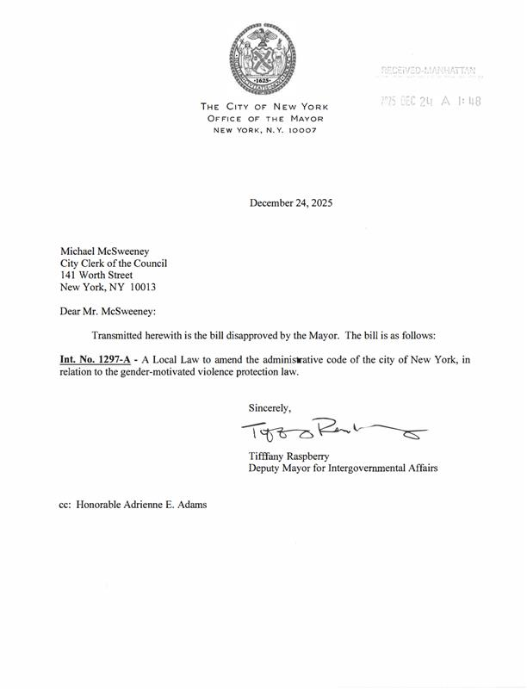
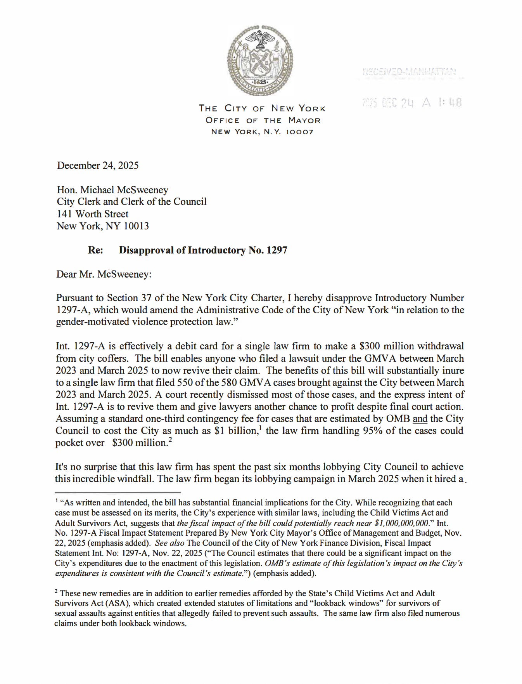

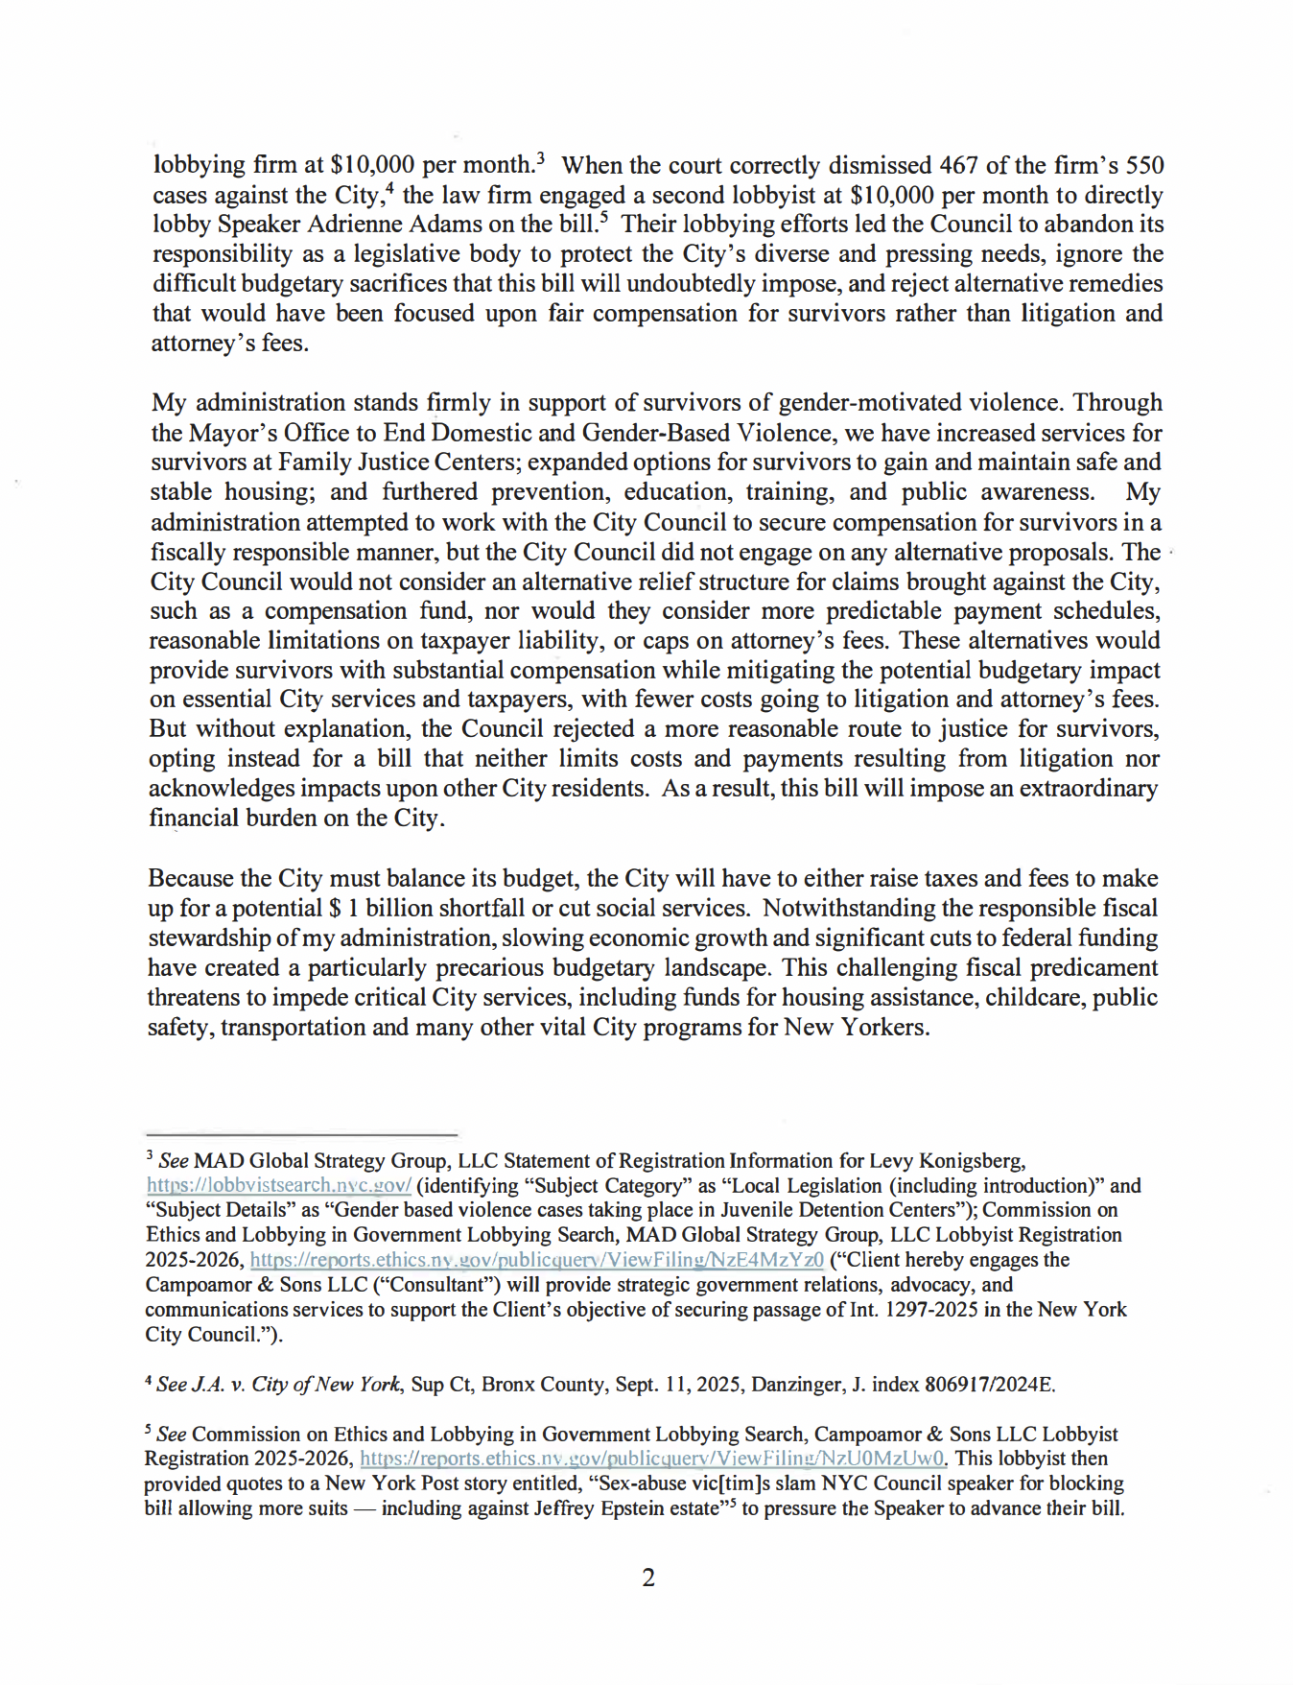

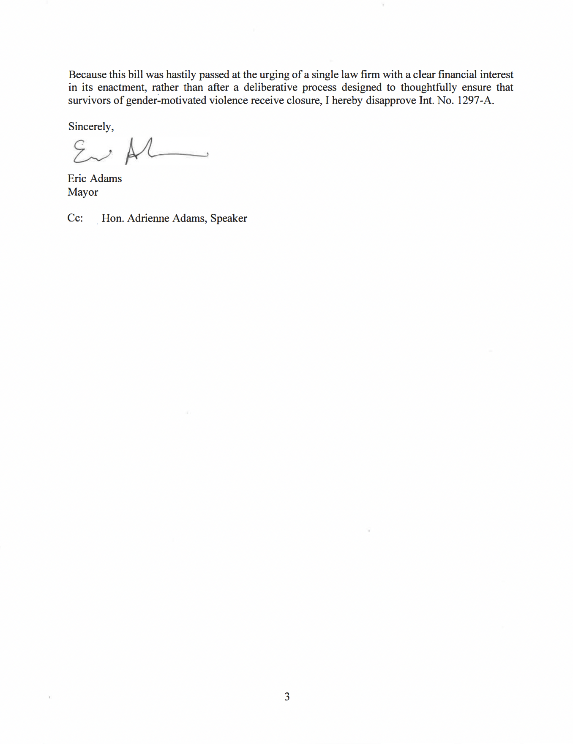

Local Law 63 for the year 2018.
Local Law 21 for the year 2022.
Id; S.S. v. Rockefeller Univ. Hosp., 236 N.Y.S.3d 145 (2025).
S.S. v. Rockefeller Univ. Hosp., 236 N.Y.S.3d 145, 146 (2025).
Id.

