Committee on Small Business
Luciano Hamel, Legislative Counsel
Rebecca Barilla, Senior Policy Analyst
Glenn Martelloni, Financial Analyst

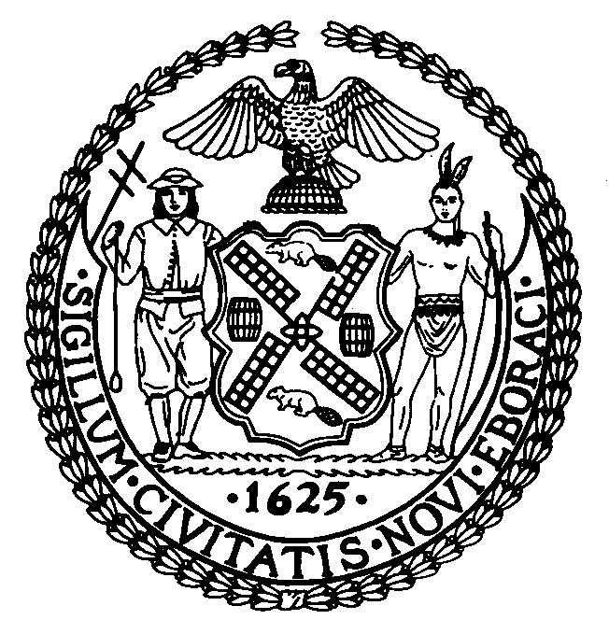

THE COUNCIL OF THE CITY OF NEW YORK

COMMITTEE REPORT OF THE GOVERNMENTAL AFFAIRS Division

Andrea Vazquez, Legislative Director
Rachel Cordero, Deputy Director, Governmental Affairs

COMMITTEE ON SMALL BUSINESS
Hon. Oswald Feliz, Chair

December 18, 2025

Proposed Int. No. 1350-a | By Council Members Farías, Louis, Brannan, Hanif, Brewer, Joseph and Schulman
Title: | A Local Law to amend the administrative code of the city of New York, in relation to small business loan readiness resources
- INTRODUCTION
On December 18, 2025, the Committee on Small Business, chaired by Council Member Oswald Feliz, will vote on Proposed Introduction Number 1350-A, sponsored by Council Member Amanda Farías, in relation to small business loan readiness resources. A previous version of this bill was heard on October 15, 2025.
- BACKGROUND
  - Small Business Financial Needs
To start and maintain a small business, owners often require access to capital. Accessing that capital can be difficult, especially for immigrant entrepreneurs and minority-owned businesses. In New York City, small businesses “face unmet capital needs of approximately $45 billion a year” with minority- and immigrant-owned businesses typically struggling the most in obtaining capital. In a survey from Goldman Sachs’ 10,000 Small Business Voices, it was reported that 81% of small business owners who have applied for a business loan or line of credit within the last year found it difficult to access affordable capital, and 51% said that they cannot afford to take out a loan due to current interest rates.
Community Development Financial Institutions (‘CDFIs’) are financial institutions that provide economic services for individuals, small businesses and communities that have historically been underserved by mainstream lending services. These institutions are often community-oriented and have been heralded for lending responsibly to low-income communities. CDFIs include community development (‘CD’) banks, CD credit unions, CD loans funds, and CD venture capital funds. Local CDFIs are generally certified through the CDFI Fund, which is an investment fund managed by the U.S. Department of the Treasury. This certification allows the institutions to apply for financial support through the CDFI Fund. During the 2025 United States federal government shutdown, the entire CDFI fund staff was eliminated. Small business associations and credit unions quickly responded to the announcement flagging the devastating impacts this elimination could have on communities and small businesses, and the economic benefits of CDFIs on private investment. The shutdown-related reductions were subsequently rescinded.
However, even without this disruption to the CDFI Fund, low-income entrepreneurs and business owners seeking financial assistance often struggle to access CDFIs or are unaware they exist. As reported by the U.S. Department of the Treasury, small businesses have also reportedly struggled “obtaining information about, or comparing, financial products.”
In 2023 the New York City Council passed two pieces of legislation through the Committee on Small Business to begin to address these economic issues. Local law 133 of 2023 required the Department of Small Business Services (‘SBS’) to provide information related to local CDFIs via an online portal, with a directory of participating CDFIs and a description of each CDFI’s mission statement, operating locations, and the services and types of loans offered. Local law 137 of 2023 required SBS to post on its website information on selecting a bank for small businesses, including information on specialized services offered by banks for small businesses, information on typical fees, interest rates, monthly charges, or balance requirements, the advantages and disadvantages of having accounts at multiple banks, and information about Federal Deposit Insurance Corporation insurance coverage or other protections provided for small business deposits.

- PROPOSED INTRODUCTION 1350-A LEGISLATIVE ANALYSIS
This bill would require the Department of Small Business Services (SBS) to provide loan readiness resources to help small businesses prepare for the lending process and understand the services offered by Community Development Financial Institutions (CDFIs) on the City’s website. These resources would include assistance with business plan development, preparation of financial documents, and understanding loan application requirements. This local law would take 180 days after becoming law.

- INTRODUCTION 1350 AMENDMENTS
On October 15, 2025, the Committee on Small Business considered Introduction 1350 at a hearing. The Committee received testimony from the Department of Small Business Services, the Bronx Chamber of Commerce, and the New York Small Business Development Center. Introduction 1350 was subsequently amended to remove the requirement that SBS post resources focusing on services offered by lenders other than CDFIs. Introduction 1350 was also amended to state the correct local law that most recently amended section 22-1002 of the Administrative Code.

This page intentionally left blank

Proposed Int. No. 1350-A

By Council Members Farías, Louis, Brannan, Hanif, Brewer, Joseph and Schulman

A Local Law to amend the administrative code of the city of New York, in relation to small business loan readiness resources

Be it enacted by the Council as follows:

Section 1. Paragraph 4 of subdivision a of section 22-1002 of the administrative code of the city of New York, as amended by local law number 137 of 2023, is amended to read as follows:
4. Information on loans and grants for small businesses which shall include, but need not be limited to:
(a) Guidance on selecting a lender, including information about local CDFIs, which shall include, but need not be limited to, a directory of local CDFIs, and for each such local CDFI, a description of services provided by such local CDFI, the neighborhood or area of the city in which such local CDFI operates or provides services, and the types of loans offered by such local CDFI;
(b) Information on specialized services that may be offered by banks for small businesses, such as a dedicated banking team, merchant services, business loans, or lines of credit;
(c) Information on typical fees, interest rates, monthly charges, or balance requirements;
(d) Potential advantages and disadvantages of having accounts at multiple banks;
(e) Information about federal deposit insurance corporation insurance coverage or other protections provided for small businesses deposits; [and]
(f) Loan readiness resources to help small businesses prepare for the lending process and understand the services offered by local CDFIs, including business plan development, preparation of financial documents and understanding loan application requirements; and
§ 2. This local law takes effect 180 days after it becomes law.

LH
LS #17133
12/3/2025

ARP
LS # 17133
7/30/25

Lee, W., & Black, S. L. (2017). Small business development: Immigrants’ access to loan capital. Journal of Small Business & Entrepreneurship, 29(3), 193–209. https://doi.org/10.1080/08276331.2017.1297106
The Opportunity Project. Improving Minority Businesses’ Access to Capital. OPPORTUNITY.CENSUS.GOV. (2021). Available at: https://opportunity.census.gov/assets/files/2021-problem-statements/post-covid/MBDA_Improving%20Minority%20Businesses%20Access%20to%20Capital.pdf
Messina, Judith and Eli Dvorkin. Bolstering Minority and Immigrant-Owned Businesses by Scaling Up CDFIs. Center for an Urban Future. December 2022. Available at: https://nycfuture.org/research/bolstering-minority-and-immigrant-owned-businesses-by-scaling-up-cdfis#:~:text=New%20York%20City%20has%20approximately,fewer%20than%20350%20loans%20annually.
Goldman Sachs. “Small Businesses Face Challenges Accessing Capital, Uncertainty Around Tax and Trade Policy.” (June 5, 2025). Available at: https://www.goldmansachs.com/pressroom/press-releases/2025/small-businesses-face-challenges-accessing-capital-uncertainty-around-tax-and-trade-policy
What is a CDFI? Opportunity Finance Network. (Accessed October 2, 2025). Available at: https://www.ofn.org/what-is-a-cdfi/
U.S. Department of the Treasury Community Development Financial Institutions Fund. Federal Deposit Insurance Corporation. (Accessed on December 10, 2025). Available at: https://www.fdic.gov/resources/bankers/affordable-mortgage-lending-center/guide/part-1-docs/cdfi-overview.pdf
Community Development Financial Institution (CDFI) and Community Development (CD) Bank Resource Directory. Office of the Comptroller of the Currency. (Accessed on December 10, 2025). Available at: https://www.occ.gov/topics/consumers-and-communities/community-affairs/resource-directories/cdfi-and-cd-bank/index-cdfi-and-cd-bank-resource-directory.html
Supra note 6.
Id.
Small Business Majority. “Firing of CDFI Fund Staff Will Do Serious Harm To Small Businesses.” (October 11, 2025). Available at: https://smallbusinessmajority.org/press-release/firing-cdfi-fund-staff-will-do-serious-harm-small-businesses
Id; America’s Credit Unions. “Government shutdown reductions in force impact CDFI Fund.” (October 14, 2025). Available at: https://www.americascreditunions.org/news-media/news/government-shutdown-reductions-force-impact-cdfi-fund
America’s Credit Unions. “Administration rescinds CDFI Fund reductions in force.” (November 18, 2025). Available at: https://www.americascreditunions.org/news-media/news/administration-rescinds-cdfi-fund-reductions-force
Id.
Supra note 3.
U.S. Department of the Treasury. “U.S. Department of the Treasury Releases Policy Brief on Small Business Financing.” (January 10, 2025). Available at: https://home.treasury.gov/system/files/136/Financing-Small-Business-Landscape-and-Recommendations.pdf
The New York City Council. Local law 133 of 2023. Legistar. Available at: https://legistar.council.nyc.gov/LegislationDetail.aspx?ID=6067651&GUID=5B72861F-87A1-40C7-ABC5-77DAE8F4EE34&Options=Advanced&Search=
The New York City Council. Local law 137 of 2023. Legistar. Available at: https://legistar.council.nyc.gov/LegislationDetail.aspx?ID=6267702&GUID=13974571-7650-4CD4-85F8-3EC678A1B4A9&Options=Advanced&Search=

