THE COUNCIL OF THE CITY OF NEW YORK
RESOLUTION NO. 312

Resolution approving the decision of the City Planning Commission on Application No. N 240146 ZRQ for an amendment of the text of the Zoning Resolution (L.U. No. 25).

By Council Members Riley and Louis

WHEREAS, Linden Canyon LLC filed an application pursuant to Section 201 of the New York City Charter, for an amendment of the Zoning Resolution of the City of New York (“ZR”), modifying APPENDIX F for the purpose of establishing a Mandatory Inclusionary Housing area, which in conjunction with the related actions would facilitate the development of a new 12-story, 224,000-square feet mixed-use residential building with 267 dwelling units, ground floor community facility uses, and 86 accessory parking spaces at 78-08 Linden Boulevard in the Lindenwood neighborhood of Queens, Community District 10, (ULURP No. N 240146 ZRQ) (the “Application”);

WHEREAS, the City Planning Commission filed with the Council on January 5, 2025, its decision dated December 17, 2025 (the “Decision”) on the Application;

WHEREAS, the Application is related to applications C 240145 ZMQ (L.U. No. 24), a zoning map amendment to change an R4/C1-2 zoning district to R7A/C2-4 and R6A zoning districts and N 240147 LDQ (L.U. No. 26), a modification of an existing Restrictive Declaration recorded against the property;

WHEREAS, the Decision is subject to review and action by the Council pursuant to Section 197-d of the City Charter;

WHEREAS, upon due notice, the Council held a public hearing on the Decision and Application on February 3, 2026;

WHEREAS, the Council has considered the land use implications and other policy issues relating to the Decision and Application; and

WHEREAS, the Council has considered the relevant environmental issues, including the Negative Declaration issued on July 14, 2025 (CEQR No. 24DCP123Q). The Negative Declaration includes an (E) designation (E-851) related to hazardous materials, air quality, and noise to avoid the potential for significant adverse impacts (the “Negative Declaration”).

RESOLVED:

The Council finds that the action described herein will have no significant impact on the environment as set forth in the (E) Designation (E-851) and Negative Declaration.

Pursuant to Sections 197-d and 200 of the New York City Charter and, on the basis of, the Decision and Application, the environmental determination and consideration described in the report, N 240146 ZRQ, incorporated by reference herein, and the record before the Council, the Council approves the Decision.

Matter underlined is new, to be added; Matter struck out is to be deleted;
Matter within # # is defined in Section 12-10;
* * * indicates where unchanged text appears in the Zoning Resolution
* * *

APPENDIX F

Mandatory Inclusionary Housing Areas and former Inclusionary Housing Designated Areas

* * *

QUEENS

* * *

Queens Community District 10

* * *

Map 2 – [date of adoption]

[PROPOSED MAP]

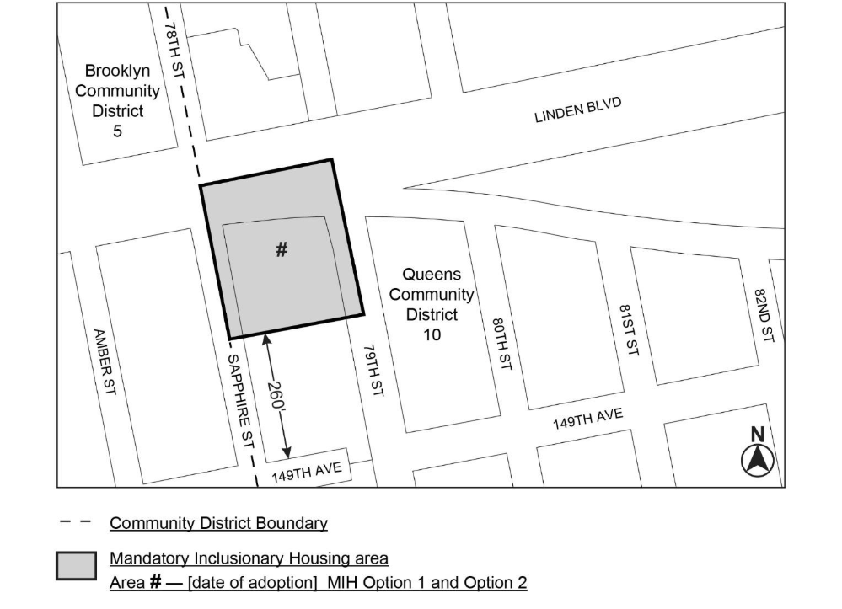
Portion of Community District 10, Queens

* * *

Adopted.

Office of the City Clerk,}
The City of New York,} ss.:

I hereby certify that the foregoing is a true copy of a Resolution passed by The Council of The City of New York on February 12, 2026, on file in this office.

.....................................................
City Clerk, Clerk of The Council

