THE COUNCIL OF THE CITY OF NEW YORK
RESOLUTION NO. 379

Resolution approving with modifications the decision of the City Planning Commission on Application No. N 260039 ZRK for an amendment of the Zoning Resolution (L.U. No. 13).

By Council Members Riley and Marte

WHEREAS, submitted by NYC Department of Housing Preservation and Development
pursuant to Section 201 of the New York City Charter, for an amendment of the Zoning Resolution of the City of New York (“ZR”), amending provisions of Article X, Chapter 1 (Special Downtown Brooklyn District) and APPENDIX F (Mandatory Inclusionary Housing Areas and former Inclusionary Housing Designated Areas) for the purpose of establishing a Mandatory Inclusionary Housing area, would facilitate an approximately 1,075,100 square-foot, 72-story mixed-use development, including 141,280 square feet of commercial and community facility uses, 933,820 square feet of residential uses with 1,263 dwelling units, of which 325 to 379 units would be permanently income-restricted pursuant to Mandatory Inclusionary Housing (MIH), and 4,745 square feet of publicly accessible open space at 395 Flatbush Avenue Extension (Block 2093, Lot 1), in the Downtown Brooklyn neighborhood of Brooklyn Community District 2, Council District 35. ULURP No. N 260039 ZRK) (the “Application”);

WHEREAS, the City Planning Commission filed with the Council on January 13, 2025, its decision dated December 17, 2025 (the “Decision”) on the Application;

WHEREAS, the Application is related to applications C 260038 ZMK (L.U. No. 12) a zoning map amendment from a C6-4 zoning district to a C6-12 zoning district, C 260040 PPK (L.U. No. 14) a disposition approval of a City-owned property at Brooklyn Block 2093, Lot 1, C 260041 HUK (L.U. No. 15) an amendment to the Brooklyn Center Urban Renewal Plan (URP) and C 260042 PCK (L.U. No. 16) a combined site selection and acquisition approval of real property interest at Brooklyn Block 2093, Lot 1;

WHEREAS, the Decision is subject to review and action by the Council pursuant to Section 197-d of the City Charter;

WHEREAS, upon due notice, the Council held a public hearing on the Decision and Application on January 27, 2025;

WHEREAS, the Council has considered the land use implications and other policy issues relating to the Decision and Application; and

WHEREAS, the Council has considered the relevant environmental issues, including the Positive Declaration issued May 1, 2025 (CEQR No. 25HPD058K), and the Final Environmental Impact Statement (FEIS) for which is a Notice of Completion was issued on December 5, 2025.

WHEREAS, FEIS identified significant adverse impacts with respect to transportation (traffic and pedestrians) and construction (traffic, pedestrians, and noise). The proposed mitigation measures are summarized in Chapter 18 “Mitigation” of the FEIS. Potential significant adverse impacts related to hazardous materials, and noise would be avoided through (E) designation (E-124) on the development site (Block 2093, Lot 1), and potential significant impacts related to air quality would be avoided through provisions contained in a Land Disposition Agreement and/or similar Regulatory Agreement which would be would be executed between HPD and the Lessee as specified in FEIS Chapter 9, Chapter 12, and Chapter 11, respectively.

RESOLVED:

Having considered the FEIS, with respect to the Decision and the Application, the Council finds:

- The FEIS meets the requirements of 6 N.Y.C.R.R. Part 617;
- The environmental impacts disclosed in the FEIS were evaluated in relation to the social, economic, and other considerations associated with the actions that are set forth in this resolution;
- Consistent with social, economic and other essential considerations from among the reasonable alternatives available, the action is one which avoids or minimizes adverse environmental impacts to the maximum extent practicable; and
- The adverse environmental impacts identified in the FEIS will be minimized or avoided to the maximum extent practicable by incorporating the mitigation measures that were identified in the FEIS

The Decision, together with the FEIS, issued December 5, 2025, constitutes the written statement of findings that form the basis of the resolution, pursuant to Section 617.11(d) of the SEQRA regulations.

Pursuant to Sections 197-d of the New York City Charter, the Application and Decision, the environmental determination and consideration described in the report, N 260039 ZRQ, incorporated by reference herein, and the record before the Council, the Council approves the Decision, with the following modifications.

Matter underlined is new, to be added;
Matter struck out is to be deleted;
Matter double-underlined is new, added by Council;
Matter double-struck out is old, deleted by Council;
Matter within # # is defined in Section 12-10 or 101-01;
* * * indicates where unchanged text appears in the Zoning Resolution.

* * *

ARTICLE X
SPECIAL PURPOSE DISTRICTS

Chapter 1
Special Downtown Brooklyn District

101-00
GENERAL PURPOSES

* * *

101-01
Definitions

For purposes of this Chapter, matter in italics is defined in Section 12-10 (DEFINITIONS), 32-301 (Definitions), Section 101-702 (Definitions Specific to the Atlantic Avenue Subdistrict) or in this Section.

Development or to develop

For purposes of this Chapter, “development” includes a #development#, an #enlargement# or an #extension#.

To “develop” is to create a #development#.

Large qualifying site

“Large qualifying site” is a #zoning lot# that:

(a) occupies an entire #block#; or

(b) has a minimum #lot area# of 30,000 square feet with at least one full #block# frontage along a #street#.

101-02
General Provisions

* * *

101-20
SPECIAL BULK REGULATIONS

* * *

101-21
Special Floor Area Regulations

R7-1 C6-1 C6-4.5 C6-6 C6-9 C6-12

(a) In R7-1 Districts
* * *

(e) In C6-9 Districts

* * *

(f) In C6-12 Districts

In C6-12 Districts, the underlying #floor area# regulations shall apply.
However, for #large qualifying sites# in C6-12 Districts:

(1) the maximum #commercial# and #community facility# #floor area ratio# shall be subject to the underlying regulations;

(2) the maximum #residential# #floor area ratio# for #qualifying affordable housing# and #qualifying senior housing# shall be 19.0; and

(3) the total #floor area ratio# for all #uses# shall be 23.0.

101-22
Special Height and Setback Regulations

The height of all #buildings or other structures# shall be measured from the #base plane#. The provisions of Section 101-221 (Permitted Obstructions) shall apply to all #buildings# within the #Special Downtown Brooklyn District#.

In R7-1, C5-4, C6-1, C6-4, and C6-9 and C6-12 Districts, except C6-1A Districts, the underlying height and setback regulations shall apply except as modified by the provisions of this Section. #Buildings or other structures# within the Schermerhorn Street Height Limitation Areas shall comply with the provisions of Section 101-30 (SPECIAL PROVISIONS WITHIN HEIGHT LIMITATION AREAS).

* * *

101-222
Standard height and setback regulations

C2-4/R7-1 C6-1 C6-4.5 C6-6 C6-9 C6-12

In the districts indicated, except C6-1A Districts, a #building or other structure# shall not exceed the applicable maximum #building# height set forth in the table in this Section. Furthermore, any portion of a #building or other structure# that exceeds the applicable maximum base height shall provide a setback pursuant to the provisions of Section 23-433 (Standard setback regulations).

MAXIMUM BASE HEIGHTS AND MAXIMUM BUILDING HEIGHTS IN C2-4/R7-1, C6-1, C6-4.5, C6-6, C6-9, AND C6-12 DISTRICTS

 | Maximum base height |  | Maximum #building# height
District | Beyond 100 feet of a #wide street# | Within 100 feet of a #wide street# | Beyond 100 feet of a #wide street# | Within 100 feet of a #wide street#
C2-4/R7-1 | 85 | 85 | 165 | 165
C6-1 | 125 | 155 | 185 | 215
C6-4.5 C6-6 C6-9 | 125 | 155 | 255 | 255
C6-12 | 155 | 155 | 395 | 395

C5-4 C6-4

In the districts indicated, the underlying height and setback provisions applicable to an R10A District shall apply. However, the minimum base height requirements need not apply.

101-223
Tower regulations

C5-4 C6-1 C6-4 C6-6 C6-9 C6-12

In the districts indicated, except C6-1A Districts, above the maximum base heights specified pursuant to Section 101-222 (Standard height and setback regulations), towers provided in accordance with the provisions of Section 23-435 (Tower regulations) shall be permitted as an alternative to the maximum #building# heights specified in Section 101-222. For #buildings or other structures# utilizing such provisions, no height limit shall apply, except that, in C6-1 Districts, the maximum height shall be 495 feet.

101-224
Special provision for certain sites

For #large qualifying sites# that have below-grade transit infrastructure which occupies at least 30 percent of the #lot area#, the underlying setback requirements shall be modified to exempt up to 30 percent of the total #street wall# width of the #development# from such setback requirements.

101-30
SPECIAL PROVISIONS WITHIN HEIGHT LIMITATION AREAS

* * *

101-40
MANDATORY DISTRICT PLAN ELEMENTS

101-41
Special Street Wall Location Regulations

Map 3 (Street Wall Continuity and Mandatory Sidewalk Widenings) in Appendix E of this Chapter specifies locations where the special #street wall# location regulations of this Section apply. However, such regulations shall not apply along the #street# frontage of that portion of any #zoning lot# occupied by existing #buildings# to remain.

* * *

(d) All other areas

* * *

(e) #Large qualifying sites#

For #large qualifying sites# where a publicly accessible area is provided along one or more #street# frontages, the #street wall# location requirements of this Section shall not apply along such #street# frontages or portions thereof occupied by the publicly accessible area.

101-42
Mandatory Sidewalk Widenings

* * *

APPENDIX F
Mandatory Inclusionary Housing Areas and former Inclusionary Housing Designated Areas

* * *

BROOKLYN

* * *

Brooklyn Community District 2

* * *

Map 2 – [date of adoption]

[EXISTING MAP]
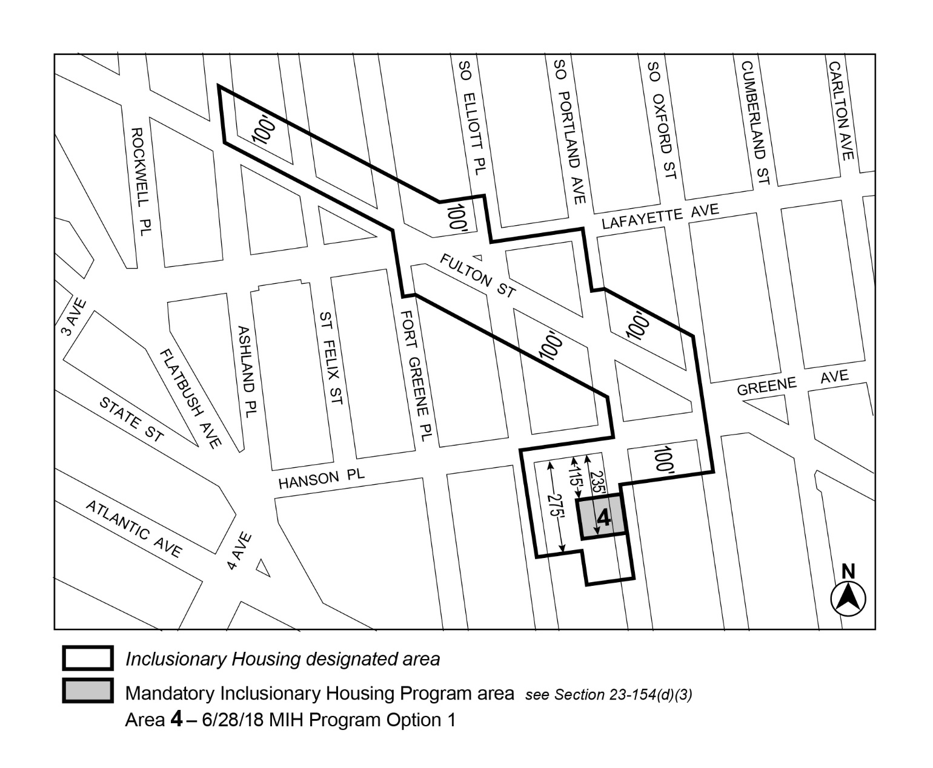

[PROPOSED MAP – APPROVED BY CITY PLANNING COMMISSION]
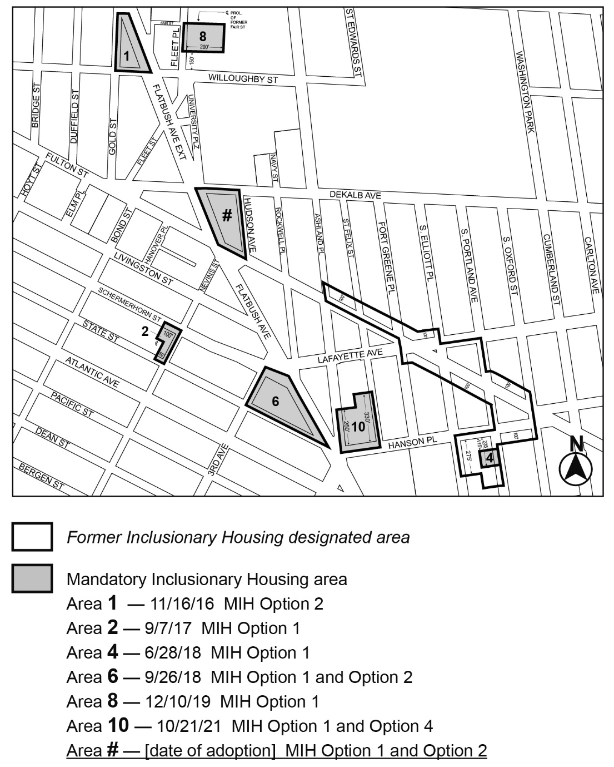

[PROPOSED MAP – MODIFIED BY CITY COUNCIL]
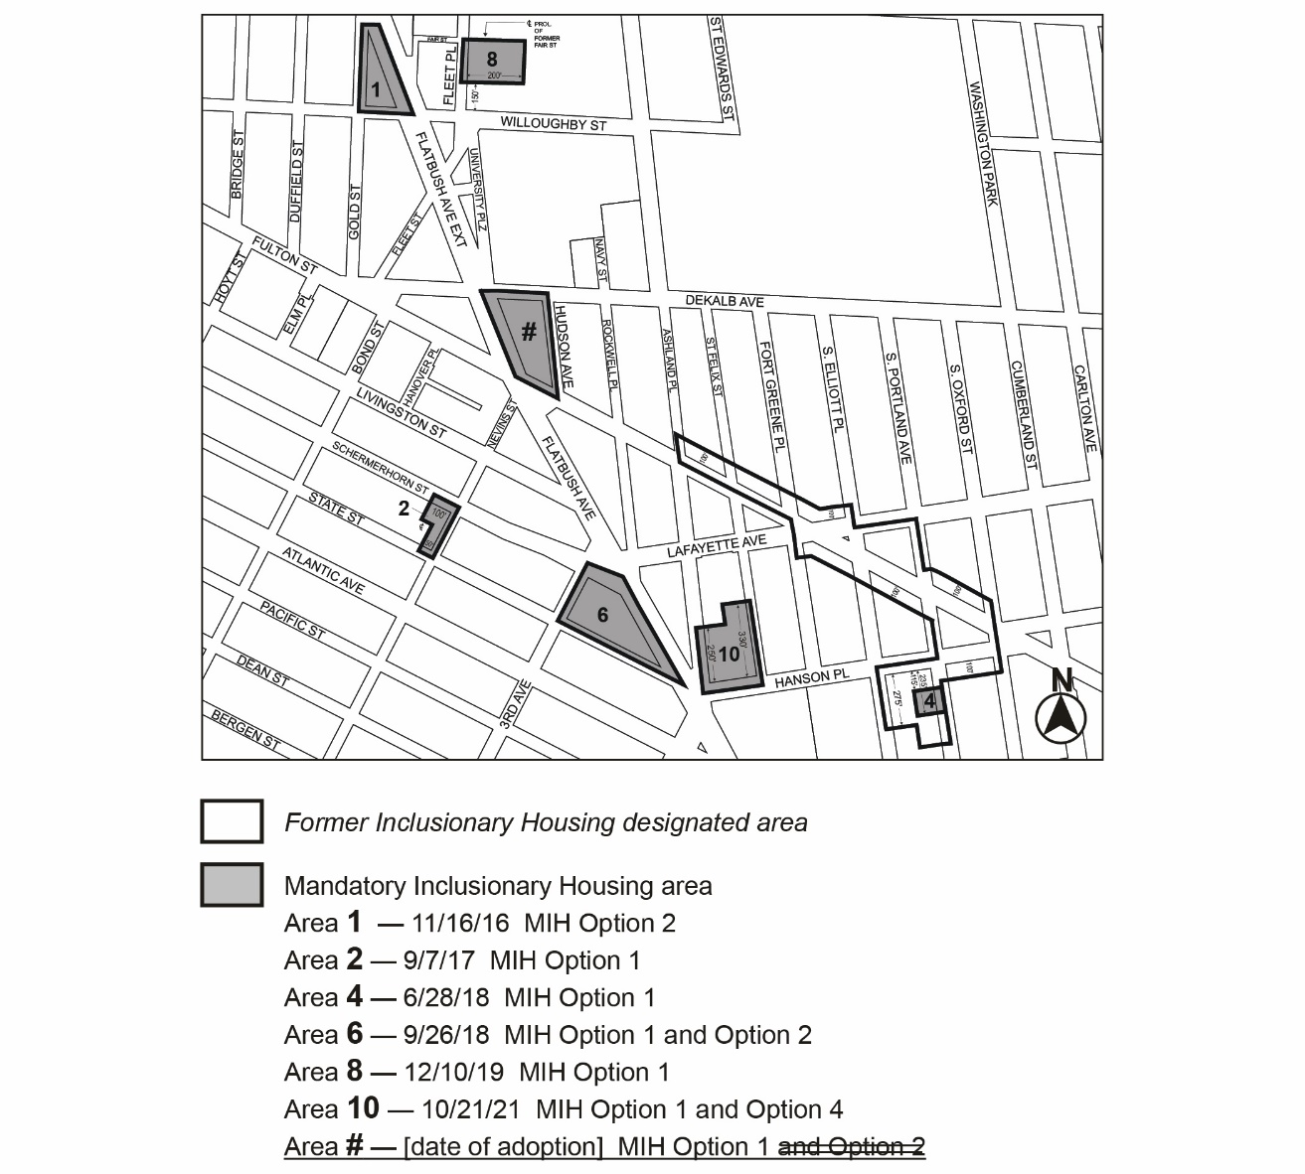
Portion of Community District 2, Brooklyn

* * *

Map 5 – (12/10/19)
[EXISTING MAP – TO BE REMOVED]
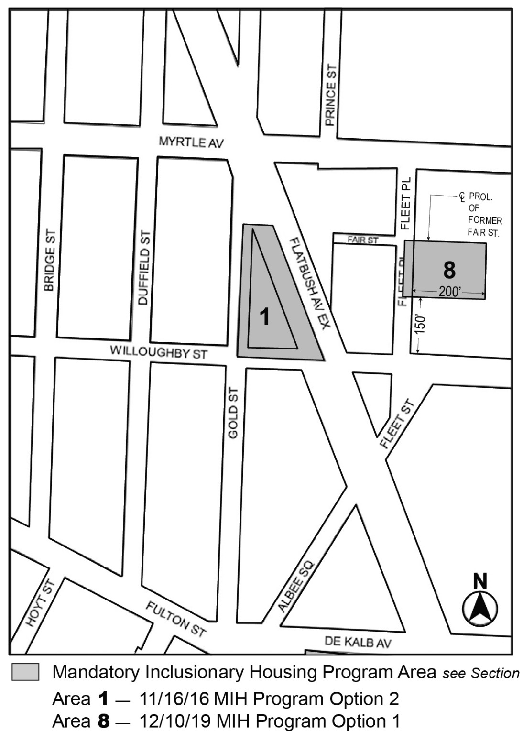

Map 6 – (9/7/17)
[EXISTING MAP – TO BE REMOVED
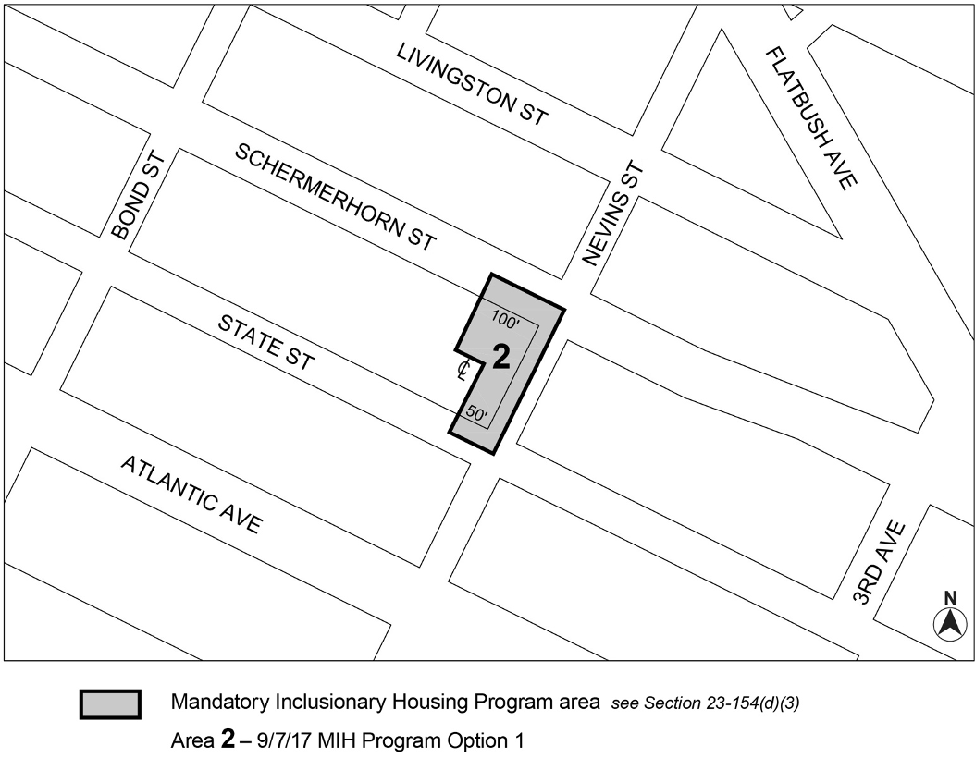

Map 8 – (10/21/21)
[EXISTING MAP – TO BE REMOVED]
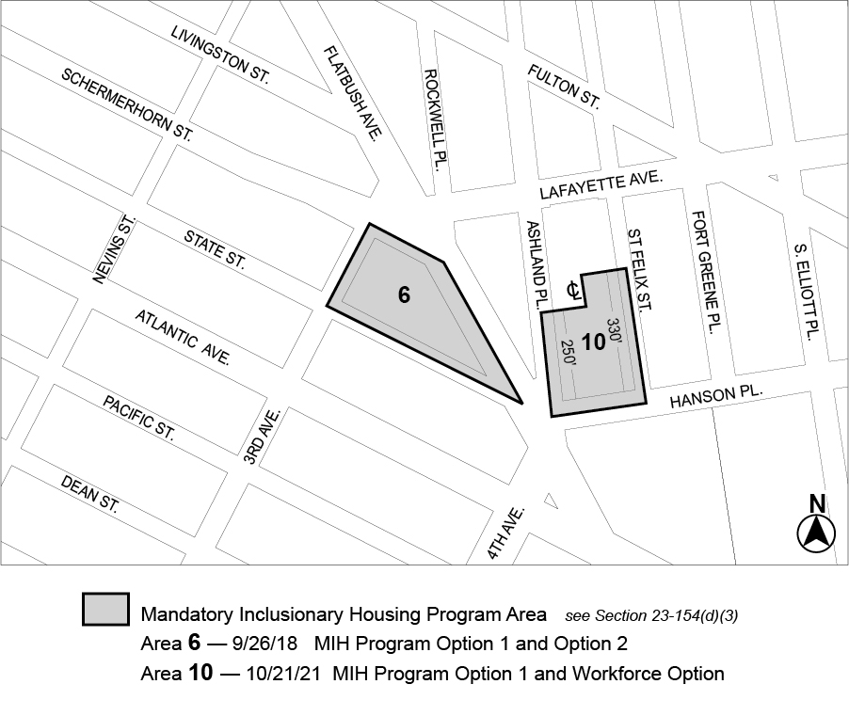
* * *

Adopted.

Office of the City Clerk,}
The City of New York,} ss.:

I hereby certify that the foregoing is a true copy of a Resolution passed by The Council of The City of New York on February ___, 2026, on file in this office.

.....................................................
City Clerk, Clerk of The Council

