THE COUNCIL OF THE CITY OF NEW YORK
RESOLUTION NO. 345

Resolution approving with modifications the decision of the City Planning Commission on Application No. N 250333 ZRK, for an amendment of the text of the Zoning Resolution (L.U. No. 18).

By Council Members Riley and Louis

WHEREAS, 1417 Avenue U Holding LLC, filed an application pursuant to Section 201 of the New York City Charter for an amendment of the Zoning Resolution of the City of New York, amending APPENDIX F (Mandatory Inclusionary Housing Areas and former Inclusionary Housing Designated Areas) for the purpose of establishing a Mandatory Inclusionary Housing area (ULURP No. N 250333 ZRK) (the “Application”);
WHEREAS, the City Planning Commission filed with the Council on December 24, 2025, its decision dated December 3, 2025 (the “Decision”) on the Application;
WHEREAS, the Application is related to applications C 250332 ZMK (L.U. No. 17), a zoning map amendment to change an existing R5/C1-3 zoning district to R5 and R7A/C2-4 and M 250334(A) LDK (L.U. No. 19), the cancellation of a previously approved Restrictive Declaration, dated December 20, 1979;
WHEREAS, the Decision is subject to review and action by the Council pursuant to Section 197-d of the City Charter;
WHEREAS, upon due notice, the Council held a public hearing on the Decision and Application on February 3, 2026;
WHEREAS, the Council has considered the land use implications and other policy issues relating to the Decision and Application; and
WHEREAS, the Council has considered the relevant environmental issues (CEQR No. 26DCP003K). This application was determined to be a Type II action pursuant to the City’s Green Fast Track for Housing (GFT) process, established via a CPC rule change in 2024, which requires no further environmental review. A Type II memorandum was issued on September 12, 2025. The Type II memorandum includes an (E) designation (E-860) related to hazardous materials, air quality, and noise to avoid the potential for significant adverse impacts (the “Type II Memorandum”).
RESOLVED:
The Council finds that the action described herein will have no significant impact on the environment, as set forth in Type II Memorandum and (E) Designation (E-860).
Pursuant to Sections 197-d and 200 of the City Charter and based on the Decision and Application, the environmental determination and consideration described in the report, N 250333 ZRK, incorporated by reference herein, and the record before the Council, the Council approves the Decision of the City Planning Commission, with the following modifications:
The Zoning Resolution of the City of New York, effective as of December 15, 1961, and as subsequently amended, is further amended as follows:
Matter underlined is new, to be added;
Matter struck out is to be deleted;
Matter double-underlined is new, added by the City Council;
Matter double struck out is old, deleted by the City Council;
Matter within # # is defined in Section 12-10;
* * * indicates where unchanged text appears in the Zoning Resolution

* * *
APPENDIX F
Mandatory Inclusionary Housing Areas and former Inclusionary Housing Designated Areas
* * *
BROOKLYN
* * *
Brooklyn Community District 15
* * *
Map 7 – (date of adoption)
[EXISTING MAP]
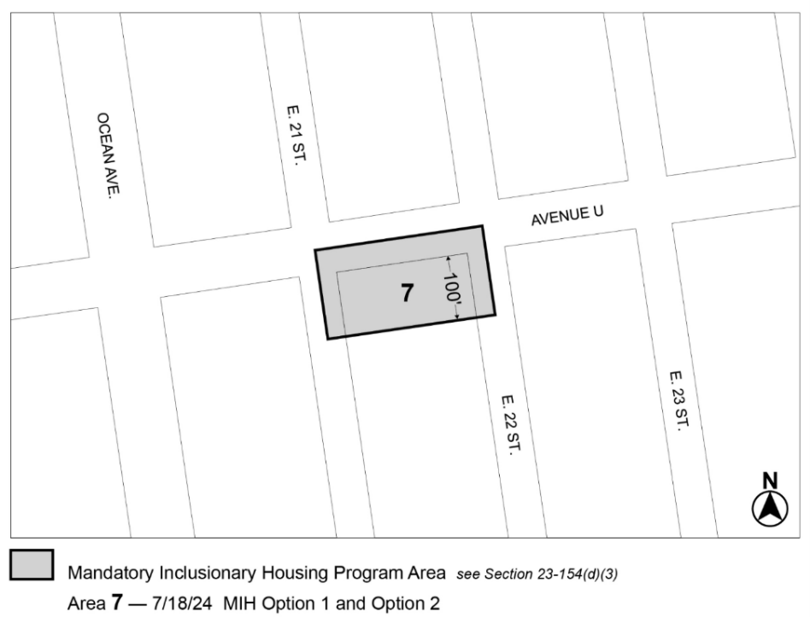

[PROPOSED MAP – Approved by CPC]
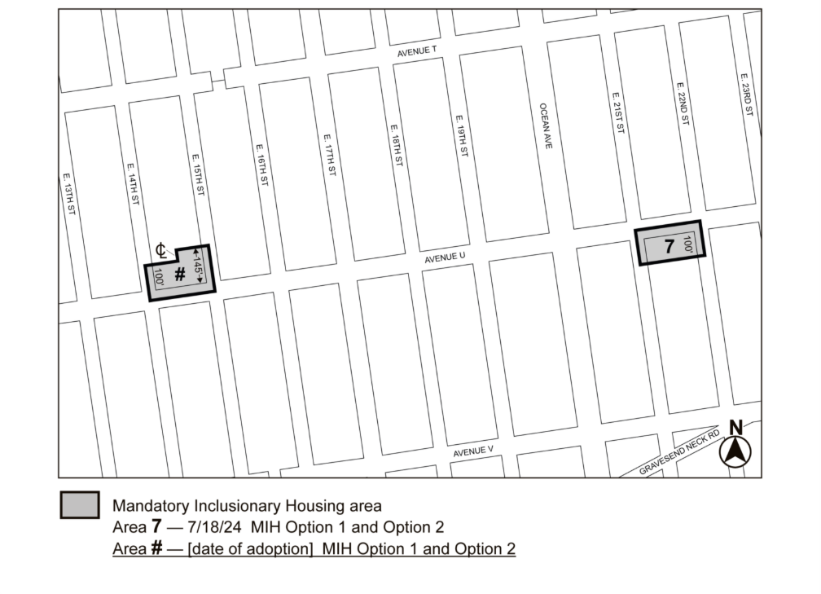
[PROPOSED MAP – Modified by City Council]
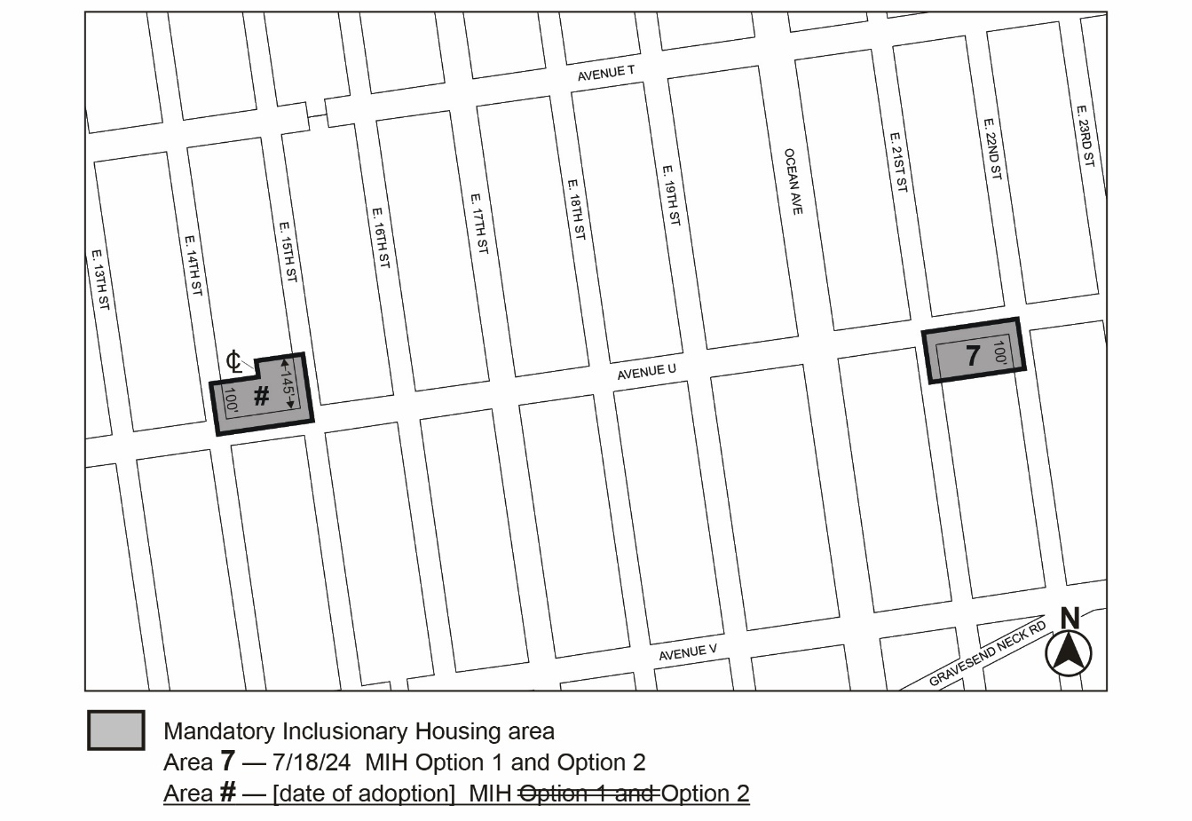

Portion of Community District 15, Brooklyn

* * *

Adopted.
Office of the City Clerk, }
The City of New York, } ss.:
I hereby certify that the foregoing is a true copy of a Resolution passed by The Council of The City of New York on ________, 2026, on file in this office.

.....................................................
City Clerk, Clerk of The Council

