THE COUNCIL OF THE CITY OF NEW YORK
RESOLUTION NO. 348

Resolution approving with modifications the decision of the City Planning Commission on Application No. N 250269 ZRQ, for an amendment of the text of the Zoning Resolution (L.U. No. 23).

By Council Members Riley and Louis

WHEREAS, Broadwood Realty LLC, filed an application pursuant to Section 201 of the New York City Charter, for an amendment of the text of the Zoning Resolution of the City of New York, amending APPENDIX F (Mandatory Inclusionary Housing Areas and former Inclusionary Housing Designated Areas) for the purpose of establishing a Mandatory Inclusionary Housing area, which in conjunction with the related action would facilitate the development of a new nine-story mixed-use building containing ground-floor commercial space and approximately 67 dwelling units, of which 22 would be income-restricted, located at 63-12 Broadway in Woodside, Queens, Community District 2 (ULURP No. N 250269 ZRQ), (the “Application”);

WHEREAS, the City Planning Commission filed with the Council on January 5, 2026 its decision dated December 17, 2025 (the “Decision”) on the Application;

WHEREAS, the Application is related to application C 250268 ZMQ (L.U. No. 22), a zoning map amendment to change an R5/C2-2 zoning district to R7A/C2-4 and R5/C2-4 zoning districts;

WHEREAS, the Decision is subject to review and action by the Council pursuant to Section 197-d of the City Charter;

WHEREAS, upon due notice, the Council held a public hearing on the Decision and Application on February 3, 2026;

WHEREAS, the Council has considered the land use implications and other policy issues relating to the Decision and Application; and

WHEREAS, the Council has considered the relevant environmental issues (CEQR No. 25DCP088Q). This application was determined to be a Type II action pursuant to the City’s Green Fast Track for Housing (GFT) process, established via a CPC rule change in 2024, which requires no further environmental review. A Type II memorandum was issued on June 27, 2025. As a requirement of that determination the applicant has entered into a restrictive declaration that enforces a requirement of a construction protection plan to protect known architectural resources identified by the Landmarks Preservation Commission. With this plan in place, there would be no significant adverse impacts related to historical resources. The Type II memorandum includes an (E) designation (E-835) related to hazardous materials, air quality, and noise analyses to avoid the potential for significant adverse impacts (the “Type II Memorandum”).

RESOLVED:
The Council finds that the action described herein will have no significant impact on the environment, as set forth in the Type II Memorandum and the (E) Designation (E-835).
Pursuant to Sections 197-d and 200 of the City Charter and based on the Decision and Application, the environmental determination and consideration described in the report, N 250269 ZRQ, incorporated by reference herein, and the record before the Council, the Council approves the Decision of the City Planning Commission, with the following modifications:
Matter underlined is new, to be added;
Matter struck out is to be deleted;
Matter double-underlined is new, added by the City Council;
Matter double struck out is old, deleted by the City Council;
Matter within # # is defined in Section 12-10;
* * * indicates where unchanged text appears in the Zoning Resolution
* * *

APPENDIX F

Mandatory Inclusionary Housing Areas and former Inclusionary Housing Designated Areas
* * *
Queens Community District 2
* * *
Map 6 – [date of adoption]
[PROPOSED MAP – Approved by CPC]
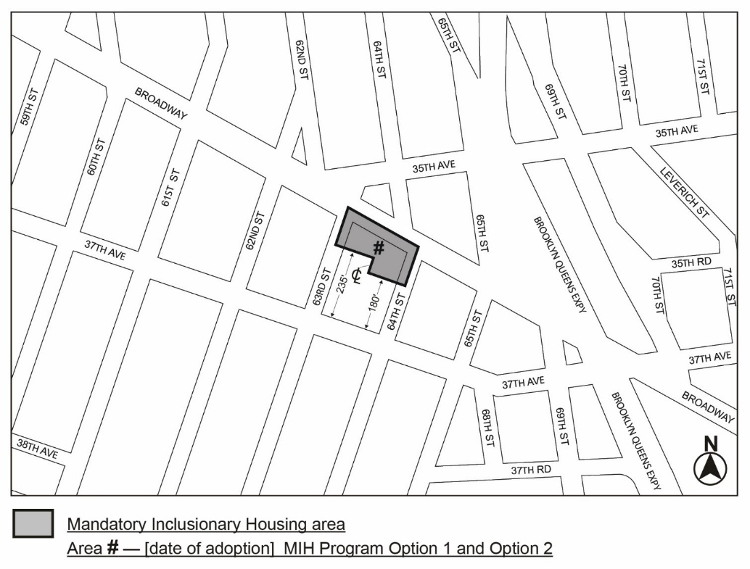

Map 6 – [date of adoption]
[PROPOSED MAP – MODIFIED by City Council]
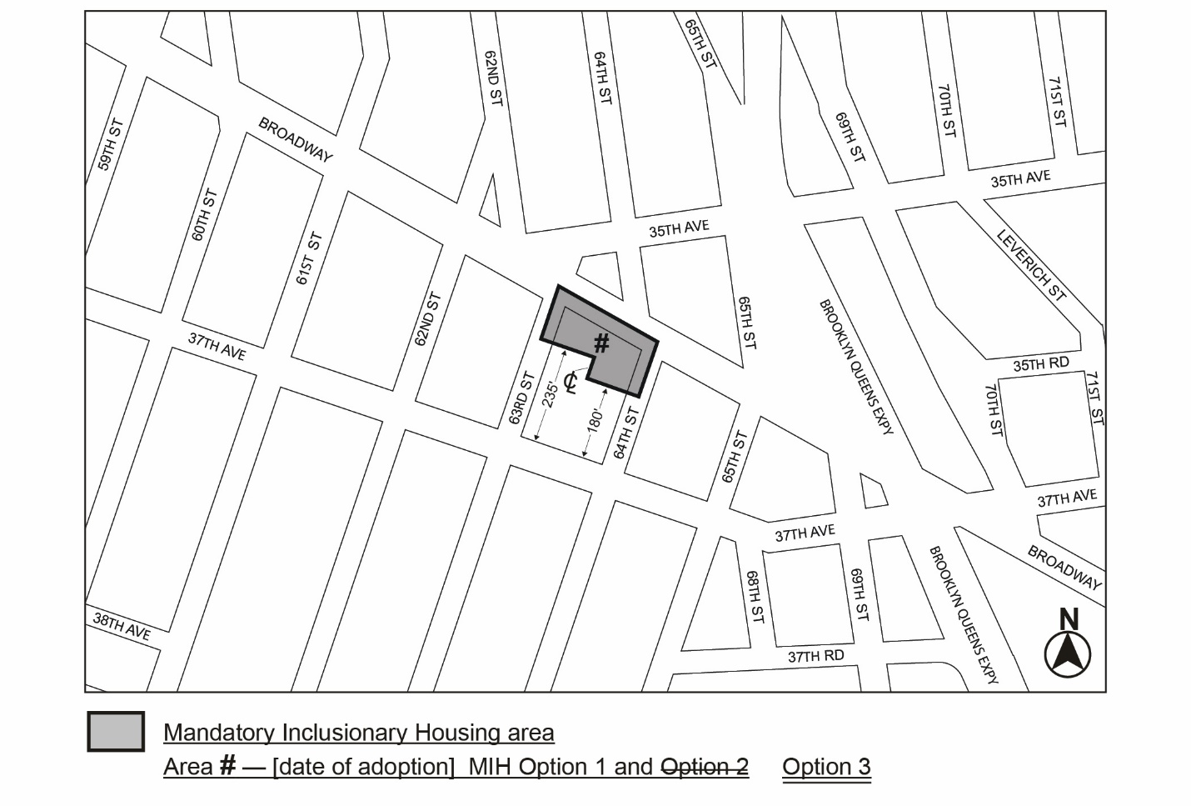

Portion of Community District 2, Queens
* * *
Adopted.

Office of the City Clerk,}
The City of New York, } ss.:

I hereby certify that the foregoing is a true copy of a Resolution passed by The Council of The City of New York on _______, 2026, on file in this office.

.....................................................
City Clerk, Clerk of The Council

