Staff: Committee on Sanitation & Solid Waste Management
Morganne Barrett, Legislative Counsel
Samia Shell, Legislative Counsel
Ricky Chawla, Senior Legislative Policy Analyst
Dirk Spencer PhD, Legislative Policy Analyst
Tanveer Singh, Finance Analyst
Reese Hirota, Data Scientist

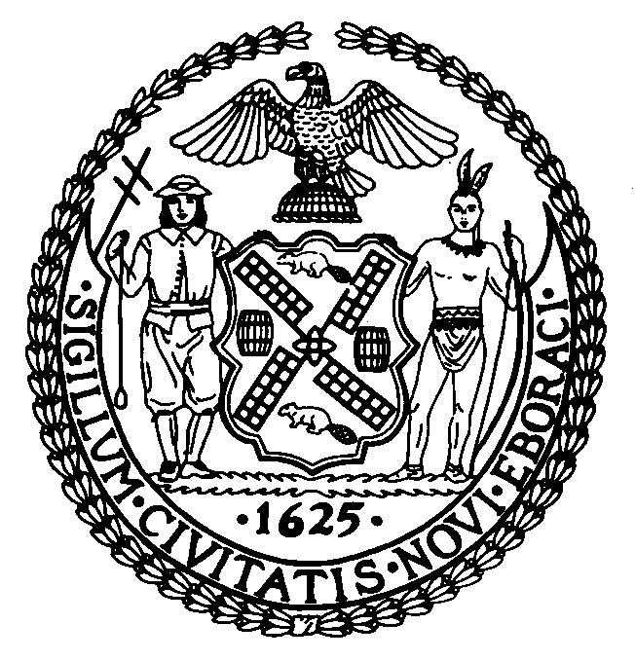

The New York City Council
Andrea Vazquez, Legislative Director

Committee Report of the Infrastructure Division
Brad Reid, Deputy Director

Committee on Sanitation & Solid Waste Management
Hon. Justin Sanchez, Chair

February 11, 2026

Int. No. 18-A By Council Members Abreu, Louis, Encarnación and Morano
Title: A Local Law in relation to a pilot program for power washing machines to clean sidewalk surfaces in commercial corridors

- Introduction

On February 11, 2026, the Committee on Sanitation and Solid Waste Management (“the Committee”), chaired by Council Member Justin Sanchez, voted on Int. No. 18-A, in relation to a pilot program for power washing machines to clean sidewalk surfaces in commercial corridors, sponsored by Majority Leader Shaun Abreu. The Committee previously heard Int. No. 18 at a hearing on January 30, 2026.
- Background
Under the NYC Administrative Code (“Ad. Code”), it is unlawful for any person to litter, sweep, throw, or cast ashes, garbage, paper, dust, or other refuse of any kind, into or upon any street or public place, vacant lot, air shaft, areaway, backyard court, park, or alley. Property owners, regardless of whether they are a public or private party, are responsible for keeping the area adjacent to the building perimeter, i.e., sidewalks including natural elements thereon and extending 18 inches from the curb into the street, clean and free from obstruction and nuisance. The Ad. Code also prohibits anyone from allowing “swill, brine, offensive animal matter, noxious liquid, or other filthy matter of any kind” to fall onto a public space. Property owners are generally responsible for injuries resulting from the negligent maintenance of sidewalks.
From November 1 until March 31 during all hours and between 11 a.m. and 7 p.m. in other months, sidewalk washing is not permitted, unless necessary to protect the health and safety of the public. The Ad. Code permits DSNY to use water as necessary for the flushing or washing of public streets, where the Commissioner of the NYC Department of Environmental Protection (“DEP”) has determined a sufficient water supply exists, however, the respective property owner remains responsible for keeping their sidewalk clean. DSNY would not be permitted to source water for power washing operations from a hydrant, since the Ad. Code prohibits the use of hydrants for water supply except in the case of a fire or where otherwise authorized by law. City rules also describe specific hose nozzle requirements for sidewalk cleaning, depending on the type of property adjacent to the sidewalk. Under drought conditions, additional water usage restrictions may apply to City agencies, like in November of 2024, where the administration of former Mayor Eric Adams, facing a rainfall deficit of over 8 inches, was forced to declare a drought warning. Under a drought warning, DSNY is directed to suspend street flushing activities and reduce fleet washing.
Any person, such as a City resident or a DSNY worker, may not discharge into storm sewers any water unless the water discharge has been authorized via DEP rule. DSNY also may not discharge water that is above 150°F, nor substances that would cause any sewer line or drain to become obstructed. Water discharge may not violate the City’s permit issued by the U.S. Environmental Protection Agency via the National Pollutant Discharge Elimination System Program (“NPDES”). The City’s NPDES Permit authorizes certain non-stormwater discharges including discharges from potable water sources and residual street wash water. “Municipal and agricultural waste discharged into water” is categorized as a pollutant. Sometimes power wash operators use barriers to contain the water.

- Legislation
Int. No. 18-A would require that by April 1, 2027, DSNY implement a pilot program for the use of power washing machines to clean and remove odors and spills from sidewalk surfaces in commercial corridors. DSNY would be required to select a pilot program location in each borough, for a 5-block distance on streets with access to mass transit and high pedestrian traffic. The bill would also require DSNY to report on such pilot program by December 1, 2027.
This local law would take effect immediately.

Update

On Wednesday, February 11, 2026, the Committee adopted Int. No. 18-A by a vote of 8 in the affirmative, 0 in the negative, and 0 abstentions.

Int. No. 18-A

By Council Members Abreu, Louis, Encarnación and Morano

A Local Law in relation to a pilot program for power washing machines to clean sidewalk surfaces in commercial corridors

Be it enacted by the Council as follows:

Section 1. a. Definitions. For purposes of this local law, the following terms have the following meanings:
Block. The term “block” means that portion of the sidewalk between the property line and the curb, running the length of each side of a street, between the boundaries of the corner areas at either end.
Power washing machine. The term “power washing machine” means a machine that uses a high-pressure stream of heated water to remove dirt and debris from outdoor surfaces.
Sidewalk. The term “sidewalk” has the same meaning as set forth in section 19-101 of the administrative code of the city of New York.
b. Pilot program development. No later than April 1, 2027, the department of sanitation shall establish a pilot program for the use of power washing machines to clean and remove odors and spills from sidewalks in a commercial corridor. Such pilot program shall have a duration of no less than 6 months. The department of sanitation, in consultation with the department of environmental protection, shall select no less than 1 location per borough for the pilot program. Each such location shall consist of no less than 5 contiguous blocks of a street with access to mass transit and high levels of pedestrian traffic. Such pilot program shall comply with rules of the department of environmental protection regarding disposal of wastewater.
c. Reporting. No later than December 1, 2027, the department of sanitation shall submit to the mayor and the speaker of the council a report on the power washing pilot program. Such report shall include an evaluation of the power washing pilot program and recommendations regarding whether to expand such program.
§ 2. This local law takes effect immediately, and expires and is deemed repealed upon submission of the department of sanitation’s report to the mayor and the speaker of the council pursuant to subdivision c of section one of this local law.
MB
LS #14378/17415
Int. #1278-2025
02/04/2026, 5:44pm

See, Int. 0018-2026, in relation to a pilot program for power washing machines to clean sidewalk surfaces in commercial corridors, NYC Council (last accessed Feb. 11, 2026), available at: https://legistar.council.nyc.gov/LegislationDetail.aspx?ID=7824596&GUID=ACD25FB3-D0F6-4C6F-B397-AAB18B84A5F0&Options=ID%7CText%7CAttachments%7C&Search=0018.
NYC Admin. Code, § 16-118.
Id.
NYC Admin. Code, § 16-118(6).
N.Y.C. Admin. Code § 7-210; see also, Committee Report of the Committee on Transportation, Nov. 12, 2002, available at: https://legistar.council.nyc.gov/LegislationDetail.aspx?ID=437904&GUID=9EEBA9C3-CAB0-4BBF-AF48-C27AEFA4A08A&Options=ID|Text|&Search= (detailing that the “result of the evolution of the “Prior Notice Law” coupled with the basic law pertaining to the duties and obligations of property owners with relation to sidewalks is that the City of New York is paying out many millions of dollars per year to claimants and plaintiffs alleging injuries proximately sustained from defective or unsafe conditions on sidewalks”).
15 RCNY § 20-08 (a)(7); see also, Sidewalk Washing Complaint, NYC 311 (last accessed Apr. 28, 2025), available at: http://portal.311.nyc.gov/article/?kanumber=KA-01937.
NYC Admin. Code, § 16-112.
Supra, n. 2.
N.Y.C. Admin. Code § 24-307.
15 RCNY § 20-08 (a)(7).
NYC Office of the Mayor. Mayor Adams Elevates Drought Level to Warning, Pauses Delaware Aqueduct Repair Project, Orders City Agencies to Implement Water-Saving Measures and New Yorkers to Continue Conserving Water. November 18, 2024. https://www.nyc.gov/office-of-the-mayor/news/839-24/mayor-adams-elevates-drought-level-warning-pauses-delaware-aqueduct-repair-project-orders-city#/0
Id.
N.Y.C. Admin. Code § 24-520.1.
N.Y.C. Plumbing Code, Ch. 8, § 803.1.
N.Y.C. Admin. Code § 24-520.
See, National Pollutant Discharge Elimination System (NPDES), EPA (last accessed Apr. 3, 2025), available at: https://www.epa.gov/npdes.
SPDES PERMIT NUMBER NY0287890, NYS Dep’t Env’t Conservation (July 15, 2022), available at: https://www.nyc.gov/assets/dep/downloads/pdf/water/stormwater/ms4/spdes-ms4-permit.pdf.
Best Practices for Power & Pressure Washing, New Pig (last accessed Apr. 28, 2025), available at: https://www.newpig.com/expertadvice/best-practices-for-power-pressure-washing/#:~:text=Remove%20gross%20contamination%20from%20surfaces,Protect%20drains.

