Committee on Contracts
Alex R. Paulenoff, Senior Legislative Counsel
Johari Frasier, Legislative Counsel
Alex Yablon, Legislative Policy Analyst
Owen Kotowski, Senior Financial Analyst

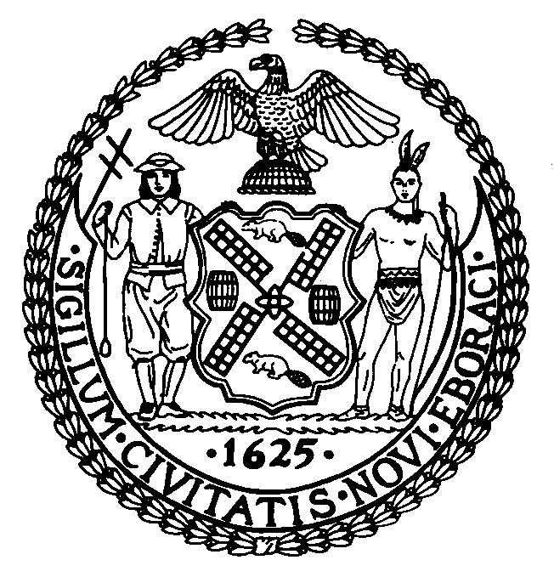
THE COUNCIL OF THE CITY OF NEW YORK
COMMITTEE REPORT OF THE GOVERNMENTAL AFFAIRS DIVISION
Andrea Vazquez, Legislative Director
Rachel Cordero, Deputy Director

COMMITTEE ON CONTRACTS

Hon. Lincoln Restler, Chair

February 11, 2026

Int. No 0069-2026: By Council Members Won, the Public Advocate (Mr. Williams) and Louis

TITLE: A Local Law to amend the administrative code of the city of New York, in relation to prohibiting city agencies from procuring single-use water containers

- INTRODUCTION
On February 11, 2026, the Committee on Contracts, chaired by Council Member Lincoln Restler, will hold a hearing on Introduction Number 0069-2026 (“Int. No. 69”) sponsored by Council Member Julie Won. Int. No. 69 would prohibit city agencies from entering into or renewing contracts for the purchase of single-use plastic water containers, with limited exceptions for emergencies, health and safety, and preexisting contracts. The Mayor’s Office of Contract Services (“MOCS”), city contractors, and other interested stakeholders were invited to testify.
- BACKGROUND
Plastic Waste, Pollution, and Carbon Emissions
Plastics represent a significant share of the waste stream. Recycling efforts have largely failed to mitigate the growing stream of plastic waste: only about 5 percent of plastic waste items are recycled in the United States, with the rest ending up in landfills, as litter, or combusted. Plastics that end up in landfills can remain there for centuries. Items made from plastic represent a strong plurality of all litter as they comprise 38.9 percent of items found on streets and sidewalks, compared to 15.2 percent for items made of paper, 7.9 percent for items made of metal, and 7.2 percent for items made of glass.
Single-use plastics, from plastic film packaging and bags to plastic eating utensils, present a challenge for waste and emissions reduction goals. Unlike metal goods, plastics are frequently manufactured with additives like coloring, which interfere with plastic recycling processes that melt down materials of identical color and composition. Single-use plastics intended for usage with food or drink are also often impracticable to recycle because they must be free of any food residue before proper disposal, and few consumers will take the time to thoroughly wash disposable plastic cutlery or bottles.
When not recycled, pieces of plastic waste often break down and degrade into fragments ranging in size from shards of several inches to microscopic particulates, known as “microplastics.” Microplastic particles have become a ubiquitous pollutant around the planet: they have been detected in marine environments, drinking water, foods, and floating in air breathed by humans; animal studies have shown ingested or inhaled microplastics can pass into organs including the brain where they may interfere with the endocrine and immune systems. However, the extent and severity of these health threats are debated: many research papers showing extremely high levels of microplastics in human organs have been criticized for utilizing methods that may confuse normal human tissue with synthetic materials.
Plastic production and pollution contribute to carbon emissions that drive global warming: plastics are made using carbon-based fossil fuels and release the greenhouse gases ethylene and methane during decomposition.
Local Procurement Policy and Plastic Waste Reduction
Government purchasing power represents a significant lever for environmental policy. This is particularly true regarding readily achievable areas, like single-use plastic reduction, that align with the City’s broader climate commitments and waste reduction targets established in the OneNYC 2050 initiative.
Since 2019, City elected officials have directed agencies to limit purchases of single-use plastics. Executive Order 42 of 2019, issued by Mayor Bill de Blasio, eliminated the use of City funds for the unnecessary purchase of single-use plastic utensils, including, but not limited to, forks, spoons, knives, and straws. Executive Order 54 of 2020 directed agencies to stop purchasing single use plastic bottles of 21 fluid ounces or less. That order said the city purchased at least one million such bottles every year. This executive order remains in effect, though it could be revoked by a future administration in the absence of codification.
- LEGISLATIVE ANALYSIS

Int. No. 69 (Won) – A Local Law to amend the administrative code of the city of New York, in relation to prohibiting city agencies from procuring single-use water containers
This bill would prohibit city agencies from entering into or renewing any contract for the purchase of single-use plastic water containers, or meals or refreshments that include single-use plastic water containers.
The bill defines “single-use plastic water container” as any sealed plastic container with a volume of less than one gallon that contains flat, unflavored drinking water and is generally recognized by the public as an item to be discarded after one use. Int. No. 69 permits exceptions when necessary to protect health, safety, and welfare, to prepare for or respond to an emergency, or where compliance would conflict with contract requirements or labor agreements in existence as of the bill’s effective date.
The bill would take effect immediately upon becoming law.
- CONCLUSION
Single-use plastic water containers contribute to a growing waste crisis in the City with the vast majority of plastic waste ending up in landfills, as litter, or combusted rather than recycled. Int. No. 69 would establish a durable prohibition on City agency procurement of single-use plastic water containers through local law.

Int. No. 69
By Council Members Won, the Public Advocate (Mr. Williams) and Louis

A Local Law to amend the administrative code of the city of New York, in relation to prohibiting city agencies from procuring single-use water containers

Be it enacted by the Council as follows:

Section 1. Chapter 3 of title 6 of the administrative code of the city of New York is amended by adding a new subchapter 9 to read as follows:
SUBCHAPTER 9
SINGLE-USE WATER CONTAINERS
§ 6-319 Single-use plastic water containers. a. Definition. For the purposes of this section, the term “single-use plastic water container” means any sealed plastic container with a volume of less than one gallon that contains flat, unflavored drinking water and is generally recognized by the public as an item to be discarded after one use.
b. No agency shall enter into or renew any contract for the purchase of single-use plastic water containers or meals or refreshments that include single-use plastic water containers, except as provided in subdivision c.
c. The provisions of subdivision b of this section shall not apply to contracts for the purchase of single-use plastic water containers or meals or refreshments that include single-use plastic water containers under the following circumstances:
i. When necessary to protect health, safety, and welfare;
ii. To prepare for or respond to an emergency; or
iii. When compliance with this section would conflict with contract requirements or labor agreements in existence as of the effective date of this section or agreements solicited before the effective date of this section.
§ 2. This local law takes effect immediately.
CJM
LS # 3531, 12451
Int. #0741-2024
1/6/2026 9:09 AM

See Millbrandt, Coney, Badgett, Beckham, “Quantification and evaluation of plastic waste in the United States,” Resources, Conservation, and Recycling, Volume 183, August 2022, available at https://www.sciencedirect.com/science/article/abs/pii/S0921344922002087?via%3Dihub
See Sarah Deweerdt, Why It’s So Hard to Recycle Plastic, Scientific Am. (Dec. 13, 2022), available at https://www.scientificamerican.com/article/why-its-so-hard-to-recycle-plastic/
See Keep America Beautiful, “2020 National Litter Study,” available at https://kab.org/wp-content/uploads/2021/05/Litter-Study-Summary-Report-May-2021_final_05172021.pdf
See Hillary Howard, “The Push to Control Plastic Waste in New York: What to Know,” New York Times, May 27, 2024, available at https://www.nytimes.com/2024/05/27/nyregion/plastic-packaging-waste-bill.html
See United Nations Development Programme, “Why aren’t we recycling more plastic?” November 28, 2023, available at https://stories.undp.org/why-arent-we-recycling-more-plastic
See id.
See National Oceanic and Atmospheric Administration, “What Are Microplastics?” June 16, 2024, available at https://oceanservice.noaa.gov/facts/microplastics.html.
See Ziani K, Ioniță-Mîndrican CB, Mititelu M, Neacșu SM, Negrei C, Moroșan E, Drăgănescu D, Preda OT. Microplastics: A Real Global Threat for Environment and Food Safety: A State of the Art Review. Nutrients. 2023 Jan 25;15(3):617, available at https://pmc.ncbi.nlm.nih.gov/articles/PMC9920460/
See Damian Carrington, “‘A bombshell’: doubt cast on discovery of microplastics throughout human body,” The Guardian, January 13, 2026, available at https://www.theguardian.com/environment/2026/jan/13/microplastics-human-body-doubt.
See Iris Crawford and Christopher Noble, “Would stopping plastic pollution help with climate change? How would we do it?” MIT Climate Portal, August 16, 2022, available at https://climate.mit.edu/ask-mit/would-stopping-plastic-pollution-help-climate-change-how-do-we-do-it
See OneNYC 2050: Building a Strong and Fair City, N.Y.C. Mayor’s Office of Long-Term Planning & Sustainability (2019), available at https://onenyc.cityofnewyork.us/
See Mayor’s Office of Contract Services, Executive Order 42 of 2019, available at https://www.nyc.gov/site/mocs/regulations/executive-order-42-of-2019.page
See Office of Mayor Bill de Blasio, Executive Order No. 54 of 2020, February 6, 2020, https://www.nyc.gov/assets/dsny/downloads/services/agencies-nonprofits/executive-order-54-2020-single-use-bottles.pdf
See id.
See Executive Order 54 was continued by Mayor Mamdani's Executive Order 01 of 2026, which continued all executive orders issued prior to September 26, 2024. See Exec. Order No. 01 § 1 (Jan. 1, 2026), available at https://www.nyc.gov/mayors-office/news/2026/01/executive-order-01.

