Committee on Veterans Staff
Alejandro Carvajal, Legislative Counsel
Mahnoor Butt, Legislative Policy Analyst
Margaret Barnsley, Financial Analyst

Committee on Women & Gender Equity Staff
Julia Goldsmith-Pinkham, Senior Legislative Counsel
Katie Salina, Legislative Policy Analyst
Taylor Francisco, Data Analyst
Allie Stofer, Financial Analyst



THE COUNCIL OF THE CITY OF NEW YORK

COMMITTEE REPORT OF THE LEGISLATIVE DIVISION
Andrea Vazquez, Director
Smita Deshmukh, Deputy Director, Human and Social Services

COMMITTEE ON VETERANS
Hon. Frank Morano, Chair

COMMITTEE ON WOMEN & GENDER EQUITY
Hon. Amanda Farías, Chair

March 04, 2026
Oversight: Serving Women Veterans
By Council Members Paladino, Thomas-Henry, Louis, Banks, Ariola, Morano, Carr, and Vernikov
Calling on the New York City Department of Education to observe Veterans Day the Friday before November 11th if it falls on a Saturday and the Monday after the 11th if it falls on a Sunday
By Council Members Ariola, Louis, and Morano
Resolution calling upon the New York City Housing Authority to include an admission preference for public housing in its next proposed agency plan for all veterans of the U.S. military
Res No. 0131-2026

TITLE:

Res No. 0014-2026
TITLE:

- INTRODUCTION
On March 4, 2026, the New York City Council Committee on Veterans, chaired by Council Member Frank Morano, and Committee on Women and Gender Equity, chaired by Council Member Amanda Farías will hold an oversight hearing titled “Serving Women Veterans.” Among those invited to testify are representatives from Department of Veterans Services (DVS) and Mayor’s Office to End Domestic and Gender-Based Violence (ENDGBV), and other relevant advocacy groups and community members.
- BACKGROUND
- National Demographic Trends
Women are one of the fastest-growing segments of the Veteran population. In 2000, women accounted for approximately 4 percent of all Veterans. By 2023, that share had increased to 11.3 percent—about 2.1 million women nationwide—and is projected to reach 17.2 percent, or roughly 2.2 million, by 2043. The median age of women Veterans was 52 in 2023, with 22.5 percent aged 65 or older and 2.2 percent aged 85 or older, reflecting both an aging cohort and continued growth among younger generations of service members.
Women have served in every branch of the armed forces, and their representation continues to rise. In 2023, women comprised 17.7 percent of the Army, 9.7 percent of the Marine Corps, 20.9 percent of the Navy, 21.5 percent of the Air Force and Space Force, and 21.9 percent of the Selected Reserves.
Women Veterans are also racially and ethnically diverse. In 2023, 68.6 percent (1.4 million) identified as White, 20.3 percent (420,000) as Black or African American, and 10.3 percent (213,000) as Hispanic or Latino of any race. By 2043, these shares are projected to shift modestly to 66.5 percent White, 20.5 percent Black, and 12.8 percent Hispanic or Latino. In 2020, 43 percent of women using Veterans Health Administration services identified as belonging to a racial or ethnic minority group.
B. Women Veterans in New York
New York City (“NYC” or “City”) is home to one of the largest concentrations of women Veterans in the country. Women comprise more than 10.4 percent of the City’s Veteran population, according to the U.S. Census Bureau’s American Community Survey (ACS) 2020–2024 estimates, up from 6.9 percent in 2015 (see Appendix Table 1). From 2016 through 2023, the share of women Veterans increased by an average of approximately 0.8 percentage points per year. Statewide, approximately 65,000 women Veterans reside in New York. The gender shift is most pronounced among younger cohorts: although the overall Veteran population remains 89.6 percent male, women account for 23 percent of all Veterans aged 18–34, compared to just 3 percent of those aged 75 and older. Most women Veterans in New York City are between the ages of 35 and 55, with a growing share having served in the post-9/11 era.
Borough-level data shows meaningful geographic differences in the size and demographic makeup of New York City’s Veteran community (see Appendix Table 2). Brooklyn has both the largest and most gender-diverse Veteran population in the city, with women accounting for 12.1% of its Veterans. Queens (10.9%) and Manhattan (10.8%) follow closely, while the Bronx (8.2%) and Staten Island (7.2%) have a smaller share of women Veteran populations. These differences suggest that outreach and service strategies may benefit from borough-level tailoring to better reflect local demographics.
The racial and ethnic composition of women Veterans reflects the diversity of New York City itself (see Appendix Table 3). Within the 18–64 age cohort—where sample sizes are most statistically reliable—women Veterans include significant proportions who identify as Black or African American, Hispanic or Latino, Asian American and Pacific Islander, and multiracial, in addition to those who identify as White. Overall, New York City’s women Veterans are more racially and ethnically diverse than the broader Veteran population. Across the citywide Veteran population, more than four in ten women Veterans identify as belonging to a racial or ethnic minority group. These overlapping identities—including race, ethnicity, immigrant background, and LGBTQ+ status—shape service needs and underscore the importance of culturally responsive outreach.
- ISSUES
A. Mental and Behavioral Health
Women Veterans experience unique difficulties in their training to join the armed forces and in their subsequent transitions to civilian life because of their gender. Their presence in the armed forces is highly visible and they can be subject to longstanding institutional prejudice. Many women Veterans also report experiencing military sexual trauma (MST), defined as sexual harassment that is threatening in character or physical assault of a sexual nature that occurred during military service. This data may understate the seriousness of this problem: the true rate of MST is likely higher than the reported rate. MST is associated with increased medical diagnoses and mental health issues, including risks of depression, anxiety, and post-traumatic stress disorder.
Women Veterans are also at disproportionately high risk for intimate partner violence compared to women who did not serve. Intimate partner violence includes physical or sexual violence, stalking and psychological aggression from a past or current intimate partner. The VA recommends sensitive, trauma-informed, routine screening for intimate partner violence for all women Veterans to provide resources and reduce negative outcomes, including the increased risk of suicide.
The suicide rates among women Veterans point to a public health crisis. Between 2020 and 2021, the suicide rate among women Veterans jumped from 14.1 people per 100, 000 which was an increase of 24.1%—nearly four times higher than the 6.3% increase among male Veterans and vastly higher than the 2.6% increase among non-Veteran women. The suicide rate among women Veterans decreased from 17.5 in 2021 to 13.7 in 2022, then increased slightly to 13.9 in 2023, the last year for which there is data, while the suicide rate for non-Veteran women remains almost half that rate. Risk factors for suicide include experiencing MST (because it is associated with increased suicidal ideation), intimate partner violence, and substance use disorder.
- Health Care Access
Access to health care remains a critical issue for women Veterans. In 2023, approximately 930,000 women Veterans were enrolled in U.S. Department of Veterans Affairs (VA) health care—representing 45 percent of all women Veterans, compared to 50.7 percent enrollment among men. Of those enrolled, about 650,000 women, or roughly 70 percent, utilized VA health services that year.
Approximately 81.3 percent of Veterans citywide report living with a disability. VA Disability Compensation is available to Veterans with service connected- illnesses or disabilities. In 2024, more than 702,550 women Veterans received disability compensation—a 26 percent increase over the past five years. Women Veterans who receive compensation tend to have higher disability ratings than their male counterparts, with an average combined rating of 68% and average annual benefits of about $26,800. This difference is partly driven by the prevalence of certain service connected conditions that more commonly affect women and that typically carry higher disability percentages, such as MST–related PTSD, migraines, gynecological conditions, and musculoskeletal injuries, including those linked to ill-fitting equipment designed for male bodies. Despite the availability of these benefits, only about one third of women Veterans apply, even though approval rates remain high, with roughly 89%- of applicants receiving compensation for at least one condition. To help close this gap, the VA conducts approximately 140 targeted outreach events each year to better connect women Veterans with the benefits they have earned.
Mental health needs among women Veterans who are pregnant, recently pregnant, or want to become pregnant are both widespread and consistently under-recognized across the United States, posing a growing challenge for the Veterans Health Administration (VHA) as the population of women Veterans continues to rise. More than 75% of women Veterans are of reproductive age, and as their numbers increase, so too does the demand for reproductive mental health (RMH) services. This trend is reflected in the more than 14-fold increase in births among women receiving VHA care between 2000 and 2015, alongside high rates of clinically significant depression and PTSD during pregnancy—rates that exceed those seen in the general population and are associated with elevated risks for obstetric complications and negative outcomes for offspring. Beyond perinatal mental health, women Veterans also face reproductive related disorders such as premenstrual dysphoric disorder and perimenopausal depression, each requiring- specialized diagnostic and treatment approaches. Despite these complex needs, RMH expertise remains limited nationwide, a gap that is especially pronounced in the VHA where women make up a small share of patients and where nearly half of these women live with a mental health condition. As one of the nation’s largest healthcare systems, the VHA faces the added challenge of ensuring consistent access to RMH specialists across both rural and urban settings, underscoring the urgent need for expanded training and capacity in reproductive mental health care.
Given the unique healthcare needs of women Veterans, it is necessary that all care services must incorporate trauma-informed- approaches and provide comprehensive support that addresses mental health concerns, reproductive health, and maternal health needs. The VA requires that every VA health care facility have an MST Coordinator who serves as a contact person for MST-related health care issues. While there are six VA health care locations in the City, only VA Bronx Health Care System and VA New York Harbor Health Care System have Women Veteran Program Managers.
- Housing and Homelessness
Rates of Veteran and female Veteran homelessness decreased nationally in 2024. However, levels still remain higher than they were in 2020 when COVID-era protections, including eviction moratoriums, were in place. Nationally, homelessness among female Veterans dropped 16% from 2023 to 2024, from 3,980 to 3,329. While the rates of homelessness among female Veterans have declined, a American Public Health Association study found that the risk of homelessness is two to four times greater for women Veterans than for non-Veterans. For women Veterans, the transition to civilian life can be full of unique challenges, and for some, it leads to the devastating reality of homelessness. Women Veterans often grapple with heightened safety concerns, as traditional shelters may not provide adequate security or privacy. For women Veterans who have experienced MST, this vulnerability can make life even more challenging. Women Veterans who have experienced MST report experiencing heightened anxiety and fear in communal living situations. The increased risk of homelessness for women Veterans perplexes researchers . Notwithstanding potential vulnerabilities, such as MST and PTSD, researchers argue women Veterans should be more resilient than their non-Veteran counterparts because of their access to resources such as subsidized education and Veterans benefits. Veteran housing benefits in New York City include federal VA home loans, HUD-VASH vouchers for homeless Veterans, and the Homes for Veterans Program.
Great strides have been made in reducing Veteran homelessness in New York City, mostly attributable to New York City’s effective model of peer-to-peer outreach and support services, combined with its use of federal housing subsidies. From 2011 to 2022, the total number of homeless Veterans in the city was reduced by 90 percent, from 4,677 to 482 individuals. Specific supports offered by DVS like eviction protection and the Veteran Housing Coordinator program assist with finding, sustaining, and affording housing.
D. Economic Stability
Financial hurdles that threaten economic stability can impact the ability of Veterans to successfully reintegrate into society as financial stress has been linked to adverse health outcomes and housing instability. For women Veterans, their risk of economic instability has been shown to be even higher compared to men Veterans across several socioeconomic indicators according to national data. For instance, about 2.5% of women Veterans are unemployed compared to 2.3% of men Veterans. Additionally, compared to their male counterparts, women Veterans were more likely to be at the lower end of the household income distribution with about 11.3% of women Veterans earning an income less than $14,000 compared to 8.6% of men Veterans. Furthermore, 65% of women Veterans reported not having enough money to make ends meet in a national survey of women Veterans.
- DVS’s CURRENT APPROACH
Because most core Veterans’ benefits—including health care, disability compensation, education assistance, and housing support—are administered through federal and state systems, DVS primarily functions as a referral and navigation agency. As such, DVS conducts outreach to women Veterans through community events, partnerships, and direct engagement to connect them with available resources. The agency assists women Veterans with benefits counseling, mental health and wellness referrals, housing and homelessness prevention, employment and education support, and peer engagement opportunities through their online portal, VetconnectNYC, or in-person at its various Veterans Resource Centers throughout the city. These systems can be complex and difficult to navigate, particularly for women balancing caregiving responsibilities or managing service-related health conditions.
DVS’s capacity to provide direct or specialized services is limited by its size and funding. As of the Fiscal 2027 Preliminary Plan, the agency’s budget is $7.7 million in fiscal year 2026 and $6.6 million in fiscal year 2027 and the outyears, with a headcount of 50 positions in fiscal year 2026, decreasing to 49 thereafter. The fiscal year 2026 budget is supported primarily by $6.4 million in City funding, along with $435,000 in State funding and $853,816 in intra-city funding. DVS does not have a dedicated funding stream for women-specific programming, which constrains its ability to design and sustain targeted initiatives beyond outreach and referrals.
Outreach is further complicated by the relatively small size of the women Veteran population in New York City and the even smaller number who directly engage with DVS. This makes it difficult to disaggregate data by demographics without raising privacy concerns, particularly because demographic information is collected on a voluntary basis. In 2023, DVS recorded a significant spike in “Undisclosed” gender entries—56.9 percent of records—which contributed to a perceived decline in reported engagement among both men and women. Limited and outdated public datasets, including Open Data records that currently extend only through 2024, further restrict transparency and analysis. While Local Law 44 of 2019 requires reporting of total monthly engagements, additional disaggregation by gender and race or ethnicity—where feasible and protective of privacy—could provide more meaningful insight into how women Veterans are accessing City services and where gaps may remain. Additionally, a recent audit of DVS by the NYC Comptroller identified discrepancies in DVS records, suggesting the need to improve staff oversight and training, especially in recordkeeping.
- CONCLUSION
Women Veterans represent a growing and increasingly diverse segment of the Veteran population. Their unique experiences and needs require targeted, gender responsive, and trauma informed services. This joint oversight hearing provides an opportunity to evaluate how effectively New York City supports women Veterans and to identify areas for improvement.

Res. No. 14

Resolution calling upon the New York City Housing Authority to include an admission preference for public housing in its next proposed agency plan for all veterans of the U.S. military

By Council Members Ariola, Louis and Morano

Whereas, The veterans of the U.S. military have served the U.S. and deserve support upon their return to civilian life; and
Whereas, According to a report published in 2023 by the Office of the New York State Comptroller citing data compiled by the U.S. Department of Housing and Urban Development (HUD), as of 2022 there were approximately 500 homeless veterans in New York City alone, highlighting the need for supportive housing measures in New York City for veterans; and
Whereas, The New York City Housing Authority (NYCHA), a public development corporation responsible for providing public housing in New York City, is home to 1 in 17 New Yorkers, providing affordable housing to 528,105 residents across New York City’s five boroughs; and
Whereas, Pursuant to section 156 of the Public Housing Law of New York State and federal regulations outlined in section 960.206 of title 24 of the U.S. Code of Federal Regulations, NYCHA has the capability to establish admission preferences and specific priorities to address the needs of certain populations; and
Whereas, Populations currently receiving specific priority in NYCHA public housing admissions include victims of domestic violence, working families, and intimidated witnesses, among others; and
Whereas, Such preferences and priorities are determined based on local housing needs through a process mandated by section 1437c–1 of title 42 of the U.S. Code of Federal Regulations, involving inclusion of such preferences and priorities in NYCHA’s annual plan that is subject to a period of public comment, consultation between NYCHA and its resident advisory board, and submission to and approval by HUD; and
Whereas, Veterans do not receive admission preference or specific priority in public housing under NYCHA, a point evidenced by Attachment A to the NYCHA Final Annual Agency Plan for Fiscal Year 2024, in which the “other preferences” section under the “(C)(1)(A)(4) Admission Preferences” subheading includes an entry for “veterans and veterans’ families” but the corresponding box remains unchecked; and
Whereas, According to the NYCHA Final Annual Agency Plan for Fiscal Year 2024, NYCHA has an allocation from HUD of 3,385 Veterans Affairs Supportive Housing vouchers intended to provide financial rental assistance to homeless veterans, but such assistance is separate and distinct from an admission preference for public housing; and
Whereas, The Council has historically advocated for the inclusion of admission preferences for veterans within NYCHA’s policies, expressly calling for a preference for veterans with a military service-connected disability in the years 2004, 2006, and 2010, yet NYCHA still does not have an admission preference for veterans; and
Whereas, Establishing an admission preference for veterans within NYCHA’s policies would directly respond to the significant challenge of veteran homelessness in New York City, providing essential support to those in need of affordable housing; now, therefore, be it
Resolved, That the Council of the City of New York calls upon the New York City Housing Authority to include an admission preference for public housing in its next proposed agency plan for all veterans of the U.S. military.
JL
LS #16150
Res. #0465-2024
1/2/2026 3:47 PM

Res. No. 131

Resolution calling on the New York City Department of Education to observe Veterans Day the Friday before November 11th if it falls on a Saturday and the Monday after the 11th if it falls on a Sunday

By Council Members Paladino, Ariola, Thomas-Henry, Louis, Banks, Morano, Carr and Vernikov

Whereas, The United States (U.S.) owes its creation and continued existence to the brave members of the armed forces who have fought, and sometimes died, for this country; and
Whereas, In recognition of their service and sacrifices, U.S. leaders have designated various holidays to celebrate members of the armed forces, past and present; and
Whereas, These holidays include Memorial Day, which honors those who have died while in military service; Armed Forces Day, which honors those currently serving in the U.S. military; and Veterans Day, which honors the service of all U.S. veterans; and
Whereas, Veterans Day was originally called Armistice Day to commemorate the anniversary of the armistice that ended World War I, which was signed the 11th hour of the 11th day of the 11th month of 1918; and
Whereas, Armistice Day was first celebrated on November 11, 1919 under the leadership of President Woodrow Wilson; and
Whereas, In 1938, November 11th was declared a legal federal holiday known as “Armistice Day” by act of Congress; and
Whereas, Armistice Day was renamed Veterans Day in 1954 by President Dwight D. Eisenhower, at the urging of major U.S. veterans organizations; and
Whereas, According to the U.S. Census Bureau, in 2022 there were 16.2 million veterans in the U.S.; and
Whereas, A 2021 New York State Department of Health survey estimated that approximately 969,000 veterans live in the state, with more than 282,000 of those residing in New York City (NYC); and
Whereas, The NYC Department of Education (DOE) typically recognizes and closes schools for all U.S. federal holidays, including Veterans Day; and
Whereas, However, DOE’s 2023-2024 School Year Calendar does not include a school closure date for Veterans Day, as November 11th falls on Saturday in 2023; and
Whereas, Generally, a fixed date federal holiday that falls on a Saturday or Sunday is usually observed on the closest weekday, so that a holiday falling on a Saturday is observed on the preceding Friday, while a holiday falling on a Sunday is observed on the succeeding Monday; and
Whereas, Some parents, teachers, and students have expressed disappointment and anger that NYC public schools will not commemorate the vital contributions of veterans this year by observing Veterans Day; and
Whereas, It is crucial for NYC schools to observe Veterans Day to honor the contributions of veterans and enable students to learn about and recognize the service and sacrifices of U.S. military veterans; now, therefore, be it
Resolved, That the Council of the City of New York calls upon the New York City Department of Education to observe Veterans Day the Friday before November 11th if it falls on a Saturday and the Monday after the 11th if it falls on a Sunday.

JA
LS # 14454
Res. #0018-2024
12/30/2025 3:58 PM

Appendix
About the Data Source
All population information in this summary comes from the U.S. Census Bureau’s American Community Survey (ACS) 2020-2024 Estimates.
Important Things to Keep in Mind
- Census figures are based on 5-year rolling averages (ACS 2020–2024), which provide a stable trend but may not capture very recent, month-to-month changes in the Veteran population.
- Certain categories, such as “Hispanic or Latino” ethnicity and military “Service Eras,” are not mutually exclusive. Because one Veteran can be counted in multiple categories, the total percentages in some sections may sum to more than 100%.
- Due to the small sample sizes of certain Veteran groups in NYC, the detailed racial breakdown is restricted to the 18–64 age cohort and to four main racial/ethnic categories to ensure the numbers are statistically reliable.

Appendix
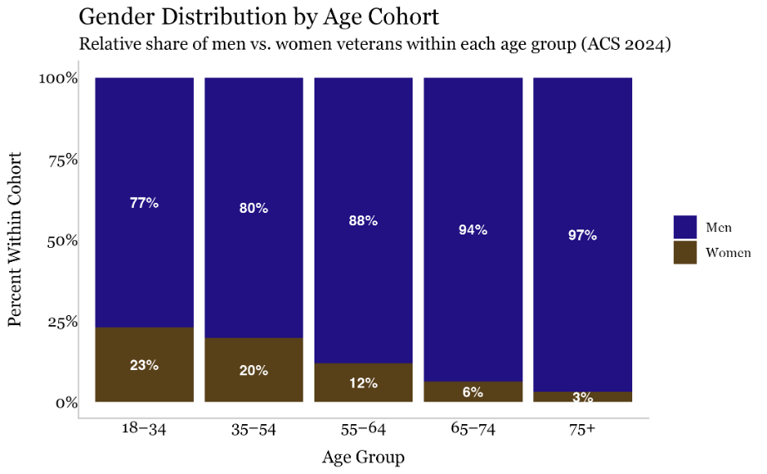
Table 1- Gender Distribution by Age

Appendix

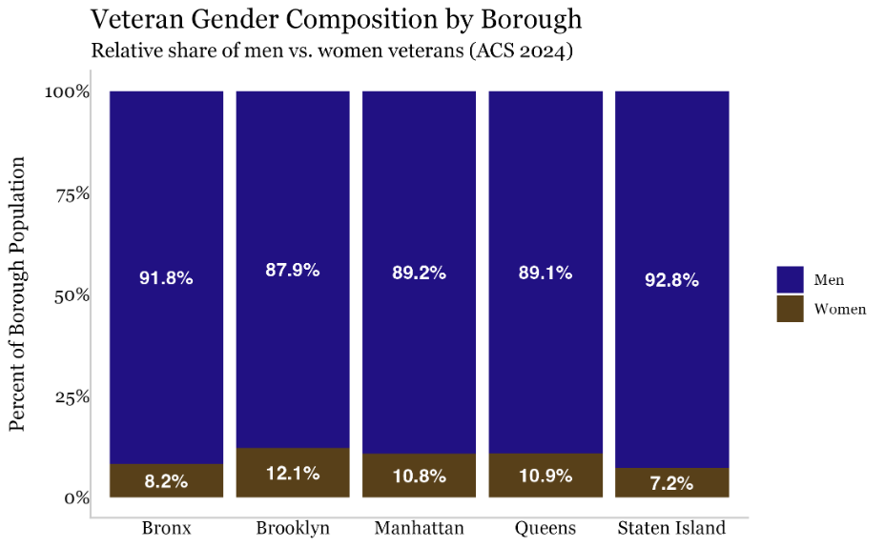

Table 2- Veteran Gender Composition by Borough

Appendix
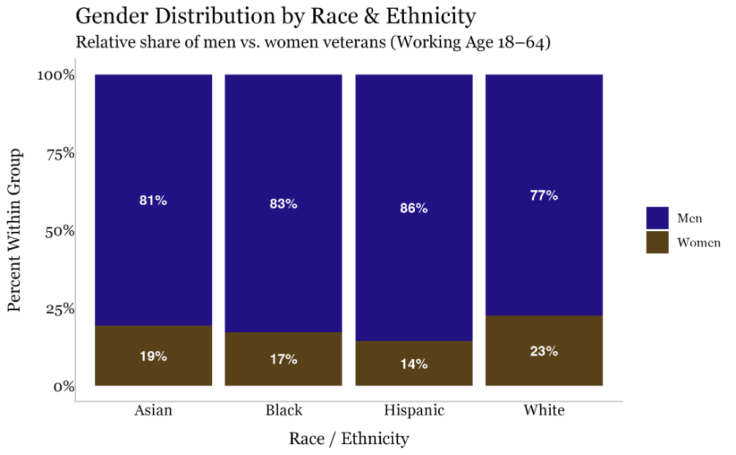

Table 3- Gender Distribution by Race & Ethnicity

U.S. Department of Veterans Affairs, “Veteran Population Projection Model (VetPop) 2020,” available at: https://www.data.va.gov/stories/s/wci3-yrsv (last visited Feb. 26, 2026).
Id.
Id.
Id.
Id.
Id.
Id.
Id.
Id.
Id.
NYC Department of Veterans Affairs, former Commissioner Hendon’s Testimony before the NYC Council Committee on Veterans, Fiscal Year 2026 Preliminary Budget Hearing, (March 2, 2026), available at: https://legistar.council.nyc.gov/LegislationDetail.aspx?ID=7102130&GUID=77E67D3C-4C54-48BF-B19C-805FA7EEC399&Options=&Search=
Department of Commerce, U.S. Census Bureau, “Veterans Data Table (ACS) for New York City Counties,” available at: https://data.census.gov/all?q=veterans&g=050XX00US36005,36047,36061,36081,36085 (last visited Feb. 26, 2026).
Supra note 11. (“Commissioner Hendon’s Testimony before the NYC Council Committee on Veterans”)
New York State Division of Veterans’ Services, “New York State Women Veterans Advisory Committee 2024 Annual Report,” available at: https://veterans.ny.gov/system/files/documents/2025/02/new-york-state-women-veterans-advisory-committee-2024-annual-report.pdf (last visited Feb. 26, 2026).
Supra note 12. (“U.S. Census Bureau, “Veterans Data Table (ACS) for New York City Counties”)
Id.
Id.
Id.
Id.
Id.
Id.
Id.
Id.
Id; Supra note 11. (“Commissioner Hendon’s Testimony before the NYC Council Committee on Veterans”)
U.S. National Library of Medicine, National Institutes of Health, “PMC Article: PMC11378233,” available at: https://pmc.ncbi.nlm.nih.gov/articles/PMC11378233/ (last visited Feb. 26, 2026).
Braun TD, Uebelacker LA, Ward M, Holzhauer CG, McCallister K, Abrantes A. "We really need this": Trauma-informed yoga for Veteran women with a history of military sexual trauma, (June 2021), available at: https://pmc.ncbi.nlm.nih.gov/articles/PMC8493766/. (last visited Feb. 26, 2026).
Id.
Id.
Id at 15. Women Veterans are 1.6 times as likely to experience IPV in their lifetime compared to civilian women.
Id.
Id at 17.
Disabled American Veterans (DAV), “Women Veterans: The Journey Ahead – 2024 Report,” (2024), available at: https://www.dav.org/wp-content/uploads/Women-Veterans-Study-2024.pdf (last visited Feb. 26, 2026).
Id.
U.S. Department of Veterans Affairs, “2025 National Veteran Suicide Prevention Annual Report Part 2 of 2,” 15 (2025), available at: https://www.mentalhealth.va.gov/suicide_prevention/data.asp. (last visited Feb. 27, 2026).
Supra note 32. Disabled American Veterans (DAV), “Women Veterans: The Journey Ahead – 2024 Report,” 2 and 13 (2024).
U.S. Department of Veterans Affairs,“ Serving Her Country: Exploring the Characteristics of Women Veterans,” available at: https://www.data.va.gov/stories/s/wci3-yrsv https://www.data.va.gov/stories/s/wci3-yrsv (last visited Feb. 25, 2026).
Id.
Id.
Id; New York City Mayor’s Office of Data Analytics, “DVS Assistance Requests (NYC Open Data search results),” available at: https://data.cityofnewyork.us/browse?sortBy=relevance&pageSize=20&q=DVS+Assistance+Requests (last visited Feb. 26, 2026).
New York City Department of Veterans’ Services, “Disabilities Support,” available at: https://www.nyc.gov/site/veterans/services/disabilities-support.page (last visited Feb. 26, 2026).
Rose L. Thayer, “More women are receiving disability benefits from VA than ever before,” Stars and Stripes, (March 21, 2024), available at: https://www.stripes.com/veterans/2024-03-21/women-disability-benefits-va-13381758.html (last visited Feb. 26, 2026).
Veterans Benefits Administration,” Annual Benefits Report” (2024), available at: https://www.benefits.va.gov/REPORTS/abr/. (last visited Feb. 26, 2026). In Fiscal Year 2024, 14.4% of Compensated women Veterans were rated between 0% and 20% disability, 25.2% were rated between 30% and 60% disability, and 60.4% were at 70% or greater disability. For male Veterans receiving disability compensation, these percentages were 23.3%, 25.4% and 51.2%, respectively. Compensated women Veterans were more likely to be rated 100% disability than their men counterparts at 25.4% and 22.6%, respectively. Id.
Supra note 41. Rose L. Thayer, “More women are receiving disability benefits from VA than ever before,” Stars and Stripes, (March 21, 2024), available at: https://www.stripes.com/veterans/2024-03-21/women-disability-benefits-va-13381758.html (last visited Feb. 26, 2026).
VA Claims Insider, “Female Veterans and VA Disability: Why Women Average Higher VA Monthly Compensation,” (December 4th, 2025), available at: https://vaclaimsinsider.com/female-veterans-va-disability-by-the-numbers/ (last visited Mar. 03, 2026)
Supra note 41. (“More women are receiving disability benefits from VA than ever before,”)Id.
Id.
Laura J. Miller MD, Sandy Rowlands LCSW, Laura Esposito PharmD, Margaret Altemus MD, and Jennifer L. Strauss PhD, “The Veterans Health Administration Reproductive Mental Health Consultation Program: An Innovation to Improve Access to Specialty Care,” Journal of General Internal Medicine, available at: https://link.springer.com/article/10.1007/s11606-022-07583-5 (last visited Feb. 26, 2026).
Id.
Id.
Id.
Id.
Id.
Yael I. Nillni, et al., “The Intersection of Trauma, Mental Health, and Reproductive Health Among Women Veterans: A Scoping Review,” Clinical Psychology Review, available at: https://www.ptsd.va.gov/professional/articles/article-pdf/id1656694.pdf (last visited Feb. 26, 2026).
U.S. Department of Veterans Affairs, “VA MST Coordinators,” available at: https://www.mentalhealth.va.gov/msthome/vha-mst-coordinators.asp (last visited Feb. 26, 2026).
U.S. Department of Veterans Affairs, “VA Facility Locator,” available at: https://www.va.gov/find-locations/ (last visited Feb. 26, 2026); U.S. Department of Veterans Affairs, “Women Veterans Program Manager Locator,” available at: https://www.womenshealth.va.gov/wvpm-locator.asp (last visited Feb. 26, 2026).
The U.S. Department of Housing and Urban Development, “The 2024 Annual Homelessness Assessment Report (AHAR) to Congress,” (2024), available at: https://www.huduser.gov/portal/sites/default/files/pdf/2024-AHAR-Part-1.pdf https://www.huduser.gov/portal/sites/default/files/pdf/2024-AHAR-Part-1.pdf (last visited Feb. 26, 2026).
Id.
Id.
Gail Gamache, Robert Rosenheck, and Richard Tessler, “Overrepresentation of Women Veterans Among Homeless Women,” American Public Health Association, (Jul. 2003), available at: https://pmc.ncbi.nlm.nih.gov/articles/PMC1447922/ (last visited Feb. 26, 2026).
Laura Heltz, “Understanding the Female Veteran Homelessness Crisis,” Veterans Outreach Center (Mar. 13, 2025), available at: https://veteransoutreachcenter.org/understanding-the-female-veteran-homelessness-crisis/ (last visited Feb. 25, 2026).
Id.
Id.
Id.
Supra note 59. Gail Gamache, Robert Rosenheck, and Richard Tessler, supra 61.
Id.
U.S. Department of Veterans Affairs, “VA housing assistance,” (n.d.), available at: https://www.va.gov/housing-assistance/ (last visited Feb. 26, 2026).
New York State Comptroller Thomas P. DiNapoli, “Reductions in Homelessness Among New York’s Veterans,” (Nov. 2023), available at: https://www.osc.ny.gov/files/reports/osdc/pdf/reductions-in-homelessness-among-new-yorks-veterans.pdf (last visited Feb. 26, 2026).
Id.
NYC Department of Veterans’s Services, “Ending Chronic Veteran Homelessness ,” (n.d.), available at: https://www.nyc.gov/site/veterans/initiatives/ending-chronic-veteran-homelessness.page (last visited Feb. 26, 2026).
Laura Heltz, “Why Economic Stability is a Critical Issue for Female Veterans,” Veterans Outreach Center, (April 18, 2025), available at: https://veteransoutreachcenter.org/why-economic-stability-is-a-critical-for-female-veterans/ (last visited Feb. 26, 2026).
U.S. Department of Veterans Affairs, “Serving Her Country: Exploring the Characteristics of Women Veterans,” (2023), available at: https://www.data.va.gov/stories/s/wci3-yrsv (last visited Feb. 26, 2026).
Id.
Id.
Wounded Warrior Project, “2023 Women Warriors Report,” (Sept. 2023), available at: https://newsroom.woundedwarriorproject.org/women-warriors-initiative (last visited Feb. 26, 2026).
Id.
New York City Department of Veterans’ Services, “Women Veterans,” available at: https://www.nyc.gov/site/veterans/services/women-veterans.page (last visited Feb. 26, 2026).
Id.
Id.
New York City Office of Management and Budget, “The Preliminary Budget of the City of New York for Fiscal Year 2027,” Page 46, available at: https://www.nyc.gov/assets/omb/downloads/pdf/feb26/perc2-26.pdf (last visited Feb. 26, 2026).
Id.
Id.
Id.
New York City Mayor’s Office of Data Analytics, “DVS Assistance Requests (NYC Open Data search results),” available at: https://data.cityofnewyork.us/browse?sortBy=relevance&pageSize=20&q=DVS+Assistance+Requests (last visited Feb. 26, 2026).
Id.
Id.
Id.
Local Law 44 for the year 2019.
Office of the NYC Comptroller Mark Levine, “Audit Report on the NYC Department of Veterans’ Services’ Coordination of Housing Assistance,” (Dec. 26, 2025) available at: https://comptroller.nyc.gov/reports/audit-report-on-the-nyc-department-of-veterans-services-coordination-of-housing-assistance/ (last visited Mar. 2, 2026)

