Staff: Committee on Sanitation & Solid Waste Management
Morganne Barrett, Legislative Counsel
Ricky Chawla, Senior Legislative Policy Analyst
Dirk Spencer PhD, Legislative Policy Analyst
Tanveer Singh, Finance Analyst
Reese Hirota, Data Scientist

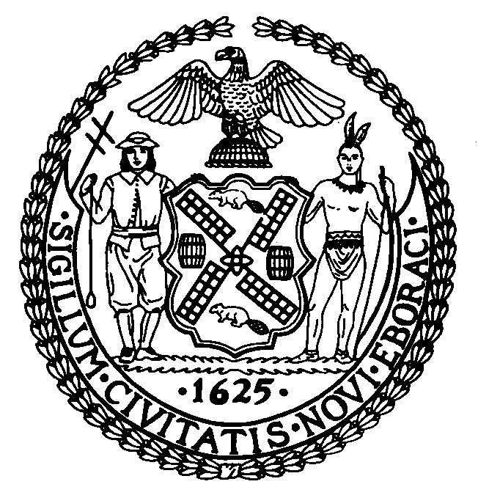

The New York City Council
Andrea Vazquez, Legislative Director

Committee Report of the Infrastructure Division
Brad Reid, Deputy Director

Committee on Sanitation & Solid Waste Management
Hon. Justin Sanchez, Chair

April 16, 2026

Proposed Int. No. 355-A By Council Members Nurse, Louis, Stevens, Joseph, Hudson, Brooks-Powers, Hanif, Brewer and Epstein
Title: A Local Law to amend the administrative code of the city of New York, in relation to organic waste recycling by city agencies
Administrative Code: Amends section 16-307

- Introduction

On April 15, 2026, the Committee on Sanitation and Solid Waste Management (“the Committee”), chaired by Council Member Justin Sanchez, will hold a hearing and vote on Proposed Int. No. 355-A, in relation to organic waste recycling by city agencies, sponsored by Council Member Sandy Nurse. The Committee previously heard Int. No. 355 on April 6, 2026.
- Background
As organic waste decomposes at landfills, it releases methane gas, which is 84 times more effective at absorbing the sun's heat than carbon dioxide over a 20 year timeframe, making it one of the most potent greenhouse gases and a huge contributor to climate change. Composting can be an effective means of carbon sequestration, as the process results in solid carbon that can be sequestered in the ground, thereby reducing emissions by 50% compared to landfilling.
Local Law 40 of 2010 set recycling goals for solid waste managed by the New York City (“NYC” or “the City”) Department of Sanitation (“DSNY”): by July 1, 2020, the City aimed to divert 33% of DSNY-managed solid waste and 25% of all DSNY-collected curbside and containerized waste. Additionally, in 2023 the City Council passed the Zero Waste Act, which, in part, establishes a citywide goal of zero divertible waste by 2030. Pursuant to Local Law 85 of 2023, DSNY rules require separation of residential organic waste. Additionally, Local Law 146 of 2013 requires designated businesses to recycle organic waste. In FY2025, the City’s recycling diversion rate was 18.5%, showing improvement by 1% in the past year, although this is only a return to the same diversion rate as in FY2020.
Collectively, NYC residential and institutional buildings, including 1,400 NYC Public Schools (“NYCPS”) buildings, discard approximately 24 million pounds of waste every day. Approximately 49% of the waste stream from NYCPS is organic material suitable for composting. In addition to NYCPS, City agencies which engage in meal service include the NYC Administration for Children’s Service, Department for the Aging, Department of Correction, and Health + Hospitals.

- Legislation
Proposed Int. No. 355-A, a Local Law to amend the administrative code of the city of New York, in relation to organic waste recycling by city agencies
This bill would designate, for City agencies, organic waste as a recyclable material, and require DSNY to establish rules governing the source separation of organic waste that is generated by City agencies in the preparation and service of meals.
This local law would take effect 180 days after becoming law.

Proposed Int. No. 355-A

By Council Members Nurse, Louis, Stevens, Joseph, Hudson, Brooks-Powers and Hanif

A Local Law to amend the administrative code of the city of New York, in relation to organic waste recycling by city agencies

Be it enacted by the Council as follows:

Section 1. Subdivision a of section 16-307 of the administrative code of the city of New York, as amended by local law number 36 for the year 2010, is amended to read as follows:
a. The commissioner shall adopt, amend and implement rules, as necessary, governing the source separation or post-collection separation, collection, processing, marketing, and sale of designated recyclable materials including, but not limited to, designated metal, glass, plastic [and], paper, and organic waste generated by any agency, [as such term is defined in section 1-112 of the code] provided that, for purposes of this section, organic waste shall be limited to such waste that is generated by the preparation or service of meals, including in institutional settings, such as schools and hospitals.
§ 2. This local law takes effect 180 days after it becomes law.
RL/MB
LS #13123
Int. #0781-2024
04/08/2026 5:00 PM

See, Int. 355-2026, a local law to amend the administrative code of the city of New York, in relation to organic waste recycling by city agencies, NYC Council (last accessed Apr. 13, 2026), available at: https://legistar.council.nyc.gov/LegislationDetail.aspx?ID=7862491&GUID=558F0D49-1781-4C97-A6ED-5C952062C7B2&Options=ID|Text|Attachments|&Search=355-2026.
Kayla Vasarhelyi, The Hidden Damage of Landfills, Univ. Colorado. Boulder Environmental Center (April 15, 2021), available at: https://www.colorado.edu/ecenter/2021/04/15/hidden-damage-landfills.
Gina Talt, The ComPOSTer: How much can composting help in solving the climate challenge?, Sustainable Composting Research at Princeton (Mar. 4, 2020), available at: https://scraplab.princeton.edu/2020/03/the-composter-how-much-can-composting-help-in-solving-the-climate-challenge/.
N.Y.C. Admin. Code, §§16-305(a)(1)(vii), (a)(2)(vii); Local Law 19 of 1989 also codified goals for the diversion from landfill of DSNY-managed solid waste, and curbside and containerized waste. See, N.Y.C. Admin. Code, §§16-304 – 16-305.
See, Local Law 86 of 2023, available at: https://legistar.council.nyc.gov/LegislationDetail.aspx?ID=5570515&GUID=C5638208-97DB-4E6D-BDA7-A129B9E5CADB&Options=ID|Text|&Search=274; Local Law 89 of 2023, available at: https://legistar.council.nyc.gov/LegislationDetail.aspx?ID=5570508&GUID=B7D2702B-9AC2-4076-B564-D341FB1EB1BE&Options=ID|Text|&Search=281; Local Law 85 of 2023, available at: https://legistar.council.nyc.gov/LegislationDetail.aspx?ID=5570477&GUID=823F79AA-BC92-451A-802A-215ED3B76D99&Options=ID|Text|&Search=244.
Local law 85 of 2023, available at: https://legistar.council.nyc.gov/LegislationDetail.aspx?ID=5570477&GUID=823F79AA-BC92-451A-802A-215ED3B76D99#:~:text=The%20commissioner%20shall%20notify%20all,in%20all%20remaining%20sanitation%20districts.&text=this%20section;%20and-,3.,a%20timeline%20for%20such%20distribution.; Requirement of Source Separation of Residential Organic Waste, NYC Rules (last accessed Mar. 31, 2026), available at: https://rules.cityofnewyork.us/rule/requirement-of-source-separation-of-residential-organic-waste/.
Local law 146 of 2013, available at: https://legistar.council.nyc.gov/LegislationDetail.aspx?ID=1482542&GUID=DDD94082-C0E5-4BF9-976B-BBE0CD858F8F; Waste Disposal for Businesses, NYC 311 (last accessed Mar. 31, 2026), available at: https://portal.311.nyc.gov/article/?kanumber=KA-01787.
Annual Report: New York City Curbside and Containerized Municipal Refuse and Recycling Statistics by Borough and District: Fiscal Year 2025, DSNY (2026), available at: https://www.nyc.gov/assets/dsny/downloads/resources/statistics/annual-curbside-collection/dsny-collections-annual-fy2025.pdf.; Annual Report: New York City Curbside and Containerized Municipal Refuse and Recycling Statistics by Borough and District: Fiscal Year 2021, DSNY (2021), available at: https://www.nyc.gov/assets/dsny/downloads/resources/statistics/annual-curbside-collection/dsny-collections-annual-fy2021.pdf. Additionally, according to a 2019 report, the New York City Housing Authority recycles at a rate of just 1.5%. See, NYCHA 2.0 Waste Management Plan (2019), available at: https://www.nyc.gov/assets/nycha/downloads/pdf/n20-waste-management-plan.pdf.
2023 Waste Characterization Study, DSNY (2023), available at: https://www.nyc.gov/assets/dsny/downloads/resources/reports/waste-characterization-studies/2023/wcs-2023.pdf .
Id.
Meal Programs, NYC Mayor’s Office of Food Policy (last accessed Apr. 13, 2026), available at: https://www.nyc.gov/site/foodpolicy/programs/acs.page.

