Committee on Children & Youth Staff
Rie Ogasawara, Senior Legislative Counsel
Elizabeth Arzt, Senior Policy Analyst
Sandra Gray, Financial Analyst

Committee on Mental Health & Substance Use Staff
Sara Sucher, Senior Legislative Counsel
Justin Campos, Legislative Policy Analyst
Amaan Mahadevan, Financial Analyst
Valeria Lazaro-Rodriguez, Financial Analyst

Committee on Oversight & Investigations Staff
Nicole Catá, Senior Legislative Counsel
Alex Yablon, Legislative Policy Analyst
Erica Cohen, Legislative Policy Analyst
Owen Kotowski, Senior Financial Analyst



THE COUNCIL OF THE CITY OF NEW YORK

COMMITTEE REPORT OF THE LEGISLATIVE DIVISION
Andrea Vazquez, Director
Smita Deshmukh, Deputy Director, Human and Social Services
Rachel Cordero, Deputy Director, Governmental Affairs

COMMITTEE ON CHILDREN & YOUTH
Hon. Althea Stevens, Chair

COMMITTEE ON MENTAL HEALTH & SUBSTANCE USE
Hon. Tiffany Cabán, Chair

COMMITTEE ON OVERSIGHT & INVESTIGATIONS
Hon. Shekar Krishnan, Chair

April 21, 2026
Oversight: The Effects of Social Media & Screen Time on Youth Mental Health
Int. No. 450-2026 | By Council Members Stevens, Riley, Williams, Banks, Brooks-Powers, and Louis
Title: | A Local Law to amend the administrative code of the city of New York, in relation to restricting social media usage for youth
Int. No. 451-2026 | By Council Members Stevens, Riley, Williams, Banks, Hudson, Brooks-Powers and Louis
Title: | A Local Law in relation to requiring the city to report on the impact of social media on the mental health of young people
Int. No. 660-2026 | By Council Members Williams, Stevens, Riley, Louis, Brewer, Brooks-Powers, Ung, Salaam, and Hanks
Title: | A Local Law in relation to requiring a study and report on in-person altercations among youth and their associated activity on online platforms
Int. No. 801-2026 | By Council Members Stevens, Louis, and Restler
Title: | A Local Law to amend the administrative code of the city of New York, in relation to creating apprenticeships for early childhood education

- Introduction
On April 21, 2026, the New York City Council’s Committees on Children & Youth, chaired by Council Member Althea Stevens; Mental Health & Substance Use, chaired by Council Member Tiffany Cabán; and Oversight & Investigations, chaired by Council Member Shekar Krishnan (“the Committees”), will hold an oversight hearing titled “The Effects of Social Media and Screen Time on Youth Mental Health.” The Committees will also be hearing the following legislation:
- Introduction Number 450-2026 (“Int. 450”), sponsored by Council Member Stevens, in relation to restricting social media usage for youth;
- Introduction Number 451-2026 (“Int. 451”), sponsored by Council Member Stevens, in relation to requiring the city to report on the impact of social media on the mental health of young people;
- Introduction Number 660-2026 (“Int. 660”), sponsored by Deputy Speaker Nantasha Williams, in relation to requiring a study and report on in-person altercations among youth and their associated activity on online platforms; and
- Introduction Number 801-2026 (“Int. 801”), sponsored by Council Member Stevens, in relation to creating apprenticeships for early childhood education.
Among those invited to testify are representatives from the Department of Health and Mental Hygiene (DOHMH), the Department of Community & Youth Development (DYCD), the Mayor’s Office of Community Mental Health (OCMH), and other relevant unions and advocacy groups.

- Background
In June 2024, DOHMH issued a report examining the relationship between social media use and mental health outcomes among children, adolescents, and caregivers in New York City. Drawing on survey data and existing research, the report finds that social media use is widespread across age groups, with a majority of children (54%), nearly all teens (93%), and a large share of parents (78%) reporting use of at least one social media platform. Among parents, there are mixed perceptions regarding appropriate levels of use; however, a substantial proportion report concern about frequency, with approximately 45% of parents of children ages 8 to 12 and 46% of parents of teens ages 13 to 17 indicating that their child uses social media too much.
The report identifies a consistent association between social media use and adverse mental health outcomes. Children who use social media report higher rates of anxiety (16%) compared to children who do not (12%). Among teens, the differences are more pronounced. Those who use social media report higher rates of anxiety and depression than their peers who do not use social media (27% and 9%, respectively, for anxiety, and 14% and 4%, respectively, for depression). The report also finds that parents who use social media are more likely to report experiencing anxiety or depression than those who do not. While these findings demonstrate a strong relationship between use and mental health outcomes, the report emphasizes that the data are correlational and do not establish causation.
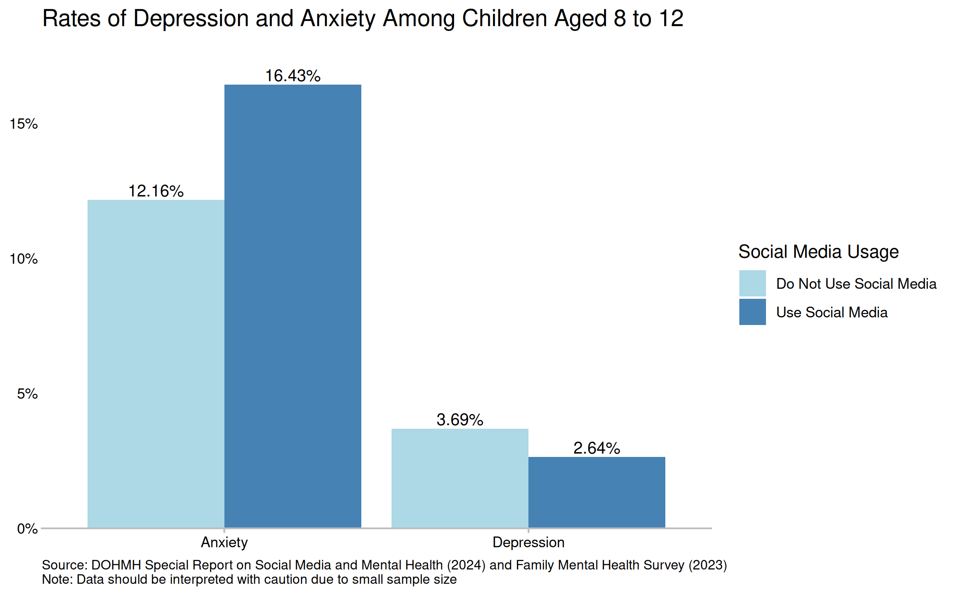

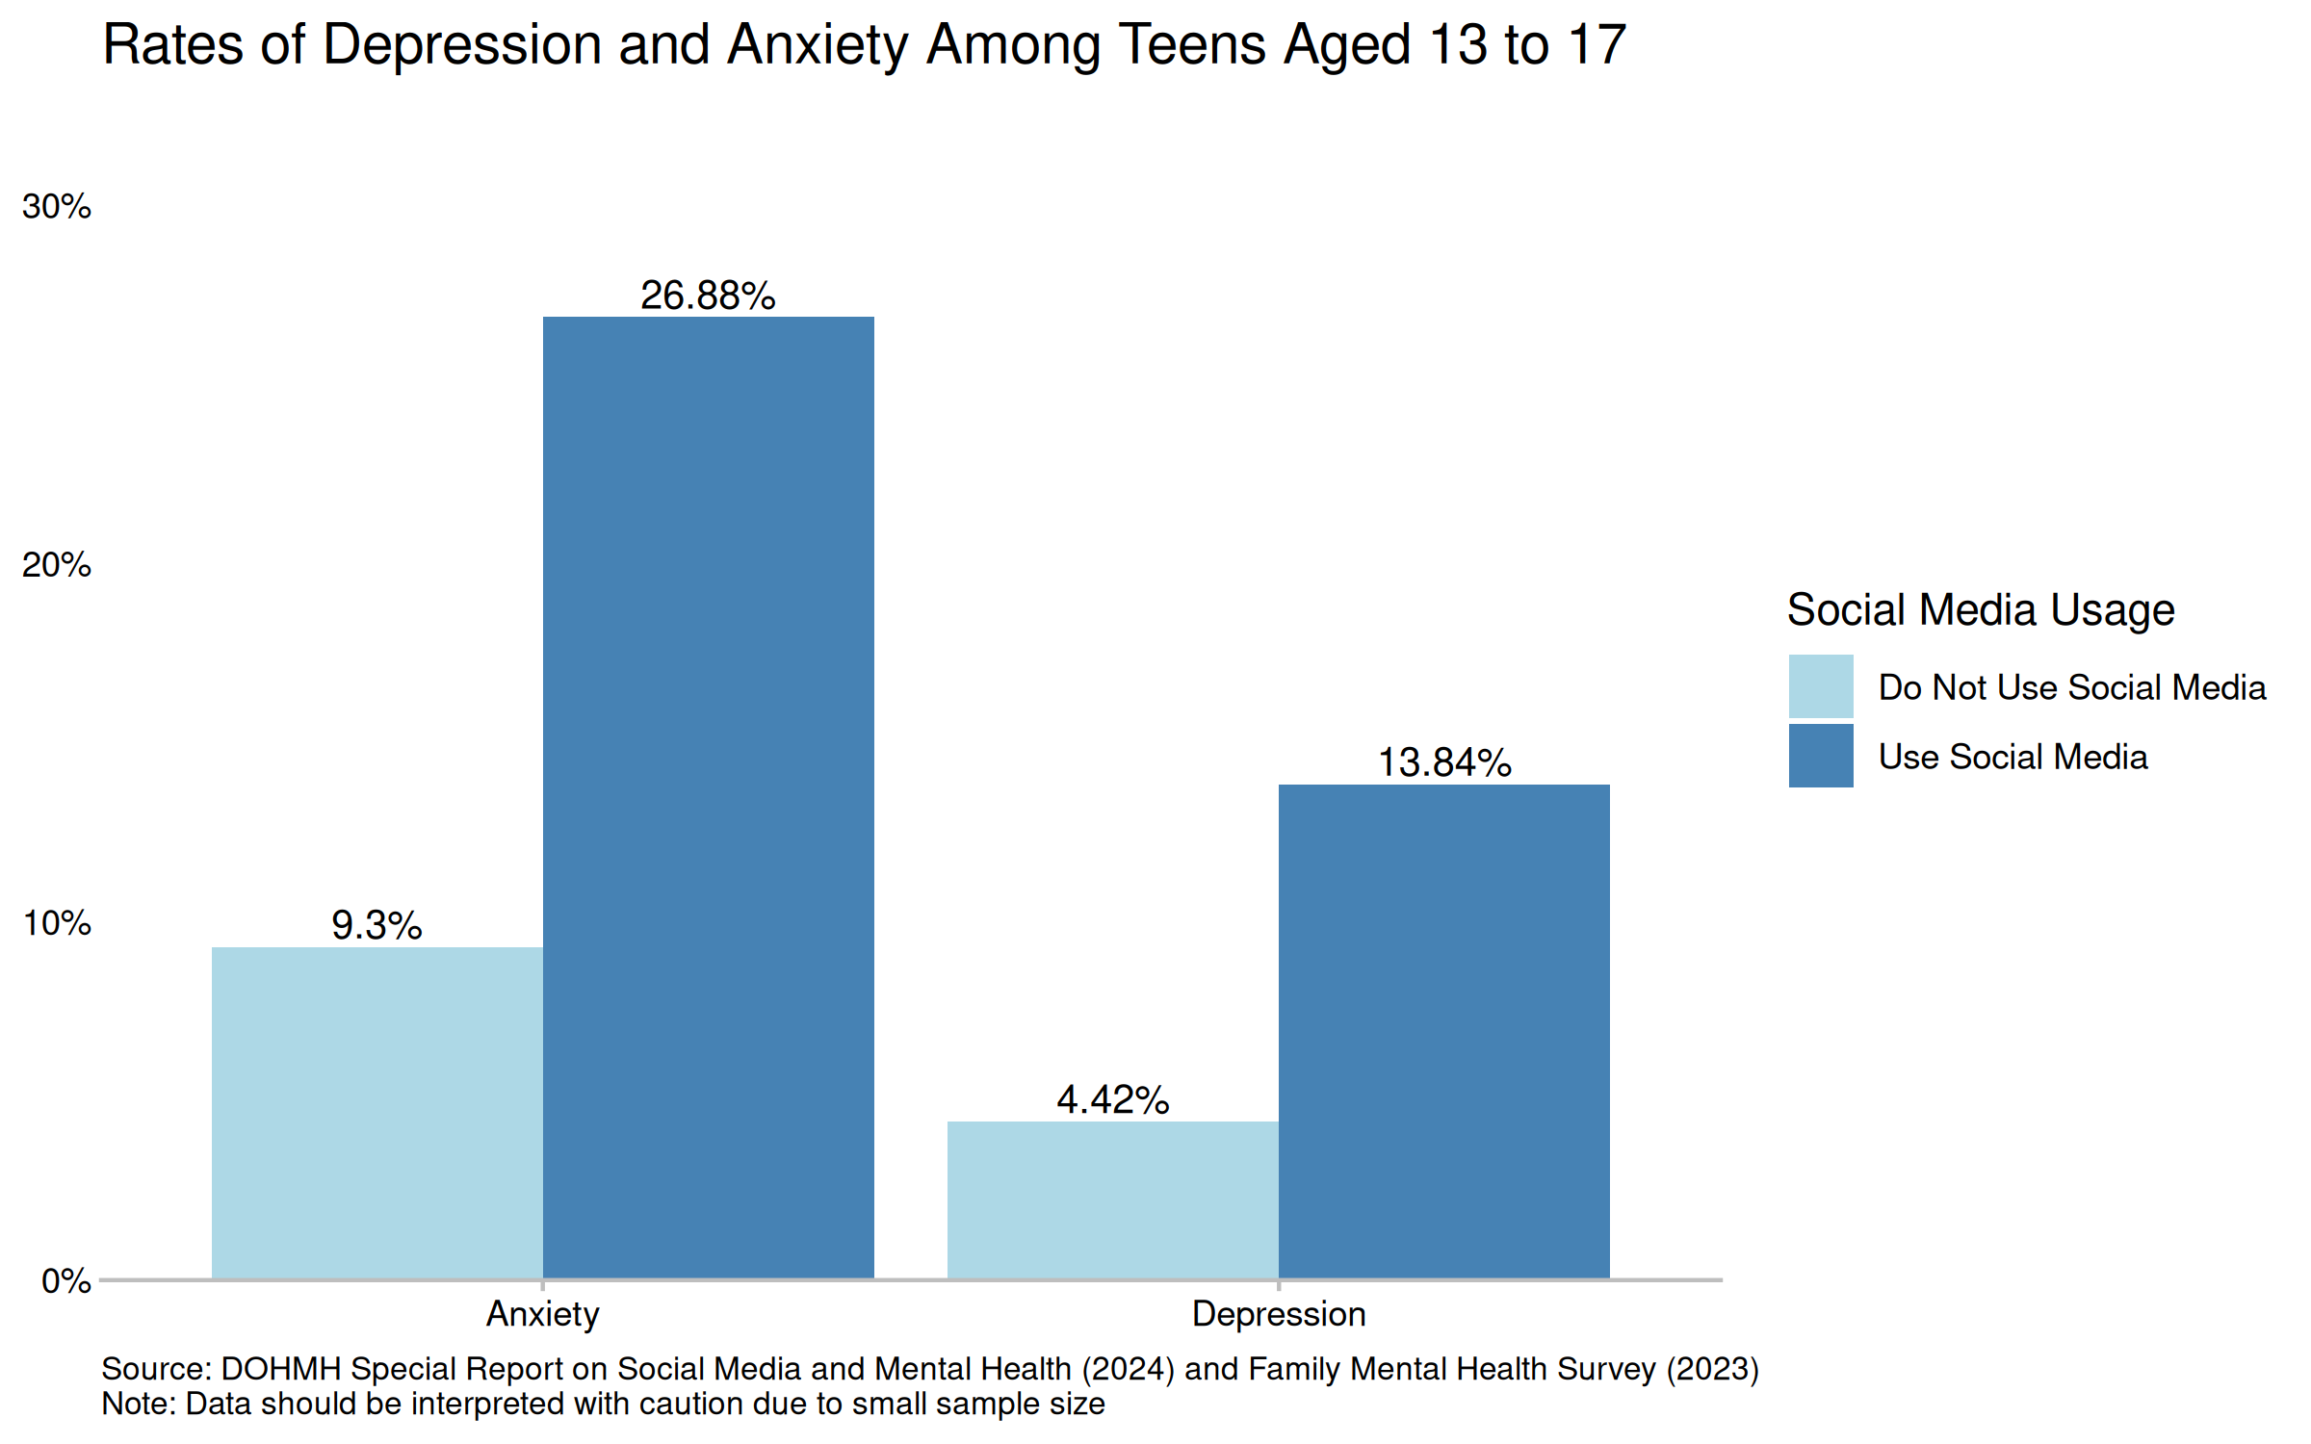
The report further highlights the role of harmful online experiences, including exposure to cyberbullying, distressing content, and pressures associated with social comparison, as contributing factors to negative mental health outcomes. It also identifies sleep disruption as a potential pathway, noting that frequent and nighttime social media use may reduce sleep, which is associated with poorer mental health outcomes. Additionally, high levels of engagement may displace time spent on in-person interactions and other activities that support well-being.
The DOHMH report also identifies differences in social media use according to the type of school a child attends. Children who attend public or charter schools (57%) or other school types (78%) are up to 40% more likely to use social media than children who attend private schools (34%). Among teens who use social media, parents report a 30% difference in usage between those attending public or charter schools (89%) or other school types (93%) compared with teens attending private schools (58%). The report notes that these differences indicate social media use is both a public health concern and an equity issue.
With respect to family dynamics, a majority of parents report that they engage in conversations with their children about social media use, including 65% of parents of younger children and 54% of parents of teens. At the same time, the report identifies disparities in parental awareness and access to information. For example, there is a 14-percentage-point gap between parents in high-poverty zip codes (74%) and those in low-poverty zip codes (60%) who report having sufficient information to discuss social media use with their children, indicating that social and economic factors shape understanding of both risks and benefits.
The report also finds strong parental support for policy intervention. A substantial majority of parents (78%) indicate that government should play a role in protecting teens by restricting access to certain types of content on social media platforms.
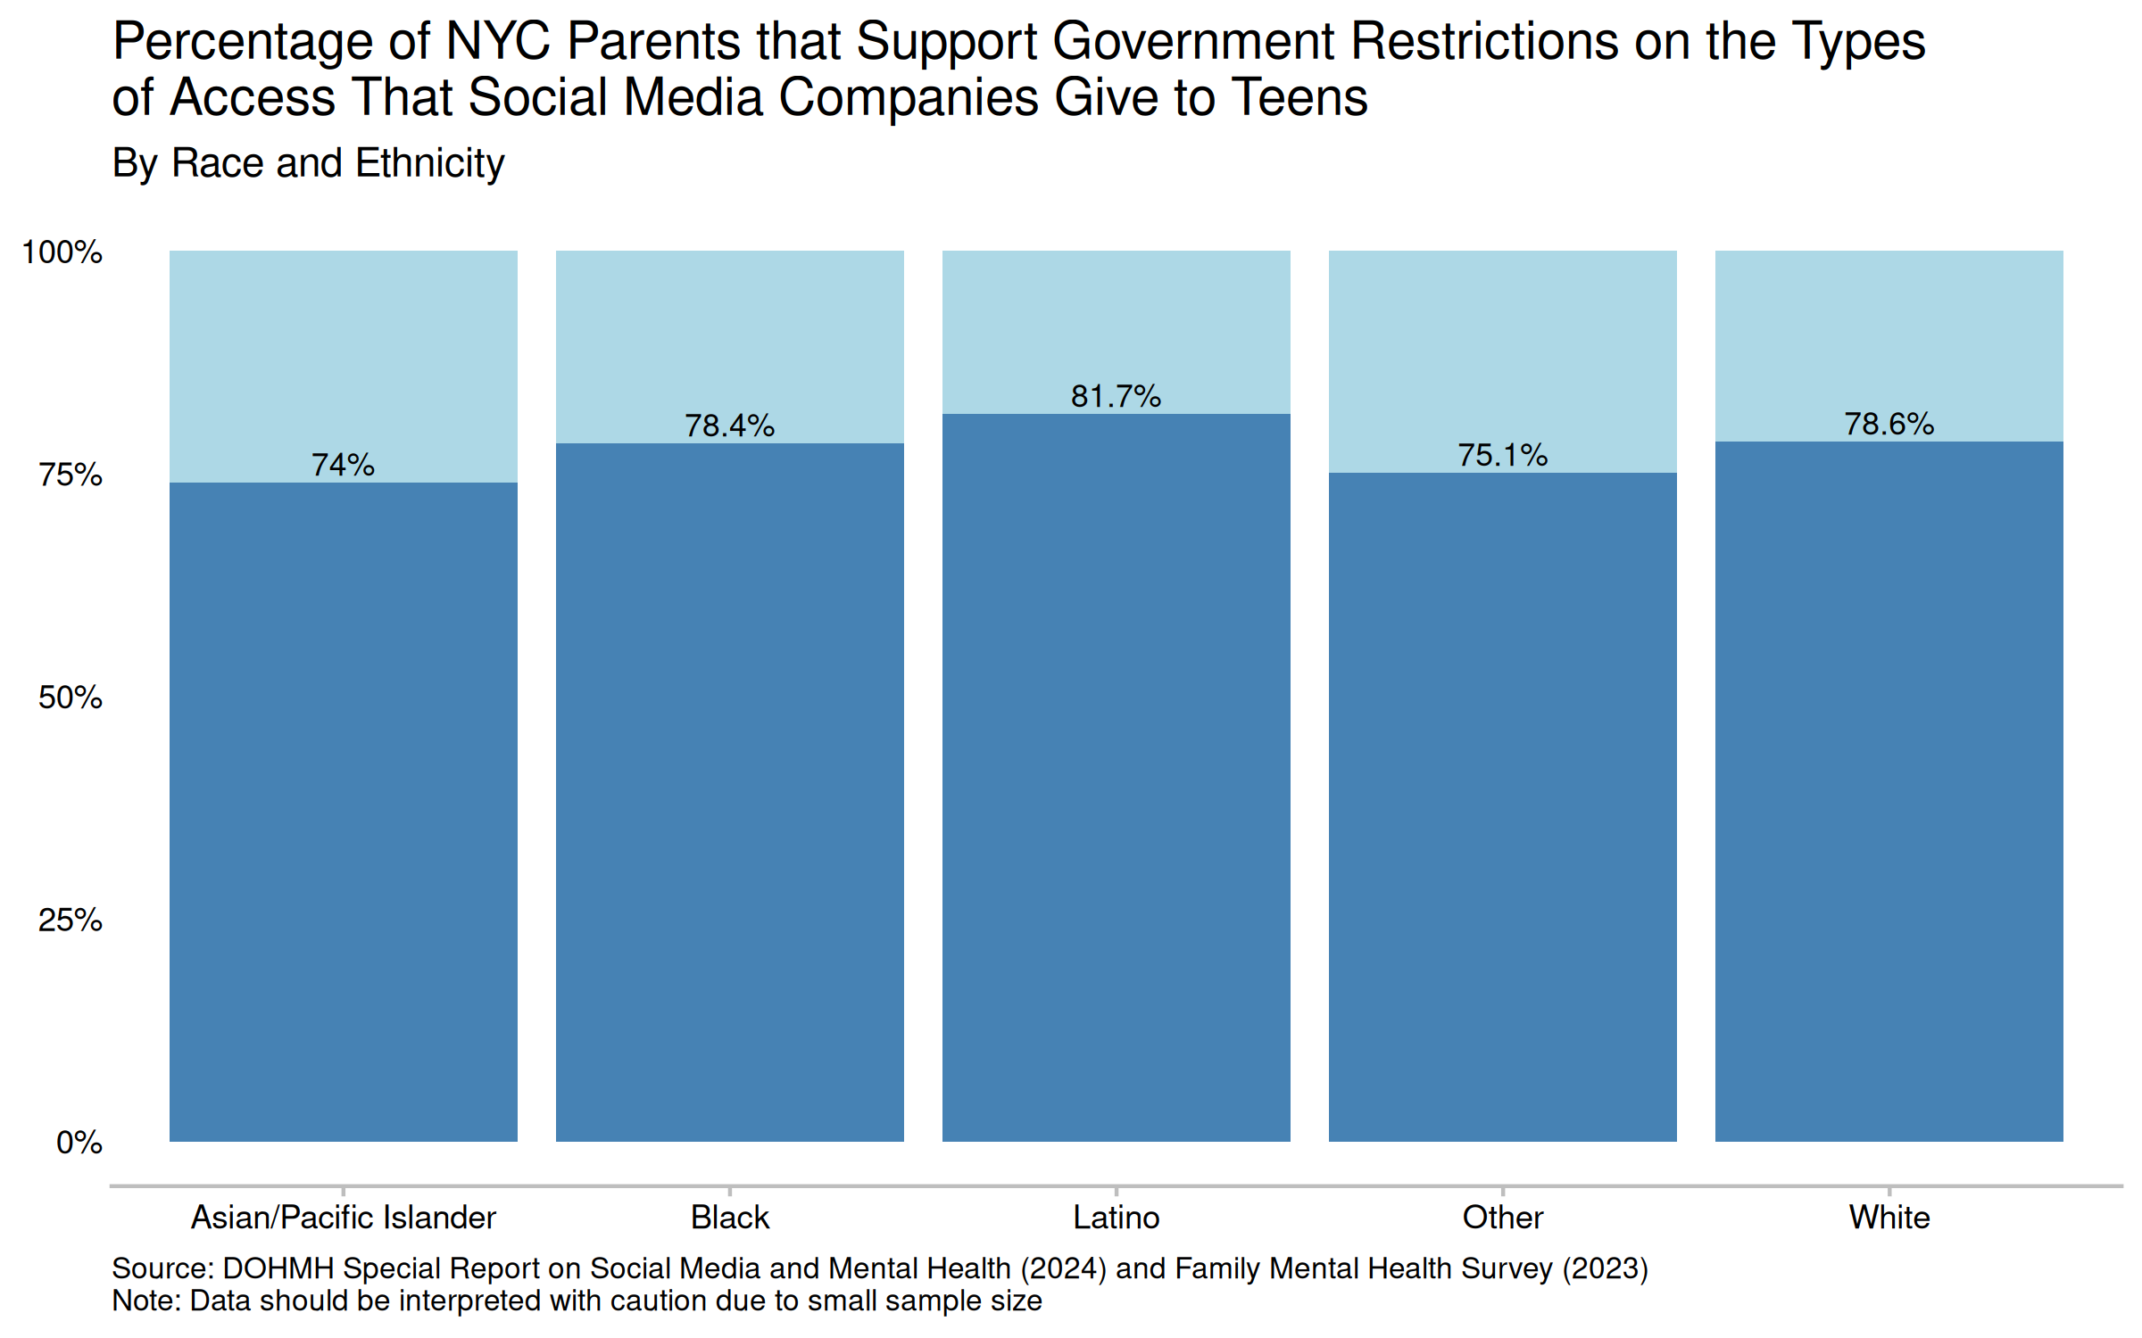
At the same time, the report acknowledges that social media can provide benefits, including opportunities for social connection, peer support, and self-expression, and emphasizes the importance of balancing potential regulatory approaches with the preservation of these positive uses. It can help young people maintain relationships with friends and family, build new social networks, and access emotional and practical support, especially for those who feel isolated or marginalized. Platforms can also provide opportunities for self-expression, creativity, and identity exploration, while exposing users to diverse perspectives and information that can enhance education and digital literacy. Additionally, social media can foster collaboration, skill development (such as writing and communication), and even civic engagement, allowing adolescents to participate in communities and social causes. Overall, its effects are mixed, but many young people report neutral or positive experiences, suggesting it can be a valuable tool when used in balanced and supportive ways. Adolescents’ social media use, for example, should be preceded by training in social media literacy to ensure that users have developed psychologically informed competencies and skills that will ultimately maximize their chances for safe and meaningful use of social media. Families are also urged to create and consistently follow “media use plans” that set limits on the type and amount of social media consumed, encourage at least one hour of daily activity and eight to twelve hours of sleep, and establish routines such as avoiding screens before bedtime, keeping devices out of bedrooms, discouraging social media use during homework, and designating media-free times and spaces.
These DOHMH report findings are consistent with the 2023 advisory issued by the Office of the United States Surgeon General on social media and youth mental health, which concludes that there is growing evidence of a relationship between social media use and poor mental health outcomes among young people, while also noting that the effects can vary depending on how platforms are used. The Surgeon General’s advisory highlights similar risk factors, including exposure to harmful content, cyberbullying, social comparison, and sleep disruption, and emphasizes that adolescents may be particularly vulnerable due to critical stages of brain development. It also underscores that current evidence is insufficient to determine causality and calls for additional research.
The Surgeon General’s advisory frames social media as an emerging public health concern and recommends a multi-faceted response, including stronger safety standards and transparency from technology companies, increased digital literacy and education for youth and families, and greater support for parents and caregivers. It also calls on policymakers to consider safeguards to reduce harm while preserving the potential benefits of social media, echoing the DOHMH report’s emphasis on balancing risks and positive uses.
  - NYC Actions to Combat the Detrimental Effects of Social Media on Youth Mental Health
In January 2024, the DOHMH Commissioner issued a formal advisory declaring social media a public health hazard for young people. The advisory noted that youth mental health in the city had been declining for over a decade—with rates of hopelessness among high schoolers up more than 42% since 2011—and that 77% of high schoolers were spending three or more hours a day on screens. Citing warnings from the U.S. Surgeon General, the American Academy of Pediatrics, and other medical authorities, the advisory urged parents to delay giving children access to social media until at least age 14, recommended that caregivers create family media plans and establish tech-free times at home, and encouraged healthcare providers to discuss social media use during routine visits. It also called on young people themselves to set limits on their use, monitor how it affects their emotions, and adjust their settings to reduce harmful content. More broadly, the advisory called on technologists, investors, and policymakers at all levels to push for safer platform design and stronger legal protections for children.
In February 2024, the City filed suit in California Superior Court against the operators of TikTok, Instagram, Facebook, Snapchat, and YouTube, alleging that their platform design features intentionally fostered compulsive use among minors and contributed to a citywide youth mental health crisis. The City subsequently refiled in federal court, and in October 2025 filed a formal complaint in the U.S. District Court for the Southern District of New York against Meta Platforms Inc., Snap Inc., ByteDance Inc., and Google LLC, alleging that the companies deliberately designed, marketed, and distributed their platforms to maximize engagement among children, using algorithms to drive addiction. The complaint cites specific features such as endless scroll, strategically timed notifications, and intermittent variable rewards as comparable mechanisms to slot machines, which are said to withhold and release positive reinforcement on algorithmically optimized schedules. The suit also highlights how features like Snapchat's "snap streak," Instagram and Snapchat's read receipts, and appearance-altering filters collectively exploit adolescent psychology, including underdeveloped impulse control. This lawsuit is separate from, though parallel to, a larger multidistrict litigation in the Northern District of California encompassing thousands of similar cases from state attorneys general, school districts, and individuals, where a judge has already allowed public nuisance claims to proceed.
In February 2024, then-NYC Mayor Eric Adams released another report on social media and youth mental health, called a "Framework for Action," outlining the City's strategy for addressing the harm social media poses to youth mental health. This report was developed after convening over 150 stakeholders, including young people, parents, educators, researchers, and community organizations, and based on data showing that nearly 40% of high schoolers reported persistent feelings of hopelessness in 2021, up from 27% a decade earlier, with Black, Latino, female, and LGBTQ+ youth disproportionately affected.
In it, the City committed to pursuing litigation, supporting state and federal legislation targeting addictive platform features, and issuing a formal call to action demanding that social media companies conduct independent safety audits, adopt safer design standards, and give parents and young users more control over their experience. The City further pledged to distribute digital literacy resources to families and schools, train teachers and pediatricians on how to address social media's mental health impacts, establish tech-free zones, and create a youth advisory council to incorporate young people's voices into policy and programming. The City also committed to surveying NYC youth about their social media habits and mental health, measuring the financial cost of the crisis to City services, and partnering with academic and government institutions to expand the evidence base. The report acknowledged that not all social media use is harmful, but emphasized that poorly designed platforms, combined with a lack of education and support for young users, create conditions that damage mental health, particularly for adolescents whose brains are still developing.
- NYC Youth Mental Health Supports and Services
As a growing body of research documents associations between social media use and adolescent mental health challenges, including elevated rates of anxiety, depression, and suicidal ideation, the City has worked to expand its portfolio of youth mental health programs.
  - NYC TeenSpace
In November 2023, then-Mayor Eric Adams and then-DOHMH Commissioner Dr. Ashwin Vasan launched NYC TeenSpace, a free tele-mental health service available to all NYC teenagers between the ages of 13 and 17, regardless of insurance status, household income, or school enrollment. Created in partnership with online therapy platform Talkspace, TeenSpace allows teens to connect with a licensed therapist through phone, video, and text messaging. All participating Talkspace therapists are licensed in New York State and have experience working with adolescents. They can address a range of concerns including anxiety, depression, stress, grief, trauma, and relationship challenges. Teens do not need to be experiencing a diagnosable mental health condition to participate, as the program is explicitly designed as both a clinical and preventive resource.
According to DOHMH, the program was developed with direct input from NYC teenagers through focus groups convened to understand their mental health needs. Per a May 23, 2024 press release, after six months since the launch of the program, more than 6,800 teenagers had signed up, with 65% of users reporting improvement in their mental health. According to the press release, underserved neighborhoods including Brownsville and East New York led in sign-ups, and 80% of users identified as Black, Hispanic, Asian American and Pacific Islander, bi-racial, or Native American.
  - NYC Health + Hospitals School-Based Mental Health Clinics
In April 2024, then-Mayor Adams and NYC Health + Hospitals announced the opening of 16 new school-based mental health clinics in NYC Department of Education (DOE) schools across the South Bronx and Central Brooklyn. The satellite clinics were funded through the $5 million Mental Health Continuum—a partnership among NYC Health + Hospitals, DOE, DOHMH, and Advocates for Children—along with $700,000 in grants from the New York State Office of Mental Health. The 16 new clinics built upon five pre-existing school-based clinics, bringing the total Mental Health Continuum footprint to 50 schools serving more than 20,000 students.
The clinics offer students access to individual, family, and group therapy, with connections to outpatient clinics and telehealth services as needed. Teachers and school staff have access to mental health clinic staff for consultation, trainings, and workshops, and schools receive support to respond to mental health crises without contacting 911 unnecessarily to reduce avoidable emergency room visits and hospitalizations. An additional 34 schools beyond the clinic sites have access to rapid referrals for evaluation and treatment directly into NYC Health + Hospitals’ outpatient mental health services.
  - EASE—Early Adolescent Skills for Emotions
EASE is an evidence-based intervention, originally developed by the World Health Organization, designed to train non-clinical staff working with youth and with their caregivers to better manage adversity and internalizing symptoms of anxiety, depression, and stress. EASE groups promote mental health skill-building and social emotional learning for youth ages 10 to 16, a key developmental stage for building resilience and emotional regulation. Staff are also trained to lead separate skill-building groups to support parents and caregivers.
In 2024, the Mayor’s Office of Community Mental Health (OCMH) partnered with the New School Center for Global Mental Health and three Brooklyn-based non-profits to develop the first-ever U.S. cultural adaptation of EASE, known as EASE NYC. This adaptation incorporated feedback from youth and community members to develop a culturally relevant model for New Yorkers. EASE NYC introduces a task-sharing approach to community-based care, integrating principles of Positive Youth Development and Social and Emotional Learning competencies through structured group-based programming. By training non-clinical community staff rather than licensed clinicians, EASE NYC is designed to expand the reach of mental health support into settings and communities where traditional clinical services are scarce.
  - NYC Council Mental Health Roadmap: Youth Mental Health
In April 2023, the Council announced its “Mental Health Roadmap,” a multi-year, multi-stop plan to improve mental health outcomes for New Yorkers. The fourth stop of the Mental Health Roadmap focused on youth mental health. Following a series of listening sessions with advocates, service providers, and young people, the Council heard and ultimately passed a package of legislation in January 2025. The package included a local law requiring DOHMH to create student wellness club toolkits to help guide middle and high school students on how to create peer-led student wellness clubs. Such toolkits would include informational materials on youth mental health, best practices for facilitating group discussions on mental health, guidance for mental health promoting activities, as well as a link to the Department of Education (DOE) website describing the process for starting a student club. The package further included a local law requiring the City to develop a two-year pilot program to involve mental health professional candidates (such as individuals training to become licensed social workers) in to student wellness clubs at public middle and high schools; a local law requiring DOHMH to offer peer-based mental health literacy training to public middle and high school students; and a local law requiring the NYC Police Department to notify OCMH within 48 hours of a violent or traumatic incident, triggering outreach to affected community members about available mental health resources including the 988 Suicide and Crisis Lifeline.
The fifth stop of the Mental Health Roadmap, passed in July 2025, extended the Council’s youth mental health focus to young people in the foster care and juvenile justice systems. That package made the Fair Futures program, which provides coaching and tutoring for youth in or exiting foster care, permanent under City law, improved data collection on foster youth, and required evidence-based behavioral support training for staff at juvenile detention facilities. Accompanying the legislation, the Council secured $6 million in baselined funding for 100 additional runaway and homeless youth beds in the Fiscal Year 2026 budget, raising the total to 160 beds citywide.
  - Social Media and Growing Use of Artificial Intelligence, Deepfakes, and Misinformation
Social media platforms play a central role in how young people access information and interact with others, but they can also facilitate the rapid spread of misinformation. False or misleading content – whether shared unintentionally or deliberately – can distort youths’ understanding of reality, contributing to confusion, fear, and the reinforcement of harmful beliefs. Social media platform moderation efforts, which typically rely on both human review and automated systems such as artificial intelligence (AI), have not consistently kept pace with the scale of online content. Further, the growing use of AI-generated posts and automated accounts can amplify misleading narratives, making it more difficult for young users to identify credible information, increasing their exposure to harmful or manipulative content.
Advances in AI have also enabled the proliferation of deepfakes and increasingly realistic synthetic media, which can be used for both benign and harmful purposes. For young people, these technologies can blur the distinction between authentic and fabricated content, particularly absent strong media literacy skills. Malicious uses of deepfakes, such as for harassment, exploitation, or reputational harm, are associated with negative psychological and social outcomes such as anxiety, social isolation, and educational disruption. At the same time, AI-driven tools such as chatbots and virtual companions may also influence adolescents’ perceptions and relationships, as younger users may be more likely to trust or anthropomorphize these systems. Together, these dynamics underscore ongoing concerns about the impact of AI-enabled content on youth well-being and highlight the importance of effective safeguards, transparency, and education.
- Legislative Analysis
Int. 450 (Stevens) - A Local Law to amend the administrative code of the city of New York, in relation to restricting social media usage for youth
This bill would require social media companies to prohibit any person in New York City under the age of 17 from using social media for longer than 1 hour per day, unless waived by a parent or guardian in writing. This bill would also prohibit social media companies from targeting its advertising or content through suggesting groups, services, products, posts, accounts, or users to any person under the age of 17. This bill would create a private right of action for any person or organization alleging a violation of this law.
Int. 451 (Stevens) - A Local Law in relation to requiring the city to report on the impact of social media on the mental health of young people
This bill would require the Department of Youth and Community Development (DYCD), in consultation with the Department of Health and Mental Hygiene (DOHMH) to create and distribute an annual report for five consecutive years relating to the impacts of social media on youth under the age of 18. The bill would require such report to include: the impacts of social media on mental health of youth; a list of the most commonly used social media applications for youth; recommendations of age restrictions for social media use; recommendations on time restrictions for social media use; and an assessment of the negative impacts of advertisements that target youth through social media.
Int. 660 (Williams) – A Local Law in relation to requiring a study and report on in-person altercations among youth and their associated activity on online platforms
This bill would require the commissioner of DYCD, in coordination with the directors of the Mayor’s Office for Neighborhood Safety and the Mayor’s Office to Prevent Gun Violence to conduct a study on verbal and physical altercations among youth who are 24 years of age or younger who receive services from DYCD. Such study would include an assessment for each reported altercation, the contributing factors for such altercation, including social media activity, any response from City agencies, proposed strategies to monitor and identify social media activity among youth to reduce incidences of altercations, and proposed strategies to provide counseling or guidance to prevent such altercations from occurring. This bill would require the commissioner of DYCD to submit a report to the Mayor and the Council Speaker within six months of the completion of such study.
Int. 801 (Stevens) - A Local Law to amend the administrative code of the city of New York, in relation to creating apprenticeships for early childhood education
This bill would require DYCD to provide employment, apprenticeship, internship, and experience-based opportunities for academic credit in the childcare and early childhood education sectors as part of the agency’s Summer Youth Employment Program.
- Conclusion
The Committees are seeking information on the impact of social media on youth mental health outcomes and the effectiveness of City interventions. This hearing will provide an opportunity to assess how agencies are implementing current programs, identify gaps in services and data, and evaluate whether additional legislative or programmatic action may be needed. The Committees also welcome feedback from the Administration on the proposed legislation. The Committees aim to better understand how City agencies are coordinating a comprehensive, evidence-based response to support the well-being of New York City’s youth, while promoting safe and responsible use of digital platforms.

Int. No. 450

By Council Members Stevens, Riley, Williams, Banks, Brooks-Powers and Louis

A Local Law to amend the administrative code of the city of New York, in relation to restricting social media usage for youth

Be it enacted by the Council as follows:

Section 1. Chapter 4 of title 20 of the administrative code of the city of New York is amended by adding a new subchapter 15 to read as follows:
SUBCHAPTER 15
SOCIAL MEDIA
§ 20-699.12 a. Definitions. For purposes of this section, the following terms have the following meanings:
Social media. The term “social media” means any website, program, or application that allows users to disseminate information to a network of users who are able to share, interact with, and comment on such information. Such dissemination of information to users is moderated by proprietary and often undisclosed algorithms that are often used to identify the user’s interest, and maximize their engagement.
Social media company. The term “social media company” means an individual or entity that provides a social media website, program, or application.
Youth. The term “youth” means any person under the age of 17.
b. Restricted social media usage. A social media company shall prohibit:
1. Youth from using social media for longer than 1 hour per day, unless waived by a parent or guardian in writing; and
2. The targeting, advertising, or suggestion to youth of groups, services, products, posts, accounts, or users.
c. Private right of action. Any person, including any organization, alleging a violation of this subchapter may bring a civil action against a social media company, in accordance with applicable law, in any court of competent jurisdiction. A prevailing party may recover:
1. An award of reasonable attorney fees and court costs;
2. An amount equal or greater to $5000 per each incident of violation; and
3. Actual damages for financial, physical, and emotional harm incurred by the person bringing the action, if the court determines that the harm is a direct consequence of the violation or violations.
d. Enforcement powers of the department. The department may impose an administrative fine of $5000 for each violation of this section.
§ 2. This local law will take effect 180 days after it becomes law.

CY
LS #12361
Int. #0442-2024
1/8/2026 1:41 PM

Int. No. 451

By Council Members Stevens, Riley, Williams, Banks, Hudson, Brooks-Powers, Louis and Farías

A Local Law in relation to requiring the city to report on the impact of social media on the mental health of young people

Be it enacted by the Council as follows:

Section 1. Reporting on impacts of social media a. Definitions. For purposes of this section, the following terms have the following meanings:
Department. The term “department” means the department of youth and community development, in consultation with the department of health and mental hygiene.
Social media. The term “social media” means any website or application of which the primary purpose is to enable users to create and share content and participate in social networking with other users that are also creating and sharing content and participating in social networking.
Youth. The term “youth” means any person under the age of 18.
b. Report. No later than October 1, 2023, and annually thereafter for 5 consecutive years, the department shall submit to the mayor and the speaker and post on its website, a report relating to the impact of social media on youth. Such report shall include, but need not be limited to:
1. The impacts that social media has on the mental health of youth;
2. A list of the most used social media applications for youth;
3. A detailed description of the social media applications and types of use of such applications that cause the greatest harm to youth;
4. The department’s recommendations, based on their findings, of what age is appropriate for youth to start using social media and how such use should look;
5. The department’s recommendations, based on their findings, of how much time per day or week is a safe and healthy amount for youth to be using social media; and
6. The negative impacts of advertisements on youth that target youth through social media.
§ 2. This local law will take effect immediately and is deemed repealed upon submission of the final report required by paragraph b of section 1 of this local law.

CY
LS #12362
Int. #0443-2024
1/8/2026 1:42 PM

Int. No. 660

By Council Members Williams, Stevens, Riley, Louis, Brewer, Brooks-Powers, Ung, Salaam and Hanks

A Local Law in relation to requiring a study and report on in-person altercations among youth and their associated activity on online platforms

Be it enacted by the Council as follows:

Section 1. a. Definitions. For purposes of this local law, the following terms have the following meanings:
Agency. The term “agency” has the same meaning as set forth in subdivision 1 of section 1-112 of the administrative code of the city of New York.
Commissioner. The term “commissioner” means the commissioner of youth and community development.
Department. The term “department” means the department of youth and community development.
Youth. The term “youth” means individuals under 24 years of age who attend programs funded by the department.
b. Study. The commissioner, in collaboration with the director of the mayor’s office for neighborhood safety and the prevention of gun violence, shall conduct a study on in-person verbal or physical altercations among youth. Through such study, the commissioner shall, as practicable, identify:
1. Each such altercation;
2. The reasons for each such altercation, including but not limited to any relevant activity on online platforms by youth who are involved in such altercation;
3. The response, if any, by an agency to each such altercation;
4. Strategies the department and other agencies can use to monitor and identify the activity of individuals under 24 years of age on online platforms in order to prevent in-person verbal or physical altercations among such individuals; and
5. Strategies the department and other agencies can use to counsel such individuals on their activity on online platforms in order to prevent such altercations.
c. Report. 1. No later than 6 months after the effective date of this local law, the commissioner, in collaboration with the director of the mayor’s office for neighborhood safety and the prevention of gun violence, shall submit to the speaker of the council and mayor a report on the findings of the study required by subdivision b of this section. Such report shall include a table in which each row references a specific in-person verbal or physical altercation identified under subdivision b of this section, indicated by a unique identification number. To the extent such information is available to the commissioner, each such row shall include, but not be limited to, the following information, set forth in separate columns:
(a) The unique identification number required under this subdivision;
(b) Details of the altercation;
(c) Details of any relevant activity on online platforms by youth that led to the altercation; and
(d) Whether an agency responded to the altercation.
2. Such report shall also include the strategies identified under paragraphs 4 and 5 of subdivision b of this section.
3. All data in such report shall be reported in a machine-readable format.
4. No information that is required to be reported under this subdivision shall be reported in a manner that would violate any applicable provision of federal, state, or local law relating to the privacy of any individual, or that would interfere with law enforcement investigations or otherwise conflict with the interests of any law enforcement agency.
§ 2. This local law takes effect immediately.

KF
LS #14755
Int. #0469-2024
1/8/2026 2:18 PM

Int. No. 801

By Council Members Stevens, Louis, Restler and the Public Advocate (Mr. Williams)

A Local Law to amend the administrative code of the city of New York, in relation to creating apprenticeships for early childhood education

Be it enacted by the Council as follows:

Section 1. Section 21-414 of the administrative code of the city of New York, as added by local law number 83 for the year 2023, is amended to read as follows:
§ 21-414. Summer youth employment program. a. Definition. For [the] purposes of this section, the [following term has the following meaning:
Summer youth employment program. The] term “summer youth employment program” means the program operated by the department of youth and community development to provide youth with opportunities for summer employment.
b. The department shall operate a summer youth employment program. In operating the program, the department shall:
1. Coordinate with other agencies to develop summer youth employment opportunities within such agencies; each agency shall have a goal of accepting summer youth employment program participants equal to at least .5 percent of its total full-time headcount; [and]
2. Coordinate with the department of small business services to promote the summer youth employment program to businesses with which such department has contact[.]; and
3. Provide employment, apprenticeship, internship, and credit-bearing opportunities for summer youth in the childcare and early childhood education sectors.
c. On or before January 31, 2024, and annually thereafter, the commissioner shall submit to the mayor and the speaker of the council a report regarding the summer youth employment program. Such report shall include the number of youth employed pursuant to the summer youth employment program during the previous summer, disaggregated by placement in each of the government, private, and nonprofit sectors. For the government sector, the report shall disaggregate the number of youth employed by each agency. For any agency that does not meet the goal of employing at least .5 percent of its total full-time headcount, the report shall include an explanation of why the goal was not met.
§ 2. This local law takes effect immediately.

ACK
LS #18779
Int. #1484-2025
1/7/2026 1:48 PM

The New York City Department of Health and Mental Hygiene, “Special Report on Social Media and Mental Health”, (June 20, 2024), available at: https://www.nyc.gov/assets/doh/downloads/pdf/mh/social-media-mental-health-report-2024.pdf (last visited March 30, 2026).
Id.
Id.
Id.
Id.
Id.
Id.
Id.
Id.
Id.
Id.
Id.
Id.
Id.
Id.
Id.
Id.
Id.
Id.
Id.
Id.
Id.
The National Academies of Sciences Engineering Medicine, The National Academies Press, Social Media and Adolescent Health, (2024), available at: https://www.ncbi.nlm.nih.gov/books/NBK603435/pdf/Bookshelf_NBK603435.pdf (last visited Apr. 15, 2026).
Id.
Id.
Id.
Id.
Id.
Office of the United States Surgeon General, The U.S. Surgeon General Advisory: Social Media and Youth Mental Health, (May 2023), available at: https://www.hhs.gov/sites/default/files/sg-youth-mental-health-social-media-advisory.pdf (last visited March 30, 2026).
Id.
Id.
Id.
Id.
The New York City Department of Health and Mental Hygiene, “Advisory From the Commissioner of Health and Mental Hygiene of the City of New York”, (Jan. 2024), available at: https://www.nyc.gov/assets/doh/downloads/pdf/notice/2023/coh-advisory-social-media.pdf (last visited Apr. 10, 2026).
Id.
Id.
Id.
Id.
New York City Office of the Mayor, “Mayor Adams Announces Lawsuit Against Social Media Companies Fueling Nationwide Youth Mental Health Crisis”, (Feb. 14, 2024), available at: https://www.nyc.gov/mayors-office/news/2024/02/mayor-adams-lawsuit-against-social-media-companies-fueling-nationwide-youth-mental-health (last visited Apr. 10, 2026).
Bloomberg Law, New York City Sues Social Media Giants Over Addictive Features, (Oct. 8, 2025), available at: https://news.bloomberglaw.com/litigation/new-york-city-sues-social-media-giants-over-addictive-features (last visited Apr. 10, 2026).
Id.
Id.
Id.
New York City Department of Health and Mental Hygiene, “New York City’s Role in the National Crisis of Social Media and Youth Mental Health: Framework for Action”, (Feb. 13, 2024), available at: https://www.nyc.gov/assets/doh/downloads/pdf/mh/social-media-youth-mental-health-framework-action.pdf (last visited Apr. 10, 2026).
Id.
Id.
Id.
Id.
Id.
New York City Office of the Mayor, “Mayor Adams, DOHMH Commissioner Dr. Vasan Launch ‘TeenSpace,’ Tele-mental Health Services for NYC Teens”, (Nov. 15, 2023), available at: https://www.nyc.gov/mayors-office/news/2023/11/mayor-adams-dohmh-commissioner-dr-vasan-launch-teenspace-tele-mental-health-service-nyc (last visited Apr. 10, 2026).
Id.
Id.
Id.
Id.
Id.
New York City Office of the Mayor, “Mayor Adams Celebrates Early Success of ‘NYC Teenspace,’ Fee Tele-Mental Health Services for NYC Teenagers,” (May 23, 2024), available at: https://www.nyc.gov/mayors-office/news/2024/05/mayor-adams-celebrates-early-success-nyc-teenspace-free-tele-mental-health-service-nyc (last visited Apr. 10, 2026).
Id.
NYC Health + Hospitals, “Mayor Adams, NYC Health + Hospitals Open 16 Mental Health Satellite Clinics”, (Apr. 17, 2024), available at: https://www.nychealthandhospitals.org/pressrelease/mayor-adams-nyc-health-hospitals-to-open-16-mental-health-clinics-in-new-york-city-public-schools (last visited Apr. 10, 2026).
Id.
Id.
New York City Office of the Mayor, “Mayor Adams, NYC Health + Hospital President and CEO Dr. Katz, Public Schools Chancellor Aviles-Ramos Celebrate Opening of 16 New Mental Health Clinics in New York City Public Schools”, (Mar. 18, 2025), available at: https://www.nyc.gov/mayors-office/news/2025/03/mayor-adams-nyc-health-hospital-president-ceo-dr-katz-public-schools-chancellor (last visited Apr. 10, 2026).
Id.
Id.
New York City Office of Community Mental Health, “About EASE”, available at: https://mentalhealth.cityofnewyork.us/ease/about-ease (last visited Apr. 10, 2026).
Id.
Id.
Id.
Id.
Id. Positive Youth Development (PYD) is based on the belief that, given guidance and support from caring adults, all youth can grow up healthy and happy, making positive contributions to their families, schools, and communities. New York City Department of Youth & Community Development, “Positive Youth Development [PYD]”, available at: https://www.nyc.gov/assets/dycd/digital_toolkit/flip_book_positiveyouthdev.html (last visited Apr. 10, 2026); Social and Emotional Learning (SEL) is s a term for the way children acquire social and emotional skills. It includes things like managing difficult emotions, making responsible decisions, handling stress, setting goals, and building healthy relationships. Child Mind Institute, “What is Social and Emotional Learning?” available at: https://childmind.org/article/what-is-social-and-emotional-learning (last visited Apr. 10, 2026).
New York City Office of Community Mental Health, “About EASE,” available at: https://mentalhealth.cityofnewyork.us/ease/about-ease (last visited Apr. 10, 2026).
New York City Council, “Mental Health Roadmap,” available at: https://council.nyc.gov/mental-health-road-map (last visited Apr. 10, 2026).
Id.
New York City Council, “NYC Council Votes to Expand School-Based Mental Health Support for Students as Next Part of Its Mental Health Roadmap,” (Jan. 23, 2025), available at: https://council.nyc.gov/press/2025/01/23/2785 (last visited Apr. 10, 2026).
Local Law 16 for the year 2025.
Id.
Local Law 15 for the year 2025.
Local Law 17 for the year 2025.
Local Law 18 for the year 2025.
New York City Council, “Mental Health Roadmap,” available at: https://council.nyc.gov/mental-health-road-map (last visited Apr. 10, 2026).
Id.; Local Law 117 for the year 2025; Local Law 116 for the year 2025; Local Law 119 for the year 2025.
New York City Council, “Mental Health Roadmap,” available at: https://council.nyc.gov/mental-health-road-map (last visited Apr. 10, 2026).
Jasleen Chhabra et al., Social Media and Youth Mental Health: Scoping Review of Platform and Policy Recommendations, (June 20, 2025), available at: https://pmc.ncbi.nlm.nih.gov/articles/PMC12228008 (last visited Apr. 15, 2026).
Id.
Id.
American Psychological Association, “Artificial intelligence and adolescent well-being: An APA health advisory,” available at: https://www.apa.org/topics/artificial-intelligence-machine-learning/health-advisory-ai-adolescent-well-being (last visited Apr. 15, 2026).
“Deepfakes” are videos, photos, or audio recordings that seem real but have been manipulated with AI. GAO, Deepfakes, (June 2020), available at: https://www.gao.gov/assets/gao-20-379sp.pdf (last visited Apr. 15, 2026).
Journalists and Writers Foundation, “Deepfake Dangers: How AI Is Undermining Youth Morality and Privacy,” (Aug. 7, 2025), available at: https://jwf.org/deepfake-dangers-how-ai-is-undermining-youth-morality-and-privacy/blog (last visited Apr. 15, 2026).
Id.
Id.
Id.
Id.

