General Welfare Committee Staff
Aminta Kilawan, Senior Legislative Counsel
Nina Rosenberg, Senior Policy Analyst
Justin Campos, Policy Analyst

Public Safety Committee Staff
Josh Kingsley, Senior Legislative Counsel
Jeremy Whiteman, Senior Legislative Counsel
Chad Benjamin, Policy Analyst



THE COUNCIL OF THE CITY OF NEW YORK
BRIEFING PAPER OF THE LEGISLATIVE DIVISION
Andrea Vazquez, Director
Smita Deshmukh, Deputy Director, Human and Social Services
Rachel Cordero, Deputy Director, Governmental Affairs

COMMITTEE ON GENERAL WELFARE
Hon. Crystal Hudson, Chair

COMMITTEE ON PUBLIC SAFETY
Hon. Oswald Feliz, Chair

February 10, 2026

- Introduction
On February 10, 2026, the New York City Council Committee on General Welfare, chaired by Council Member Crystal Hudson, jointly with the Committee on Public Safety, chaired by Council Member Oswald Feliz, will hold an oversight hearing titled “Protecting Lives in the Cold: Oversight of NYC's Code Blue Operations.” Among those invited to testify are representatives from the Department of Homeless Services, New York City Police Department and New York City Emergency Management (NYCEM), and stakeholders and community members. Other agencies, including the New York City Fire Department (FDNY), Health + Hospitals (H+H), the Office of the Chief Medical Examiner (OCME), the Department of Health and Mental Hygiene (DOHMH), and the Department of Youth and Community Development (DYCD) have been invited to answer questions from members of the Committees.
- Background
  - What is Code Blue?
“Code Blue” refers to an emergency notice that is issued automatically during winter nights when the temperature drops to 32 degrees Fahrenheit or below, including wind-chill, between 4:00 PM to 8:00 AM. New York State Rules and Regulations obligate each Social Service district to take action to “mitigate the effects of inclement winter weather and the resulting impacts of such weather on individuals experiencing homelessness.” In New York City, this responsibility falls to the Department of Social Services (DSS); specifically the Department of Homeless Services (DHS), which is charged with preventing and addressing homelessness in the city. When the Code Blue notice is in effect, DHS relaxes its policies to further expand access to shelter and to ensure the safety of those seeking shelter. Code Blue, according to DHS Commissioner Molly Park, essentially directs DHS to temporarily expand the scope of its already existing right to shelter legal mandate. This will be discussed in greater detail in the coming sections. Additionally, during Code Blue, 311 calls regarding New Yorkers in cold weather are routed to 911 to ensure a rapid response from outreach teams to get people inside.
An Enhanced Code Blue is activated when there is continuous or accumulating precipitation of 3 inches of snowfall or more, ice-storms and/or freezing rain, temperature or wind chills below -5 degrees Fahrenheit for any amount of time, or sustained winds of 40 miles per hour or higher. Code Blue can also be activated at the request of New York City Emergency Management (NYCEM) or City Hall. Enhanced Code Blue means the Code Blue alert is in effect 24 hours a day as opposed to the overnight hours specified by the Code Blue notice. This builds upon the State law mandate which directs social service districts to take steps “to mitigate the effects of inclement winter weather and the resulting impact of such weather on individuals experiencing homelessness.”
  - Unsheltered Homelessness in New York City
The U.S. Department of Housing and Urban Development (HUD) defines unsheltered individuals as those “having a primary nighttime location [that] is a public or private place not designated for, or ordinarily used as, a regular sleeping accommodation … such as the streets, vehicles or parks.” In 2025, the HOPE Count identified 4,504 unsheltered individuals in New York City. This was 364 more individuals than in 2024, a 9% increase. Notably, unsheltered homelessness in subways increased by nearly 300 individuals and comprised more than half of the overall estimate.
Individuals experiencing unsheltered homelessness are typically single adult males, a high percentage of whom are over the age of 50. Adults over 50 have higher rates of physical health issues in part due to their age and also due to exposure to the harshness of living on the streets without access to routine medical care. Unsheltered individuals also have higher rates of mental and behavioral health issues and substance use disorders. In Fiscal Year (FY) 2024, there were 770 deaths among persons experiencing homelessness, with 389 of those deaths among those who were unsheltered. This is a nearly 20% increase from FY 2023, when there were 325 deaths among unsheltered individuals. The number of outdoor deaths among unsheltered individuals also increased in FY 2024 to 77 from 71 in FY 2023. The leading causes of death among unsheltered individuals in New York City were drug-related (48%), followed by heart disease (19%), accidents (excluding drug overdose) (9%), and alcohol misuse/dependence (6%).
The subset of individuals experiencing street homelessness who have been unsheltered for an extended period are sometimes referred to as the chronically homeless. The City defines the “chronically homeless” as those who have lived on the street or subway for nine months of the past two years. Chronically street homeless individuals have more entrenched needs, as their physical and mental health conditions are complicated by years of living on the streets without access to routine medical, mental health, and dental care. They also often mistrust others and public institutions because of repeated attempts to navigate street homelessness and the complicated government services systems. Accordingly, they are often less responsive to traditional outreach efforts, such as offers of a warm meal or a night in shelter, and street outreach workers must repeatedly engage them to develop a rapport, bond, and trust. Many are also reticent to enter shelter due to policies including abstinence which can be both dangerous and impossible for those experiencing active addiction. Finally, shelter safety and poor shelter conditions have often been cited as reasons for unsheltered homeless individuals to remain on the streets.
Regardless of whether a Code Blue exists, numerous entities work to engage unsheltered individuals and attempt to bring them off the streets and into transitional and permanent housing. For example, members of the public and the DHS Joint Command Center (formerly HOME-STAT) canvassing team report individuals who appear to be street homeless by calling 311 and using the 311 app. The DHS Joint Command Center canvassing team traverses each block in Manhattan from Canal Street to 145th Street, as well as certain locations in the outer boroughs, to identify and inform the DHS-contracted street outreach teams about unsheltered individuals. Additionally, five DHS-contracted homeless services nonprofits respond to 311 requests in their respective catchment areas and conduct daily street outreach across the five boroughs as follows:
- Center for Urban Community Services (CUCS), Goddard Riverside, and Breaking Ground constitute the Manhattan Outreach Consortium and conduct homeless outreach in Manhattan;
- Breaking Ground provides street outreach services in Brooklyn and Queens;
- BronxWorks conducts street outreach in the Bronx; and
- Project Hospitality provides street outreach services in Staten Island.
The subway and the street are the two most common locations of outreach worker’s first engagement with clients, as demonstrated in the chart below:
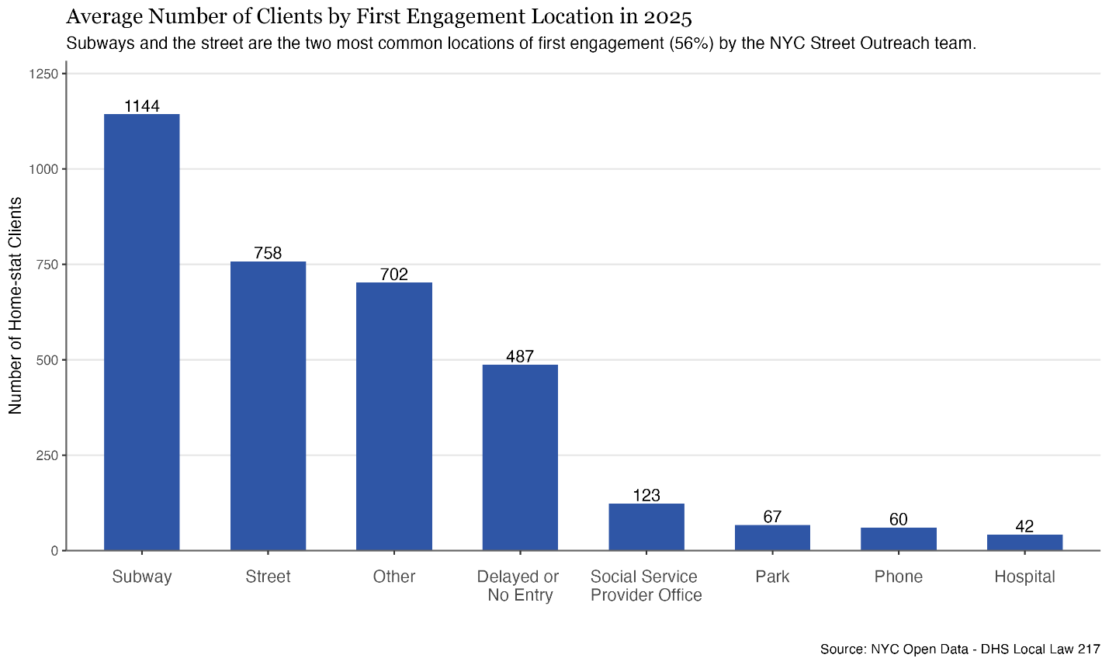
The number of unsheltered homeless New Yorkers who have been engaged by Street Outreach teams has increased by 56% from 2019 to 2025, as demonstrated below:
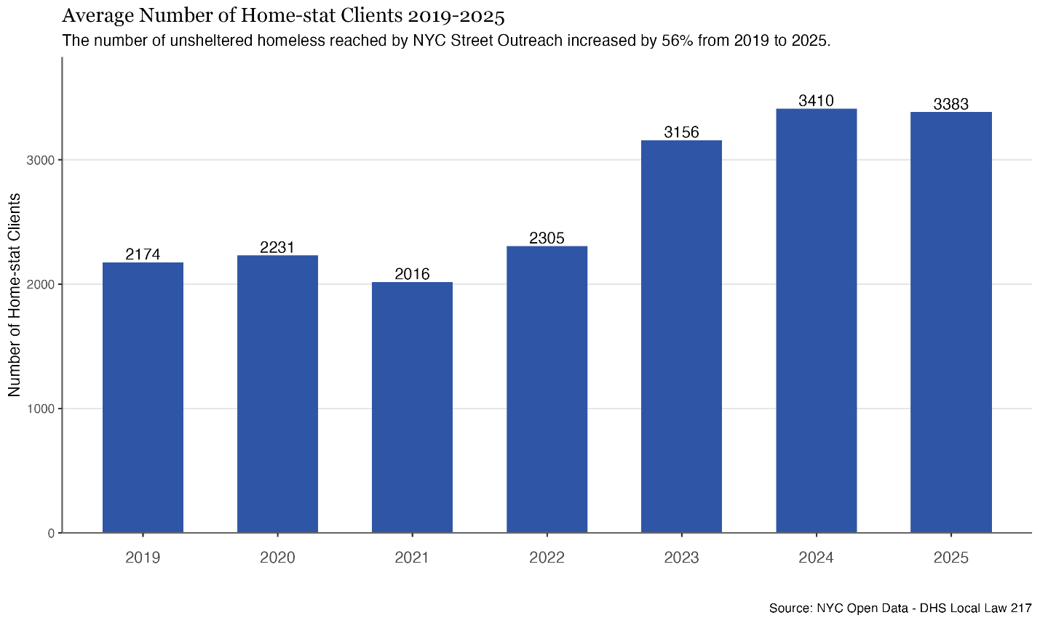
  - Agency Obligations during a Code Blue
The Department of Homeless Services (DHS)
During a Code Blue, DHS shelter beds are made available system-wide to anyone who is reasonably believed to be homeless and seeking warmth. Standard intake procedures and eligibility requirements to enter shelter are relaxed. Walk-ins are accepted where individuals are able to go directly to shelters or drop-in centers without being referred. When Code Blue is in effect, all drop-in centers are open 24 hours. Drop-in centers are low-barrier programs that target those who may otherwise be resistant to entering traditional shelter. The centers are equipped with on-site case management services and staff with locations across the five boroughs. The centers assist as many people as possible and can coordinate placements into other facilities such as shelters or safe havens. During Code Blue, no one who is homeless and seeking shelter is denied access due to typical shelter protocols including intake. Additionally, shelters are prohibited from suspending or discharging clients during any Code Blue Alert period.
During Code Blue, DHS outreach teams intensify their efforts to locate and assist unsheltered individuals. Specifically, outreach teams contact vulnerable individuals on their Code Blue Priority Lists to ensure their safety and to bring them into shelter. DHS requires that these individuals be contacted a minimum of once every four hours beginning at 8:00pm through 8:00am during Code Blue Alerts and once every two hours beginning at 8:00pm through 8:00am during Enhanced Code Blue Alerts in efforts to encourage the individuals to accept transportation to a safe location. DHS street outreach teams are also required to call 911 to request NYPD and Emergency Medical Services (EMS) assistance for those who are experiencing a medical or psychiatric emergency and in need of transportation to an emergency room. DHS street outreach teams coordinate their efforts directly with other city agencies such as the Department of Sanitation (DSNY), and the Department of Parks & Recreation. The street outreach teams also play an administrative role during Code Blue and are required to create and submit a 24-hour plan to ensure adequate staff coverage as well as add additional vans operating overnight in each borough.
New York City Fire Department Bureau of Emergency Medical Services (FDNY EMS)
During Code Blue activations, all 311 calls related to unsheltered persons are automatically routed to the City’s 911 system, and first responders are dispatched, including police officers and EMS personnel.
Generally, EMS operating protocols are established by the Regional Emergency Medical Services Council of New York City (REMSCO), a not-for-profit organization designated under Article 30 of the New York State Public Health Law to coordinate emergency medical response, oversee the City’s ambulance medical operations, and establish protocols for the delivery of services. REMSCO ambulance operating guides including procedures and special considerations for responding to cold-related medical emergencies. Once on the scene, first responders are directed to follow standard protocols for assessing and treating an unconscious or critically ill patient—including attempts to stabilize vital functions through clearing of airways, confirming breathing and checking circulation. In addition, these protocols direct targeted treatment for localized cold injuries and generalized hypothermia; which include wrapping affected areas with dry, bulky dressings, to protect injuries from pressure, trauma and friction; and when available, wrapping a patient in a dry blanket and placing heat packs in the patient’s groin area, lateral chest, and neck. Finally, in circumstances involving a patient with a suspected altered mental status, EMS personnel are instructed to request support from an advanced life support (ALS) ambulance that can provide advanced airway management and cardiac monitoring, establish intravascular access to deliver fluids and medicine, and transport the patient to a hospital.
The New York City Police Department (NYPD)
Due to NYPD’s substantial personnel deployment and ability to quickly arrive at the scene of an emergency, police officers are often dispatched to respond to 311 or 911 calls related to unhoused persons during cold weather emergencies when EMS or DHS outreach workers might otherwise be unavailable, due to those agencies having less staff in the field, and experiencing high demand during periods of extreme cold. When responding in these circumstances, or when engaging in routine patrol, the NYPD’s Patrol Guide §214-06 provides detailed operational procedures for officers to follow when encountering unhoused persons, including specific protocols for cold weather emergencies.
Pursuant to Patrol Guide §214-06, when a police officer assists an individual who is unhoused, or appears to be unhoused, they should seek to assess the individual’s need for medical attention, shelter or other services; advise the individual of available services; and contact DHS for support in ongoing outreach efforts. If an unhoused individual accepts an offer of shelter, police are directed to provide transport to the nearest DHS 24-hour Intake Shelter or Drop-in Center. Specific guidelines pertain to actions to be taken when a Cold Weather Emergency is declared—including, instructing patrol officers to be alert during overnight hours for unhoused persons with no available means of shelter and requesting a supervisor respond to the location if the person refuses an offer of shelter. Upon arrival, patrol supervisors are advised to encourage the individual to seek shelter and determine if the person is potentially mentally ill or incapacitated due to alcohol or other substances, and apply protocols related to evaluating the need for involuntary removal. Finally, commanding officers and patrol borough commands are directed to maintain records, and report to the Chief of Patrol, any locations with a persistent congregation of unhoused persons.
New York City Emergency Management (NYCEM)
NYCEM is tasked with coordinating the City’s multi-agency response to all emergency conditions and potential incidents that affect public health and safety, including severe weather conditions. NYCEM is responsible for overall planning and emergency preparation, including educating the public about preparedness, and collecting and disseminating critical information to key stakeholders and the public during emergencies.
Generally, for all extreme weather emergencies, NYCEM-coordinated plans include the following procedures: (i) real-time tracking of weather conditions in conjunction with the National Weather Service and dissemination of relevant hazards to City agencies; (ii) convening interagency steering committee conference calls to coordinate preparation and activate relevant plans and operations; (iii) activation of the Emergency Operations Center (EOC); (iv) public messaging through Notify NYC, social media and other means; (v) as needed, coordinating identification of vendors that can provide appropriate resources or requesting support from the state through the established mission request process; and (vi) if conditions warrant, NYCEM may concurrently activate additional all-hazards and recovery plans and protocols.
NYCEM’s “Winter Weather Emergency Plan” (WWEP) is triggered by: (i) snowfall exceeding three inches; (ii) temperatures or wind chill below negative five-degrees Fahrenheit; (iii) sustained winds exceeding 40 miles per hour; and (iv) forecasted ice storms or freezing rain. Pursuant to the WWEP, the following operational strategies may be implemented to address specific hazards posed by extreme cold temperatures: (i) provide hazard awareness to agency partners and disseminate public information; (ii) monitor and support vulnerable populations, including through situational awareness, resource escalation, and homeless outreach; and (iii) issue Cold Weather Alert to trigger increased outreach to vulnerable populations, including through the activation of DSS Code Blue procedures. Of note, NYCEM’s WWEP is activated at temperatures far below that which triggers Code Blue; thus, there are circumstances when DHS Code Blue is in effect, but the WWEP is not activated.
New York City Health and Hospitals (H+H)
During Code Blue emergencies, hospitals provide refuge for anyone who needs to get out of the cold. As part of Code Blue operations, DHS requests hospitals act as warming centers. DSS sent Code Blue guidance to hospitals in September 2025, as part of regular planning for cold weather. On January 26, DSS issued updated guidance, reiterating the policy that waiting rooms and other areas in hospital buildings remain accessible to New Yorkers even if they do not have a medical need. The updated guidance also requested that hospitals limit discharge for unsheltered New Yorkers. The New York State Department of Health does have guidance on discharge planning for the Medical Respite program which states that the program must make reasonable efforts to discharge a patient to safe and stable housing, however for patients that are not in the Medical Respite program, hospitals are only required to provide a written discharge plan to all patients. During the 2026 Code Blue Emergency, 18 H+H hospitals are providing dedicated warming centers and are open from 7 am to 7 pm, although the hospital buildings themselves are open 24 hours a day.
- New York City’s 2026 Code Blue
  - Weather conditions and deaths
In New York City, the average temperature was below 32 degrees Fahrenheit from January 19th through January 21st, and again from January 23rd through February 8th. On January 25th, the City also experienced record snowfall, receiving over a foot of snow. In response to the weather conditions, NYCEM announced a Code Blue in a press release on January 17, 2026, a second Code Blue on January 24, and a third Code Blue on February 6, lasting through February 8 at 1 p.m.
Between January 19 and February 8, 2026, 18 New Yorkers died from the cold. According to Mayor Zohran Mamdani, hypothermia played a role in 13 of those deaths, while the other three appeared to be deaths related to substance use. The mayor also stated that at least 10 of the decedents were involved in the City’s shelter system at some point. As of February 6, 1,250 New Yorkers had been placed in shelters and safe havens, and 27 had been involuntarily transported to hospitals. As of February 2nd, 2026, there was no indication that any of the New Yorkers who died due to weather conditions were living in homeless encampments.
On February 6, in advance of the third Code Blue, the Mayor announced a number of new initiatives designed to help protect New Yorkers from the cold. Among these were the opening of an additional 50 safe haven beds in Upper Manhattan, adding 60 hotel shelter rooms for individuals reticent to enter congregate shelters, operating an additional 62 warming center and buses including in public schools, CUNY campuses, and Northwell Health locations, and keeping two overdose prevention centers open for 24 hours over the weekend. To increase staff capacity, the mayor also announced a partnership with Association of Community Employment Programs for the Homeless (ACE) to enhance direct outreach efforts; working with school nurses and the neighborhood based violence interruption Crisis Management System, and piloting a peer outreach model where formerly homeless New Yorkers join outreach workers to help convince individuals to come inside. Finally, the time to reach a homeless assistance prompt when calling 311 was halved to 40 seconds, and LinkNYC Kiosks were set up to allow New Yorkers to call 311 from them directly.
Comparison to previous Code Blues
In 2018, DOHMH’s Bureau of Environmental Surveillance and Policy published an analysis of cold-related deaths in the city from 2005-2014. The report examined hospital discharges, death certificates, and medical examiner data during the cold season, and found that on average, each cold season there were 180 treat-and-release emergency department visits, 240 hospital admissions for cold-related illness, and 15 cold-related deaths. 75% of decedents were exposed to the cold outside, half of which were homeless or suspected to be homeless. Of those exposed inside, none had home heat. The report concluded that homeless individuals, people with substance use disorders and psychiatric conditions, and those without home heat are most at risk of cold-related illness or death. Data from the New York City DOHMH Environment and Health Data Portal confirms these findings. Cold-Stress deaths, or deaths due to cold weather, have increased city-wide since 2016, as seen in the chart below:
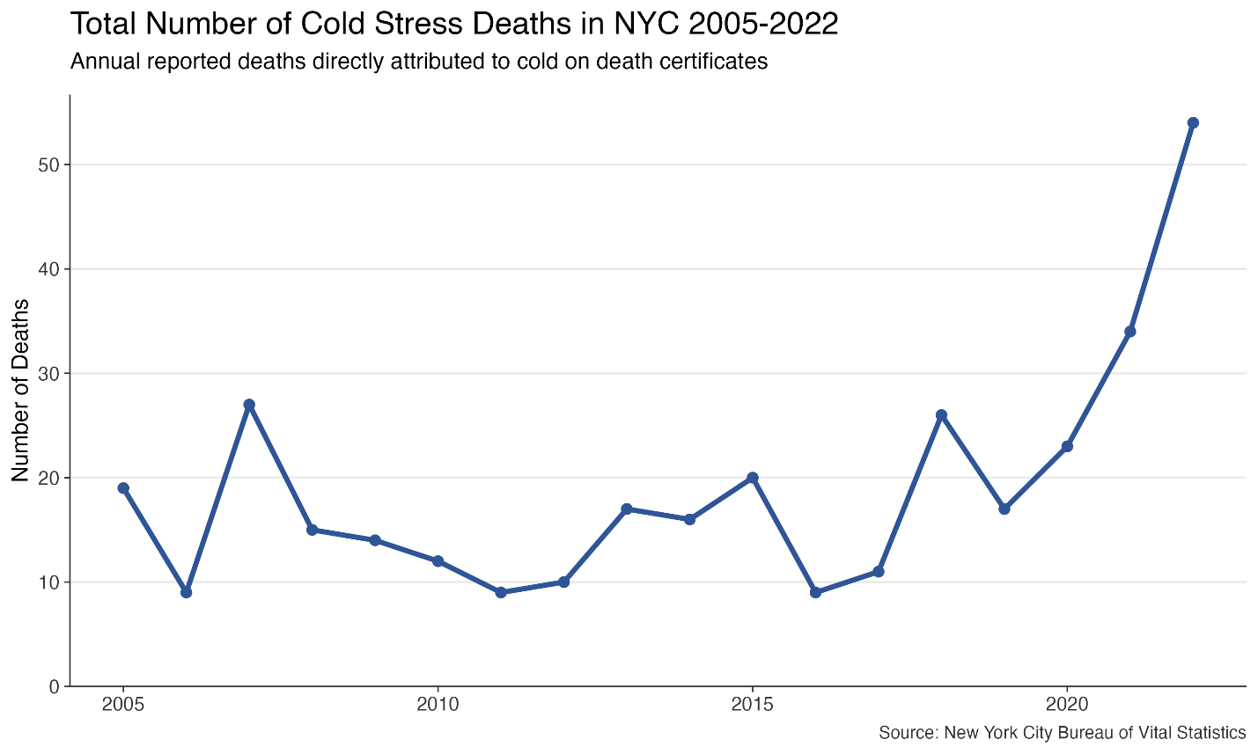
Similarly, the number of cold-related emergency room visits for cold-related ailments, such as hypothermia, frostbite, and worsened chronic conditions due to the cold, have also increased, as seen in the chart below:
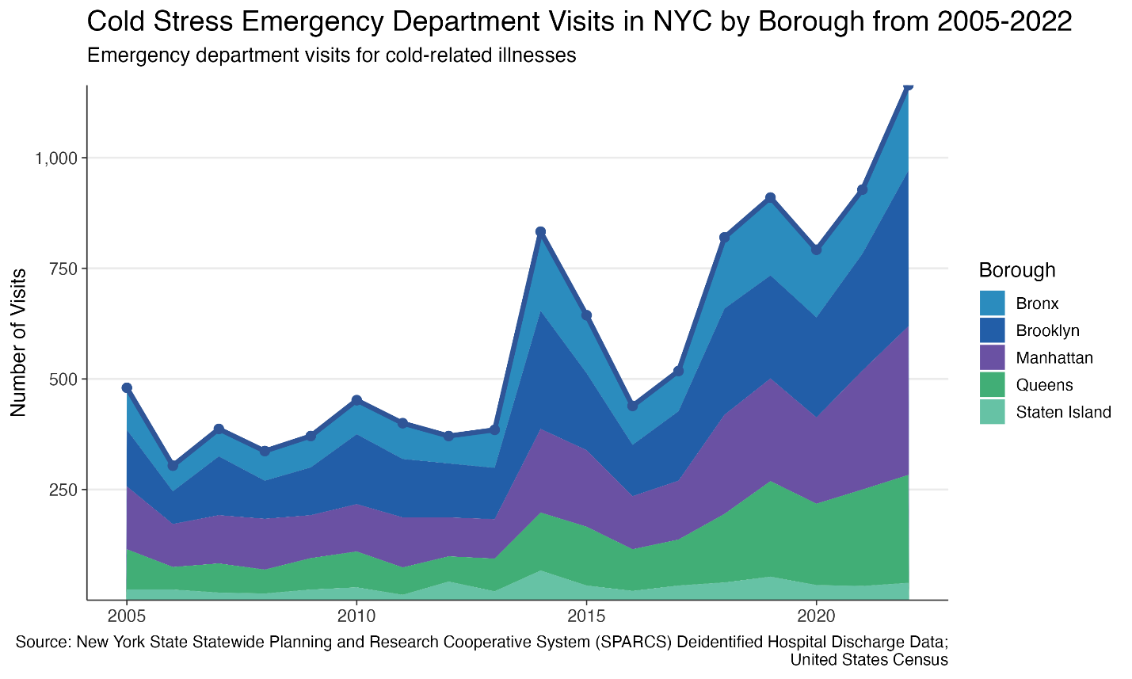
  - Issues with agency responses
Ineffective 311 Responses
Code Blue guidance states during Code Blue emergencies that 311 calls related to homeless individuals in need of assistance are routed directly to 911. While it is unclear if this process was implemented during the 2026 Code Blue, 311 data does show that between January 19 and February 2, 2026, 311 received 1,855 calls for DHS citing “Homeless Person Assistance.” Of the closed cases, 1,057 – or over 50% – were closed because DHS was unable to locate the individual. It has been reported that one of the decedents succumbed to the cold after a 311 call about his welfare was erroneously logged as a “disorderly male,” which may have contributed to the inability of the dispatched officer to locate him.
Poor Communication
Code Blue operations require the rapid deployment of multi-agency coordination, and there have been reports of communication breakdowns that have limited effectiveness. Gothamist reported that while the City did dispatch 20 warming busses across the city, in the case of two warming buses that were made available at the Staten Island Ferry Terminal, poor communication and coordination resulted in a complete lack of awareness on the part of terminal employees and NYPD officers stationed at the terminal that such warming buses were available. Volunteers in the terminal noted that there was no signage on the buses and that they had to personally inform homeless people that the buses were available for use. Mayor Mamdani has acknowledged this communication issue and pledged to provide clear signage and additional for warming buses going forward.
Under Resourcing
Resource shortages may have also played a role in the lack of adequate response to the cold. The City news outlet reported that FDNY had been soliciting staff to join the task force responding to cold-related calls; however Anthony Almojera, vice president of Local 3621, has stated that FDNY’s Emergency Medical Services unit does not have enough staff to handle all of the calls, despite the number of staff members who are picking up overtime to be part of the efforts. On February 6, the Mayor announced a number of initiatives to increase response capacity including partnering nonprofit organizations for more targeted outreach.
- Conclusion
At today’s hearing, the Committees seek to assess the effectiveness of the City’s Code Blue operations this winter thus far. The Committees look forward to receiving testimony from the administration, advocacy groups, and other interested members of the public to learn more about how the City can improve upon its Code Blue operations going forward.

Coalition for the Homeless, “Extreme Cold: Code Blue”, available at: https://www.coalitionforthehomeless.org/get-help/know-your-rights/extreme-cold-weather-code-blue/ (last visited Feb. 2, 2026).
18 N.Y.C.R.R. § 304.1.
NYS Department of Homeless Services. “About” available at: https://www.nyc.gov/site/dhs/about/inside-dhs.page (Last visited Feb. 5, 2026).
Jeanmarie Evelly, “What does ‘Code Blue’ Mean for Homeless New Yorkers?”, City Limits, (Jan. 15, 2025), available at: https://citylimits.org/what-does-code-blue-mean-for-homeless-new-yorkers/#:~:text=Code%20Blue%20is%20a%20standard,jurisdiction%2C%20but%20in%20many%20places, (last visited Feb. 4, 2026).
Supra Note 4
NYC 311, “Homeless Assistance”, available at: https://portal.311.nyc.gov/article/?kanumber=KA-01037 (last visited Feb. 5, 2026).
NYC Emergency Management, New York City is under a Weather Alert, with wind chills near or below 0°F. An Enhanced Code Blue is in effect 24 hours a day, (Feb. 1, 2026), available at: https://x.com/nycemergencymgt/status/2017968605745267100 (last visited Feb. 5, 2026).
U.S. Dept. of Housing and Urban Development, The 2024 Annual Homeless Assessment Report (AHAR) to Congress, Part 1: Point-In-Time Estimates of Homelessness (Dec. 2024), available at https://www.huduser.gov/portal/datasets/ahar/2024-ahar-part-1-pit-estimates-of-homelessness-in-the-us.html
The HUD-mandated Homeless Outreach Population Estimate Count (the “HOPE Count”) has volunteers canvass streets and subway stations on a single night, typically occurring in January. The HOPE count has used a consistent sampling methodology since 2005 and advocates have long stated that a one night count does not lead to accurate data.
Dept. of Homeless Services, NYC HOPE 2025 Results, available at https://hoperegistration.cityofnewyork.us/about-us/previous-results/
Id.
Id.
Id.
Id.
National Alliance to End Homelessness, “The Link Between Homelessness and Health,” available at https://endhomelessness.org/people-with-unaddressed-health-conditions/.
Bureau of Vital Statistics, NYC Dept. of Health and Mental Hygiene, Nineteenth Annual Report on Homeless Deaths, July 1, 2023 – June 30, 2024, available at https://a860-gpp.nyc.gov/downloads/2801pm59m?locale=en
Id.
Id.
Id.
NYC Mayor’s Office of Operations, NYC HOME-STAT, Stakeholder Research Insights Report, Documenting the Journey from Street to Home, Jan. – May 2016 (Nov. 2017), available at https://www1.nyc.gov/assets/servicedesign/downloads/pdf/NYC-Home-Stat_Insights_Report-2017 (hereinafter NYC HOME-STAT, Documenting the Journey from Street to Home). The term “chronically homeless” is utilized here as it is the term used by City agencies however advocates do not use the term as it can reinforce certain stereotypes. Advocates intend choose to use the term “experiencing homelessness.” See https://schoolhouseconnection.org/article/why-we-use-the-phrase-experiencing-homelessness#:~:text=We%20recognize%20the%20stigma%20and,with%20their%20emphasis%20on%20deficits..
Basic Facts About Homelessness: New York City,” Coalition for the Homeless, January 2026, https://www.coalitionforthehomeless.org/basic-facts-about-homelessness-new-york-city/.
Health Care for the Homeless Clinicians’ Network, Adapting Your Practice: General Recommendations for the Care of Homeless Patients, 2010 Edition, available at https://nhchc.org/wp-content/uploads/2019/08/GenRecsHomeless2010.pdf.
NYC HOME-STAT, Documenting the Journey from Street to Home, supra note 20.
Breaking Ground, Street to Home, available at https://breakingground.org/what-we-do/street-to-home
Supra Note 15
National Alliance for Mental Illness, “Untangling the Web: The Complex Reality of Homelessness, Mental Illness, and Substance Abuse,” available at https://namisc.org/untangling-the-web-the-complex-reality-of-homelessness-mental-illness-and-substance-abuse/.
The City, “New City Rule Will Make it Harder to Get People Off Streets Into Shelter,” February 5, 2026. available at https://www.thecity.nyc/2026/02/05/shelter-rules-eric-adams-zohran-mamdani/
Supra Note 15
NYC Mayor’s Office of Operations, NYC HOME-STAT website, available at https://www1.nyc.gov/site/operations/projects/HomeStat.page (last visited April 25, 2022) (hereinafter NYC HOME-STAT).
Goddard Riverside, Homeless Outreach, available at https://goddard.org/programs/fighting-homelessness/homelessoutreach/ (last visited February 5, 2026)
Breaking Ground, Street to Home, available at https://breakingground.org/what-we-do/street-to-home (last visited February 5, 2026).
Bronxworks, Homeless Outreach Teams, https://bronxworks.org/our-services/adult-and-family-homeless-services/homeless-outreach-team/
NYC Dept. Of Homeless Services, Project Hospitality, https://www1.nyc.gov/site/dhs/about/project-hospitality.page
NYC Department of Homeless Services, “Street Outreach,” available at https://www.nyc.gov/site/dhs/outreach/street-outreach.page
Coalition for the Homeless, “”Extreme Cold: Code Blue,” available at https://www.coalitionforthehomeless.org/get-help/know-your-rights/extreme-cold-weather-code-blue.
Id.
Id.
Supra Note 42
Id.
Id.
Id.
See 18 NYCRR 352.35
Supra Note 42
Id.
NYC Department of Homeless Services Office of Policy, Procedures and Training, “DHS-PB-2021-015: Code Blue Procedure,” Available at DHS-PB-2021-015_Code_Blue_2021_11-3-21.pdf.
Id.
Supra Note 32
Supra Note 43
Supra Note 4
Regional Emergency Medical Services Council of New York City; available at: https://nycremsco.org/about-us/
Unified Prehospital Treatment Protocols, Regional Emergency Medical Advisory Committee of New York City, effective April 8, 2025; available at: https://nycremsco.org/wp-content/uploads/2025/07/2024-02-REMAC-Unified-Prehospital-Treatment-Protocols-07-09-25.pdf.
Id.
Id.
Id.
Sahalie Donaldson, “How NYC’s Code Blue emergency notice aims to protect homeless people” City and State, (Nov 23, 2022) available at: https://www.cityandstateny.com/policy/2022/11/how-nycs-code-blue-emergency-notice-aims-protect-homeless-people/380149/ (Last visited Feb 4, 2026)
NYPD Patrol Guide §214-06, Homeless Contact Guidelines for Uniformed Members of the Service; available at: https://www.nyc.gov/site/nypd/about/about-nypd/manual.page.
Id.
Id.
Id. See Involuntary Removal (Mental Hygiene Law 9.58): If an individual is at-risk but refuses to move, police can assist with involuntary transport to a hospital emergency department if the person meets the criteria under NYS Mental Hygiene Law, Section 9.58 (i.e., they appear to have a mental illness and are acting in a manner likely to result in serious harm to themselves or others)
Id.
New York City Charter § 497.
NYC Emergency Management Strategic Plan 2022-2026, available at: https://nyc-oem.maps.arcgis.com/apps/Cascade/index.html?appid=72522e0db548473b9f4fce4d030a976b.
NYCEM, Weather Emergency Protocols; available at: https://www.nyc.gov/assets/em/downloads/pdf/LL-24-of-2011_Weather-Emergency-Protocols-Report_2025.pdf.
Id.
Haidee Chu, “‘Code Blue’ Nights: How Homeless Outreach Works When It’s Freezing,” The City, (Jan 22, 2026), available at: https://www.coalitionforthehomeless.org/wp-content/uploads/2022/01/DHS-PB-2021-015_Code_Blue_2021_11-3-21.pdf (last visited Feb 5, 2026)
Amanda D’Ambrosio, “City reiterates hospital shelter guidance after 10 died during cold weather emergency” Crain’s (Jan 20, 2026). Available at: https://www.crainsnewyork.com/health-pulse/new-york-city-reiterates-hospital-shelter-guidance-during-cold-weather-emergency (last visited Feb 5, 2026)
Id.
NYS Department of Health, “Guidance on Discharge Planning” available at: https://www.health.ny.gov/health_care/medicaid/redesign/sdh/guidance/discharge.htm
NYS Department of Health, “Your Rights as a Hospital Patient in New York State - Section 2” available at: https://www.health.ny.gov/publications/1449/section_2.htm#:~:text=A%20plan%20must%20be%20provided,Not%2DResuscitate%20(DNR)%20Order
NYC 311, “Warming Centers,” available at: https://www.coalitionforthehomeless.org/wp-content/uploads/2022/01/DHS-PB-2021-015_Code_Blue_2021_11-3-21.pdf (last visited Feb 9, 2026)
The National Weather Service, “NOWData”, available at: https://www.weather.gov/wrh/Climate?wfo=okx (last visited Feb 4, 2026)
Id.
NYCEM, “NYCEM Issues Travel Advisory, Warns of Weekend Snow and Potential Travel Impacts,” (Jan 17, 2026), available at: https://www.nyc.gov/site/em/about/press-releases/20260117_pr_nycem_issues-travel-advisory.page? (last visited Feb 4, 2026)
NYCEM, “A Winter Storm Warning is in effect for New York City from 3 a.m. Sunday, January 25 Until 6 p.m. Monday, January 26,” (Jan 23, 2026), available at: https://www.nyc.gov/site/em/about/press-releases/20260123_pr_nycem_issues-hazardous-travel-advisory.page? (last visited Feb 4, 2026)
NYCEM, “NYCEM Issues Extreme Weather Alert as Snow and Extreme Cold Temperatures Return This Weekend,” (Feb 6, 2026), available at: https://www.nyc.gov/site/em/about/press-releases/20260206-NYCEM-Issues-Weather-Alert-Snow-And-Extreme-Cold-Temperatures.page (last visited Feb 9, 2026)
Erica Brosnan, “Outdoor death toll in New York City rises to 18 amid extreme cold,” Spectrum News, (Feb 9, 2026), available at: https://ny1.com/nyc/all-boroughs/news/2026/02/09/death-toll-in-new-york-city-rises-to-18-after-extreme-cold (last visited Feb 9, 2026)
Mira Wassef, “New York City death toll reaches 16 amid stretch of freezing weather,” Pix 11, (Feb 3, 2026), available at: https://www.newsnationnow.com/weather/new-york-city-death-toll-freezing-weather/ (last visited Feb 4, 2026)
Supra, Note 42
Office of the Mayor, “Mayor Mamdani Announces New Shelter and Outreach Efforts to Keep New Yorkers Safe as Temperatures Plummet” (Feb 6, 2026), available at: https://www.nyc.gov/mayors-office/news/2026/02/mayor-mamdani-announces-new-shelter-and-outreach-efforts-to-keep, (last visited Feb 9, 2026)
Adam Daly, “Extreme cold: Death toll rises to 16 in NYC, Mamdani said none lived in homeless encampments,” AmNY, (Feb 2, 2026), available at: https://www.amny.com/weather/extreme-cold-death-toll-nyc-mamdan-02022026/ (last visited Feb 4, 2026)
Supra, Note 79
Id.
Id.
Id.
Lane, K., Ito, K., Johnson, S., Gibson, E. A., Tang, A., & Matte, T. (2018). Burden and Risk Factors for Cold-Related Illness and Death in New York City. International Journal of Environmental Research and Public Health, 15(4), 632. https://doi.org/10.3390/ijerph15040632
Id.
Id.
Id.
Id.
New York City Department of Health, Environment & Health Data Portal. Weather-related illness data. Cold stress: deaths., available at: https://a816-dohbesp.nyc.gov/IndicatorPublic/data-explorer/weather-related-illness/?id=2175 on 02/04/2026.
Id.
Supra Note 53
NYC Open Data, “311 Service Requests from 2020 to Present,” available at: https://data.cityofnewyork.us/Social-Services/311-Service-Requests-from-2020-to-Present/erm2-nwe9/about_data (last visited Feb 4, 2026)
Id.
David Brand, “Man’s death on freezing Manhattan street reveals limits of NYC's emergency response.” Gothamist, (Jan 30, 2026). Available at: https://gothamist.com/news/mans-death-on-freezing-manhattan-street-reveals-limits-of-nycs-emergency-response (last visited Feb 5, 2026)
Elizabeth Kim, “NYC sent a warming bus to a hub for homelessness. Those who needed it had no idea.” Gothamist (Feb 2, 2026), available at: https://gothamist.com/news/nyc-sent-a-warming-bus-to-a-hub-for-homelessness-those-who-needed-it-had-no-idea
Id.
Elizabeth Kim, “Mayor Mamdani takes the rap for mishaps around warming buses for homeless people,” Gothamist, (Feb 5, 2026), available at: https://gothamist.com/news/mayor-mamdani-takes-the-rap-for-mishaps-around-warming-buses-for-homeless-people (last visited Feb 9, 2026)
Supra, Note 42
Supra, Note 79

