THE COUNCIL OF THE CITY OF NEW YORK
RESOLUTION NO. 407

Resolution approving the decision of the City Planning Commission on ULURP No. N 240272 ZRK, for a Zoning Text amendment (L.U. No. 39).

By Council Members Riley and Louis

WHEREAS, Mihata Corp., filed an application pursuant to Section 201 of the New York City Charter for an amendment of the Zoning Resolution of the City of New York, adding an Industrial Business Incentive Area to Article VII, Chapter 4 (Special Permits by the City Planning Commission). (ULURP No. N 240272 ZRK) (the "Application");
WHEREAS, the City Planning Commission filed with the Council on February 20, 2026 its decision dated February 2, 2025 (the "Decision") on the Application;
WHEREAS, the Application is related to applications C 240271 ZMK (L.U. No. 38), a zoning map amendment changing from a M1-1 zoning district to a M1-2 zoning district and C 240273 ZSK (L.U. No. 40), a zoning special permit to allow an increase in maximum permitted floor area ratio (FAR), modify publicly accessible open space requirements, modify bulk requirements, and modify off-street parking and loading requirements;
WHEREAS, the Decision is subject to review and action by the Council pursuant to Section 197-d of the City Charter;
WHEREAS, upon due notice, the Council held a public hearing on the Decision and Application on March 4, 2026;
WHEREAS, the Council has considered the land use and other policy issues relating to the Decision and Application; and
WHEREAS, the Council has considered the relevant environmental issues, including the Negative Declaration issued on September 12, 2025 (CEQR No. 24DCP038K), which includes an (E) designation (E-858) related to hazardous materials, air quality, and noise to avoid the potential for significant adverse impacts (the “Negative Declaration”).
RESOLVED:
The Council finds that the action described herein will have no significant impact on the environment as set forth in the Negative Declaration.
Pursuant to Sections 197-d and 200 of the New York City Charter and the Decision and Application, the environmental determination and consideration described in the report, N 240272 ZRK, incorporated by reference herein, and the record before the Council, the Council approves the Decision of the City Planning Commission.
The Zoning Resolution of the City of New York, effective as of December 15, 1961, and as subsequently amended, is further amended as follows:
Matter underlined is new, to be added;
Matter struck out is to be deleted;
Matter within # # is defined in Section 12-10;
* * * indicates where unchanged text appears in the Zoning Resolution.
* * *
ARTICLE VII
ADMINISTRATION
Chapter 4
Special Permits by the City Planning Commission
* * *
74-90
ADDITIONAL PERMITS
* * *
74-94
Industrial Business Incentive Areas
* * *
74-948
Maps of Industrial Business Incentive Areas
Map: 1 Brooklyn
[EXISTING MAP]
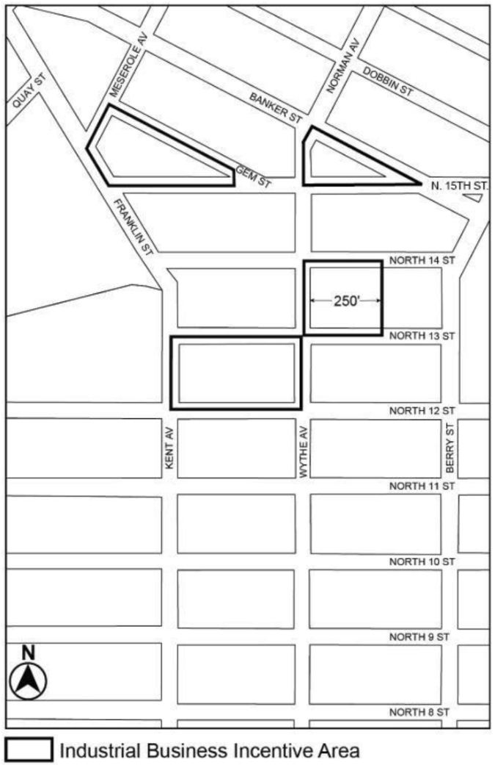
[PROPOSED MAP]
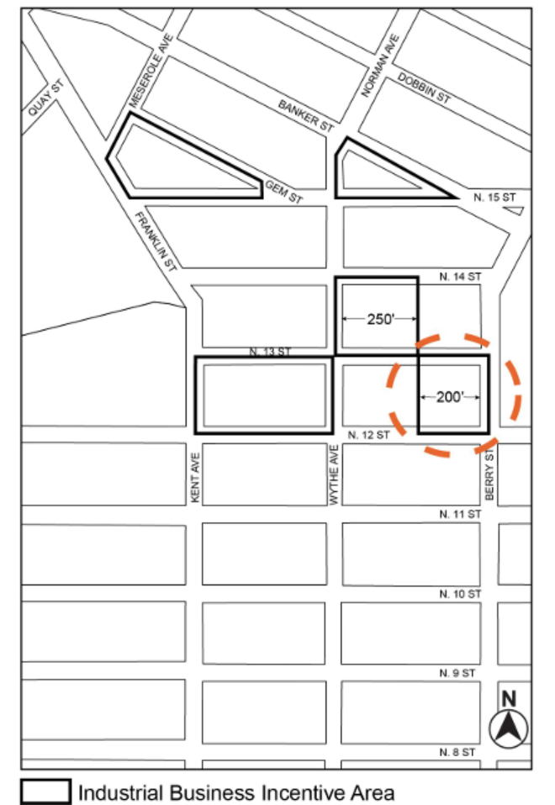

Portion of Community District 1, Borough of Brooklyn
* * *
Adopted.

Office of the City Clerk, }
The City of New York, } ss.:

I hereby certify that the foregoing is a true copy of a Resolution passed by The Council of The City of New York on March 26, 2026, on file in this office.

.....................................................
City Clerk, Clerk of The Council

