Staff: Committee on Sanitation & Solid Waste Management
Morganne Barrett, Legislative Counsel
Ricky Chawla, Senior Legislative Policy Analyst
Dirk Spencer PhD, Legislative Policy Analyst
Tanveer Singh, Finance Analyst

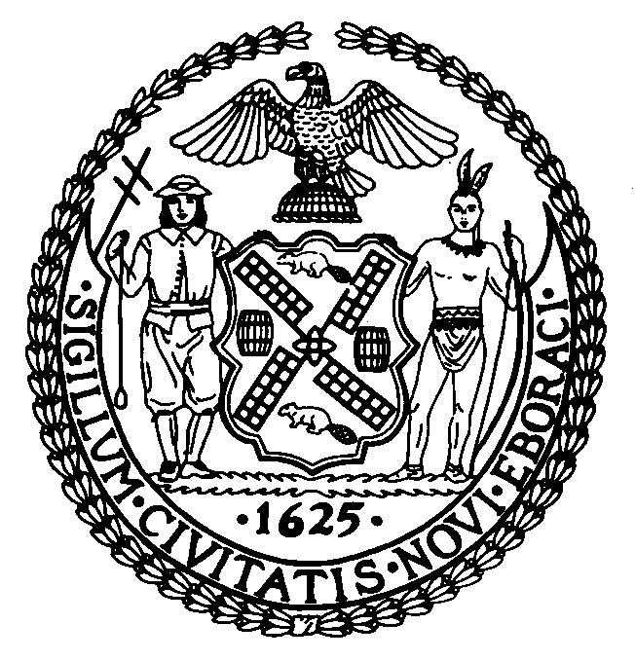

The New York City Council
Andrea Vazquez, Legislative Director

Committee Report of the Infrastructure Division
Brad Reid, Deputy Director

Committee on Sanitation & Solid Waste Management
Hon. Justin Sanchez, Chair

August 13, 2026

INT. NO. 857-A: By The Speaker (Council Member Menin) and Council Members Louis, Hanif, Epstein, Brewer, Aldebol, Farías, Cabán, Dinowitz, Maloney, Wilson and the Public Advocate (Mr. Williams) (in conjunction with the Manhattan Borough President)

TITLE: A Local Law to amend the administrative code of the city of New York, in relation to requiring the department of sanitation to install and refill dog waste bag dispensers on public litter baskets

ADMINISTRATIVE CODE: Adds section 16-132.1

INT. NO. 872-A: By Council Members Hanif, Hudson, Louis, Restler, Aldebol, Epstein, Farías, Cabán, Dinowitz, Wilson and Morano

TITLE: A Local Law to amend the administrative code of the city of New York, in relation to a public education and outreach campaign regarding the removal of dog waste, and to repeal such local law upon the expiration thereof

- Introduction

On August 13, 2026, the Committee on Sanitation and Solid Waste Management (“the Committee”), chaired by Council Member Justin Sanchez, held a hearing to vote on Int. No. 857-A, sponsored by the Speaker, Council Member Julie Menin, in relation to requiring the department of sanitation to install and refill dog waste bag dispensers on public litter baskets; and Int. No. 872-A, sponsored by Council Member Shahana Hanif, in relation to public education and outreach campaign regarding the removal of dog waste, and to repeal such local law upon the expiration thereof. The Committee heard previous versions of Int. No. 857 and Int. No. 872 on May 19, 2026.
- Background
Pet ownership in New York City (“NYC” or the “City”), particularly dog ownership, has been a point of tension for the City’s residents since 1872. This past winter NYC experienced two major snowstorms that significantly affected trash collection and street cleaning by the New York Department of Sanitation (“DSNY”), and has exacerbated issues around dog ownership. The winter weather events were followed by increases in 311 complaints about dog waste. New York State Public Health Law requires that dog owners or responsible caretakers, such as dog walkers, remove any feces left by the dog on any sidewalk, gutter, street, or other public area. Failing to comply could result in a maximum fine of $250. In NYC, this law is enforced by DSNY. Under the NYC Administrative Code (“Ad. Code”), it is unlawful for any person to litter, sweep, throw, or cast ashes, garbage, paper, dust, or other refuse of any kind, into or upon any street or public place, vacant lot, air shaft, areaway, backyard court, park, or alley. The Ad. Code also prohibits anyone from allowing “swill, brine, offensive animal matter, noxious liquid, or other filthy matter of any kind” to fall onto a public space. Property owners, regardless of whether they are a public or private party, are responsible for keeping the area adjacent to the building perimeter (i.e., sidewalks including natural elements thereon and extending 18 inches from the curb into the street) clean and free from obstruction and nuisance.
Any individual can make a report to 311 regarding dog or animal waste on public or private property. DSNY surveils areas with frequent reports of dog or animal waste and issue fines to dog owners that fail to clean up after their dog.
- Legislation
Int. No. 857-A
This bill would require DSNY to install no less than 1,200 dog waste bag dispensers on public litter baskets across the 5 boroughs. DSNY could engage a local entity to volunteer to refill any dog waste bag dispenser with bags no less than monthly, and where no such entity is engaged, DSNY would be required to refill any dog waste bag dispenser with bags no less than monthly until June 30, 2030. DSNY would also be required to, by March 1, 2030, report to the Speaker of the Council regarding the program’s impact on public complaints about dog waste and whether the program should be continued.
This local law would take effect 180 days after it becomes law and would expire and be deemed repealed on June 30, 2030.
Int. No. 872-A
This bill would require the Commissioner of Health and Mental Hygiene, in consultation with the Commissioner of Sanitation, to develop and conduct an annual public education and outreach campaign for 3 years to inform the public about dog waste removal, the dangers of failing to remove dog waste, health risks associated with exposure to dog waste, and the legal obligations to remove dog waste. This bill would also require the Commissioner of Health and Mental Hygiene to make any materials developed for the outreach and education campaign available in English and all designated citywide languages, and to submit a report to the Speaker of the Council regarding the effectiveness of the education and outreach campaign.
This local law would take effect 150 days after it becomes law and would expire and be deemed repealed upon submission of the report to the mayor and the speaker of the council as required by subdivision c of section one of this local law. Upon such submission, the mayor would be required to notify the corporation counsel for the purpose of effectuating section 7-111 of the administrative code of the city of New York. Any failure to provide a notification described in this section would not affect the effective date of any provision of this local law.
Update
On Thursday, August 13, 2026, the Committee adopted Int. No. 857-A and Int. No. 872-A by a vote of 10 in the affirmative, 0 in the negative, and 0 abstentions.

[This page intentionally left blank]

Int. No. 857-A

By The Speaker (Council Member Menin) and Council Members Louis, Hanif, Epstein, Brewer, Aldebol, Farías, Cabán, Dinowitz, Maloney, Wilson and the Public Advocate (Mr. Williams) (in conjunction with the Manhattan Borough President)

A Local Law to amend the administrative code of the city of New York, in relation to requiring the department of sanitation to install and refill dog waste bag dispensers on public litter baskets

Be it enacted by the Council as follows:

Section 1. Chapter 1 of title 16 of the administrative code of the city of New York is amended by adding a new section 16-132.1 to read as follows:
§ 16-132.1 Dog waste bag dispensers on public litter baskets. a. Definitions. For the purposes of this section, the following terms have the following meanings:
Dog waste bag dispenser. The term “dog waste bag dispenser” means any container manufactured for the purpose of containing and dispensing dog waste bags.
Public litter basket. The term “public litter basket” means a basket, container, or receptacle placed in a public place by the department or an authorized agent of the department for the purpose of public disposal of litter.
b. The commissioner shall establish a program to install no less than 1,200 dog waste bag dispensers on public litter baskets citywide, provided that installations occur in all 5 boroughs, and installations are prioritized in areas where there is the greatest need for dog waste mitigation. Such program shall include criteria for the installation of such dispensers, including the type of litter basket on which a dog waste bag dispenser may be installed. The department may engage 1 or more local not-for-profit organizations, civic organizations, or community groups to refill on a volunteer basis any dog waste bag dispenser with dog waste bags no less often than once each month, and where no such organization or group can be identified the department shall refill each such dispenser no less often than once each month. The department may, in its discretion, supply dog waste bags to any organization or group that has agreed to refill on a volunteer basis any dog waste bag dispenser. The department shall share information about the program and the eligibility criteria with community boards and council members and post such information regarding such program on the department’s website.
c. No later than March 1, 2030, the commissioner shall submit to the mayor and the speaker of the council a report that assesses the impact of the program established pursuant to subdivision b of this section on the number of complaints from the public about dog waste. The report shall also include a recommendation as to whether such program should continue.
§ 2. This local law takes effect 180 days after it becomes law and expires and is deemed repealed on June 30, 2030.

SM/MB
LS #13557
Int. #0281-2024
08/05/2026 9:00 PM

Int. No. 872-A

By Council Members Hanif, Hudson, Louis, Restler, Aldebol, Epstein, Farías, Cabán, Dinowitz, Wilson and Morano

A Local Law in relation to a public education and outreach campaign regarding the removal of dog waste, and to repeal such local law upon the expiration thereof

Be it enacted by the Council as follows:

Section 1. a. The commissioner of health and mental hygiene, in consultation with the commissioner of sanitation, shall develop materials about the removal of dog waste and the dangers of failing to remove dog waste, and annually conduct an education and outreach campaign. The education and outreach campaign shall include information on health risks associated with exposure to dog waste and the legal obligations to remove dog waste.
b. The commissioner of health and mental hygiene shall make the materials developed for the education and outreach campaign available in English and all designated citywide languages as defined in section 23-1101 of the administrative code of the city of New York.
c. Upon completion of 3 annual education and outreach campaigns conducted pursuant to subdivision a of this local law, the commissioner of health and mental hygiene shall submit a report to the mayor and the speaker of the council regarding the effectiveness of such education and outreach campaigns in providing information. Such report shall include the number of 311 complaints related to dog waste for each year of such education and outreach campaigns.
§ 2. This local law takes effect 150 days after it becomes law and expires and is deemed repealed upon submission of the report to the mayor and the speaker of the council as required by subdivision c of section one of this local law. Upon such submission, the mayor shall notify the corporation counsel for the purpose of effectuating section 7-111 of the administrative code of the city of New York. Any failure to provide a notification described in this section shall not affect the effective date of any provision of this local law.

DPM/MB
LS #22291
8/05/2026 7:30 PM

R Sugar, Where Does a Dog Belong? In restaurants or grocery stores? Tensions between canine lovers and other New Yorkers are boiling over, Curbed (April 8, 2026), available at: https://www.curbed.com/article/dogs-public-places-new-york-city.html
January 25-26, 2026 Major Winter Storm, National Weather Service (Jan. 26, 2026), available at: https://www.weather.gov/okx/20260125_26; February 22-23, 2026 Blizzard, National Weather Service (Feb. 23, 2026), available at: https://www.weather.gov/okx/20260222_23.
J Leland, Dog Poop Wars: In New York, the Snow Is Foul, and So Is the Discourse, New York Times (Feb. 20, 2026), available at: https://www.nytimes.com/2026/02/20/nyregion/new-york-snow-dog-waste.html
Id.
NY Pub Health L § 1310 (2025)
Id.
Id.
NYC Admin. Code, § 16-118.
Id.
Id.
Dog or Animal Waste, NYC 311 (last accessed august 3, 2026), available at: https://portal.311.nyc.gov/article/?kanumber=KA-02247
Id.

