Committee on Civil and Human Rights
Jessica Boulet, Legislative Counsel
Wiam Diouri, Senior Legislative Policy Analyst
Allie Stofer, Finance Analyst
Danylo Orlov, Data Analyst



THE COUNCIL OF THE CITY OF NEW YORK
BRIEFING PAPER
OF THE GOVERNMENTAL AFFAIRS DIVISION
Andrea Vazquez, Legislative Director
Rachel Cordero, Deputy Director, Governmental Affairs

COMMITTEE ON CIVIL AND HUMAN RIGHTS
Hon. Sandy Nurse

April 28, 2026

Oversight: Fair Chance Act – Challenges and Successes

- Introduction
On April 28, 2026, the Committee on Civil and Human Rights, chaired by Council Member Sandy Nurse, will hold a hearing on the “Fair Chance Act – Challenges and Successes.” During this hearing, the Committee is looking to hear about both the hurdles and success stories in the years since the passage of the Fair Chance Act (FCA) laws, which protect against discrimination on the basis of criminal record in employment and housing. Additionally, the Committee hopes to learn more about ongoing work to ensure the long-term success of FCA and impacted individuals. Those invited to testify include the New York City Commission on Human Rights (CCHR), community and legal aid organizations, employers and real estate professionals, and the public.
- Background
  - Prison Industrial Complex and Mass Incarceration
The roots of mass incarceration have historically been linked to long-term fear surrounding criminal behavior by racial and ethnic minorities and the use of that fear to justify control of these populations. From 1850 to 1940, racial and ethnic minorities made up 40 to 50 percent of the prison population, with a large number being foreign-born. In 1970, a deliberate policy decision aimed at increasing the United States prison population set into motion what would later become known as the prison industrial complex (PIC). Veiled racial rhetoric used to fear monger during political campaigns helped greatly to set the stage for what was to come.
Arguably one of the PIC’s biggest catalysts, the War on Drugs, was initially launched by President Richard Nixon as part of a “tough on crime” policy agenda but later took shape under President Ronald Reagan. When Reagan first took office in 1980, the total U.S. prison population, including both state and federal prisons, was 329,000 people, and the imprisoned population nearly doubled in size by the time he left office. Later on, the passage of the 1994 Crime Bill provided financial incentive for states to fill prisons. A crucial component of maintaining a high incarcerated population came from the Truth-In-Sentencing grant program, which made states’ eligibility for funding contingent on requiring people convicted of violent crime to serve at least 85 percent of their sentence in prison. Between 1972 and 2009, the number of people imprisoned grew by nearly 700 percent despite crime rates greatly declining after peaking in 1991. In 2023, the total number of people imprisoned (including both federal and state) was over 1.25 million.

  - Modern Day Trends
Currently, the U.S. has the largest prison population in the world, with roughly 1.83 million total people incarcerated. The societal barriers to reintegration created by having a criminal background is a highly intersectional issue and has consistently and disproportionately impacted some communities more than others to a staggering degree. For example, while only about 13 percent of the general U.S. population is Black, Black individuals make up 37 percent of people in prison or jail and 30 percent of people on probation or parole. Additionally, the arrest rate for Black Americans is over double that of white Americans, leaving arrest records that can negatively impact someone’s employment and housing options even if they were never charged with or convicted of a crime. Other marginalized communities, including other communities of color, LGBTQIA+, and those with histories of mental illness, are also disproportionately incarcerated. New York, in particular, has an incarceration rate of 443 per 100,000 people. While Black and Latino people represent 16 percent and 18 percent of New York’s population, respectively, they are incarcerated at a disproportionate rate of 53 percent and 22 percent. Furthermore, one in three people in the United States (U.S.) has a criminal record. In New York, over 2 million people have a criminal record of some kind and approximately 750,000 New York City residents have a criminal conviction. Among the many ongoing challenges of having a criminal record, it often impedes the search for housing where criminal background checks are required as part of the tenant application process. Notably, formerly incarcerated people are ten times as likely to become homeless after release from jail or prison as those without a criminal record. Another study found that in certain large urban areas, 30 to 50 percent of people on parole were homeless. Exclusionary housing policies often force families to choose between excluding a family member with a criminal record or losing their home, creating ripple effects of housing instability or family separation that contribute to broader structural discrimination. A survey of formerly incarcerated people and their families found that 79 percent of participants were denied housing due to either their own or a loved one’s criminal record.
Even after having served a sentence in full, having a criminal record can impede an individual’s ability to successfully reintegrate into society for years afterwards. One such challenge is securing employment. Formerly incarcerated individuals experience unemployment at a rate of around six out of every ten people during the four years after release, although more than 93 percent of formerly incarcerated individuals state that they are actively working or looking for work. Studies have found that individuals are less likely to commit crimes when they have stable, full time employment. Those who struggle to secure and/or maintain employment experience recidivism at a rate of 52 percent over three years, significantly higher than the rate for those who are stably employed (16 percent).
The inaccessibility of housing for formerly incarcerated people is another barrier to reintegration that can perpetuate the cycle of criminality if not addressed. For example, a study by the Urban Institute found that 61 percent of formerly incarcerated individuals were less likely to be re-incarcerated if they received supportive housing. A study conducted by the Vera Institute with formerly incarcerated individuals living in New York City also found that those who were homeless after their first month out on parole were seven times more likely to abscond from their release terms.
  - Fair Chance Act in New York City
To address these issues, the City Council passed the first Fair Chance Act (FCA) (Local Law 63 of 2015) to increase access to employment opportunities for those with criminal records. The protections in the FCA were further expanded under Local Law 4 of 2021. Under the FCA, it is illegal for most employers to ask about an applicant’s criminal record before making a job offer or to include such requirement in a job advertisement. Employers are also prohibited from rejecting an applicant or taking adverse action against an employee based on their criminal history, unless there is a direct relationship between the alleged or convicted crime and the job, or if that person would pose an unreasonable risk to people or property associated with the job. Employers must consider prospective employees based on specific factors set forth in the law and must provide an applicant or employee with a copy of any criminal background check conducted, their written analysis of its applicability to the job, and an opportunity for an applicant to respond with relevant context or any corrections.
Local Law 24 of 2024, which took effect in January 2025, created similar “fair chance” protections for housing. This law prohibits landlords, real estate brokers or their agents for most types of housing in NYC from discriminating against renters and buyers because of arrest records, convictions, or other criminal history. The law requires a similar evaluation process to the job applicant process required under the FCA: it limits when, how, and what types of criminal history can be considered when evaluating a housing application, and requires that applicants be provided with a copy of any criminal background check conducted, written analysis of its applicability to the housing opportunity, and an opportunity to respond.
New York State also provides for a fair chance employment process under Article 23-A of the Correction Law, and protects against discrimination in employment and housing on the basis of prior arrest or conviction record in the New York State Human Rights Law. However, the City’s FCA imposes stronger procedural protections that improve transparency for applicants as well as enforceability. And, although federal protections in employment and housing do exist, the current Trump Administration has effectively ceased enforcement, repealed the federal rules guiding the implementation of the law, and cut funding for non-profits that enforce anti-discrimination laws. The dismantling of federal protections and law enforcement systems increase pressure on local government enforcement mechanisms; this is true for civil and human rights protections even more so than in many other regulatory areas, because such laws typically depend heavily on government-led enforcement for meaningful implementation. Indeed, evidence from multiple jurisdictions bears out that the effectiveness of fair chance laws and policies relies primarily on consistent implementation and monitoring by government agencies.
  - Fair Chance best practices and evidence from other jurisdictions
A number of jurisdictions around the country have also enacted fair chance laws in the areas of employment and housing, providing a robust evidence base for best practices in implementation. As of 2023, 37 states had enacted fair chance employment laws for the public sector, with 15 also extending protections to the private sector. At least 22 cities including Chicago, the District of Colombia, Los Angelos, Philadelphia, and Seattle have also adopted fair chance laws and policies. Fair chance laws across jurisdictions may vary in terms of when an employer is allowed to ask about an applicant’s criminal history and the size of employers subject to fair chance requirements. Evidence from multiple jurisdictions shows that fair chance employment laws are most effective when they require individualized assessments and delay background checks until after a conditional offer has been made to an applicant for a job. New York City’s laws, as in many jurisdictions, align with these recommended frameworks. The City’s protections thus exceed New York State’s requirements, which permit a background check earlier in the process and do not require employers to automatically provide rejected applicants with an explanation of why an adverse decision was made.
In the area of housing, San Francisco, Oakland, Detroit, the District of Columbia, Seattle, and Cook County, IL have all enacted fair chance housing laws. At the state level, New Jersey’s Fair Chance in Housing Act came into effect in January 2022, and Colorado has restricted owners from reviewing criminal convictions that are older than five years since 2019. While there is some variation, these laws generally limit the amount of information that landlords and sellers can use when considering an applicant; for example, a landlord may be prohibited from examining criminal history that is irrelevant to a tenancy, is significantly old or outdated, or relates to non-conviction offenses. This is intended to allow prospective tenants to be evaluated solely on the background and qualifications that are relevant to their ability to be reliable tenants.
While fair chance housing laws are relatively new compared to fair chance employment protections, preliminary evidence generally echoes best practices for implementing fair chance employment laws. First, strong government monitoring and enforcement efforts are critical to making housing protections meaningful, including through proactive monitoring of housing advertisements, testing programs, government-initiated litigation, and the imposition of meaningful fines and penalties. For example, within the first 2.5 years of its fair chance housing law coming into force, New Jersey brought over 200 enforcement actions for illegal housing advertisements alone, and is working to scale up paired testing efforts. Secondly, experiences in other localities and states suggest that, in order to prevent inadvertent violations, public outreach and engagement are key, with the dual purposes of informing all stakeholders about the law’s requirements and changing the public narrative around housing, public safety, and recidivism. And thirdly, to support and expand the impact of the first two strategies, government agencies should engage closely with community partners. Experts emphasize the urgent and time-sensitive nature of housing protections, especially in markets where housing is scarce, since a lease or sale may be immediately awarded to another applicant. In some cases, quick action to send initial letters alleging violations could be enough to prompt a landlord to reverse a discriminatory denial, or to offer monetary compensation. In most cases, however, justice delayed is justice denied.
  - Commission on Human Rights Implementation
- Fair Chance in Employment rollout
When the FCA Employment law took effect in late 2015, the City Commission on Human Rights (CCHR) implemented a range of strategies to ensure the law’s effectiveness. First, CCHR created new supervisory and leadership roles for a dedicated Fair Chance legal unit in its Law Enforcement Bureau (LEB); by the end of 2016, LEB consisted of 50 staff, including 34 attorneys. CCHR also issued legal enforcement guidance, conducted rulemaking in advance of the law’s coming into effect, and launched public awareness campaigns and training modules for both employers and people with criminal records. This support infrastructure allowed the Fair Chance unit to engage in concerted enforcement efforts beginning immediately, including 138 claims filed in FCA Employment complaints in 2016, the first full year that the law was in effect. CCHR prioritized proactive, Commission-initiated enforcement efforts during the launch of the FCA Employment law: in 2016, CCHR initiated 190 investigations into discrimination based on arrest or conviction record (representing nearly half of all Commission-initiated investigations that year), and conducted 235 tests for discrimination for arrest or conviction record across 13 different employment sectors. Out of these 235 tests, 148 (63 percent) were found to be in violation of the FCA; 25 of these resulted in a complaint being filed, with the remainder resolved prior to filing a complaint. At the same time, CCHR fielded 200 inquiries related to discrimination on the basis of arrest or conviction record, of which 69 percent (138 claims) were converted to complaints. Also in 2016, CCHR settled a criminal record discrimination case with a nationwide employer for $65,000 in damages and civil penalties, and an agreement to undertake remedial actions.
Altogether, over the first four years of the law’s taking effect, CCHR filed more than 450 complaints, including 69 Commission-initiated complaints resulting from discrimination uncovered by CCHR’s in-house testers, and resolved cases with a number of large employers including CityMD, Yelp, Mount Sinai Medical Systems, and CVS. Altogether, these cases secured over $1 million in damages and penalties. By 2018, in testament to the effectiveness of CCHR’s rollout, legal advisors in New York were specifically advising clients that “[c]ompliance with the Fair Chance Act, while complicated and burdensome, is necessary given the Commission’s active involvement in implementation and enforcement.”
In order to improve compliance and prevent violations from ever occurring, CCHR’s legal guidance and rulemaking are essential, especially given that Fair Chance laws prohibit previously commonplace conduct and entail following multi-step procedures. By the time the law came into effect in late 2015, CCHR had already published legal enforcement guidance; by 2017 it had promulgated the Fair Chance Employment Rules, pursuant to a public rulemaking process. These rules explain to providers how to implement the law in practice, including through examples of how to comply and how the rules are enforced, including a penalty schedules for violations. The rules also provide a standard form that employers may use in compliance with FCA Employment requirements, and create a streamlined, early resolution process for per se violations.
Fair Chance trainings for employers and formerly incarcerated individuals, which CCHR has offered in multiple languages, include information on employer obligations and applicant rights under the Human Rights Law, including prohibitions against discrimination due to credit history, as well as resources for proper implementation of these obligations, how to report violations, and available remedies under the law. In 2016, CCHR conducted 250 outreach and educational activities for 9,383 individuals while providing technical assistance to 1,066 people regarding the new Fair Chance protections; the following year, this was increased to 305 outreach and educational activities for 9,169 individuals and technical assistance for 918 people. Over the initial 4 years after the law took effect, CCHR conducted approximately 1,150 trainings, including over 500 at the jail complex on Rikers Island and more than 50 in partnerships with the City Departments of Correction (DOC) and Probation (DOP), the NYC Housing Authority (NYCHA), and counterpart agencies at the state level. CCHR also provided such trainings to community organizations, businesses, houses of worship, and bar associations across the five boroughs, and launched a large public outreach campaign with multilingual ads in subways, online, on radio, and in print publications.
The successful launch of FCA Employment protections, considered some of the strongest in the nation, also had positive effects outside of New York City. Major case settlements have secured nationwide commitments from multi-state employers, and CCHR’s rule-making and proactive enforcement push have been cited as examples to follow for the wave of other jurisdictions that implemented fair chance laws in subsequent years.
- Recent enforcement trends under the Fair Chance in Employment law
Enforcement of FCA Employment protections has demonstrably weakened in recent years, as staffing levels have fallen and inquiries have more than doubled. Whereas in FY 2016 and 2017, respectively, CCHR filed 138 and 116 claims of discrimination on the basis of arrest or conviction record, CCHR only filed complaints containing 29 and 32 such claims in FY 2024 and FY 2025, respectively. Furthermore, despite the fact that FCA Employment cases are good candidates for early and pre-complaint intervention (as demonstrated by the dozens of such cases that were resolved in this way every year from 2016 to 2021), not a single Fair Chance case has been resolved through pre-complaint intervention since 2022.
These data suggest several concerns about how the agency is detecting and pursuing cases against violators of the law. First, it seems likely that not all viable claims are being identified at the beginning of the process, when CCHR first receives a request for help. When a member of the public believes that unlawful discrimination has occurred, they can reach out to CCHR in person, on their telephone “Infoline,” or by email. CCHR records such requests as “inquiries” and tries to identify what aspect of the Human Rights Law may provide protection, which CCHR refers to as a “protected class.” Where a protected class can be identified, this information is recorded and reported annually to track any changes in frequency of various types of discrimination. It can also provide a useful point of context to understand what proportion of inquiries are being resolved in pre-complaint resolution or pursued as complaints.
The percentage of FCA Employment inquiries that result in viable claims has been consistently high (a strong majority) since the law came into effect nearly a decade ago. It is all the more concerning, then, that today the percentage of inquiries with an identified protected class has dropped precipitously compared to the years when FCA Employment first came into effect. Many people who contact CCHR may never proceed past the inquiry stage, especially in recent years as wait times for an intake have skyrocketed to months. Yet even as the rate of inquiries has doubled, the total number of inquiries for which CCHR identified protected class and the number of claims CCHR filed as complaints has stalled and them begun to fall, as seen below.
Volume Trend: Inquiries and Claims Over Time (2016–2025)
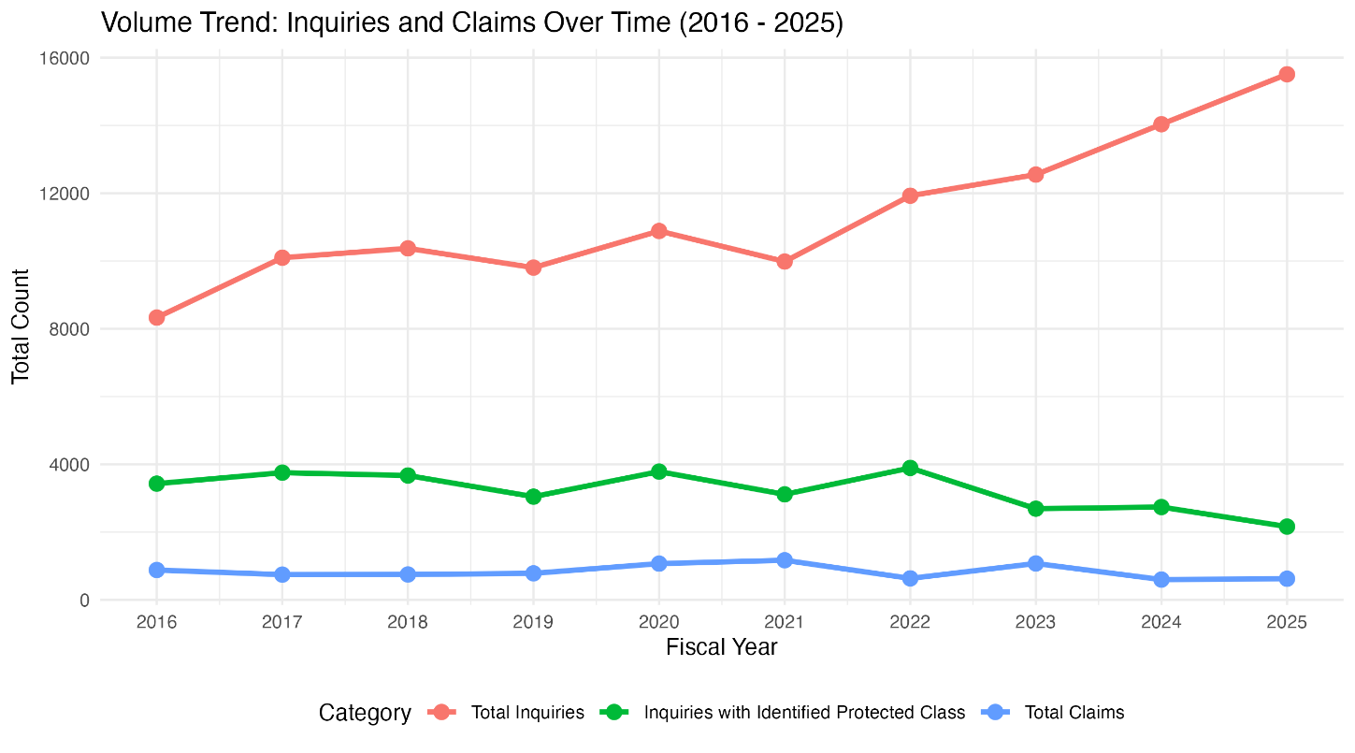
This is even more visible when examining the percentage of inquiries where a protected class is identified and the rate at which inquiries lead to complaints being filed. In 2016 and 2017, CCHR was able to identify a protected class and jurisdiction for 41 percent and 37 percent of all inquiries, respectively. By FY 2023 the number of inquiries with an identified protected class plummeted to 21 percent, and in FY 2025, per CCHR’s most recent report, the agency was only able to identify a protected class for 14 percent of inquiries—in other words, fewer than 1 in 7 calls to the Infoline collected enough information to identify what type of discrimination may have occurred.
Inquiry Volume vs. Protected Class Identification and Claims as % of Total Inquiries
Bars show raw volume of inquiries, units on Left Axis. Lines show the % of total inquiries for which a protected class was identified (orange line), and that led to a claim being filed (green line), units on right Axis.

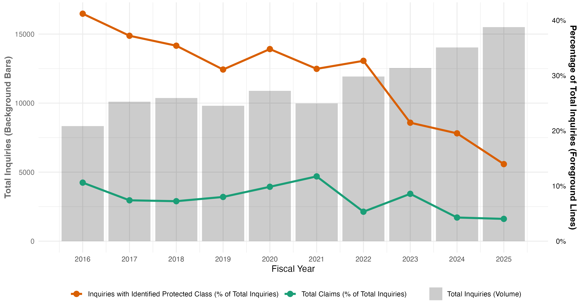
These trends raise the question of whether all potential claims are being identified, both generally and with respect to the FCA, especially given that overall inquiries to CCHR have more than doubled since 2016 while CCHR’s staffing levels fell by 30 percent. These staff reductions, which occurred under the Adams Administration’s hiring restrictions, mean that CCHR’s Infoline staffers fielded an average of nearly 2,000 inquiries per person in 2025, whereas in 2016, each Specialist was responsible for, on average, 926 inquiries annually. The number of attorneys at the agency fell by nearly a third, from 34 to 24 attorneys, alongside cuts to other legal and community relations staff that support the processing and resolution of discrimination complaints.
Fair Chance Employment (FCE) Volume Funnel: Inquiries to Claims
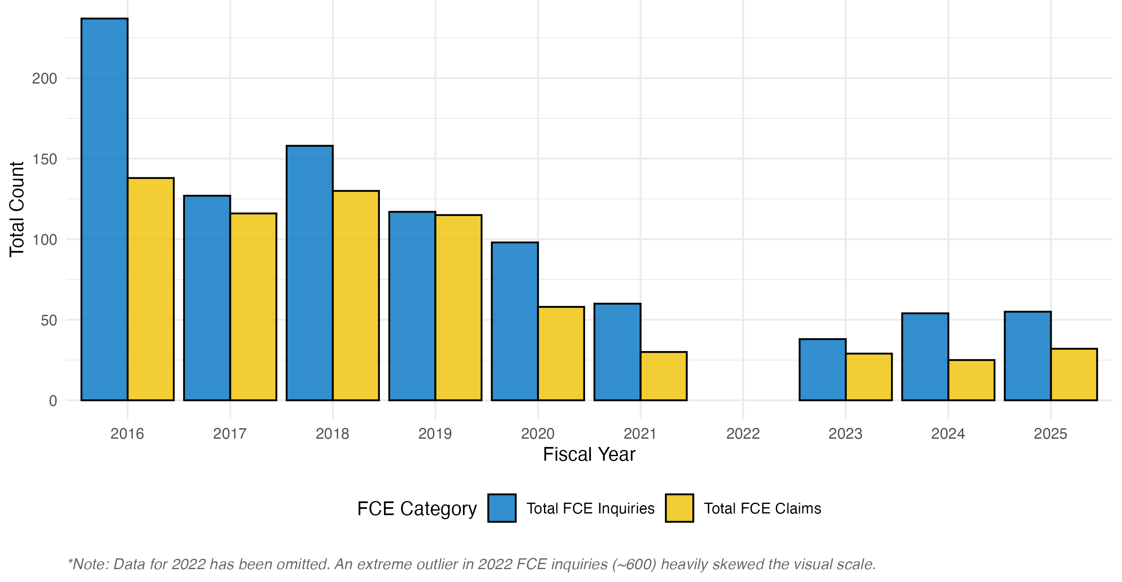
Fluctuations in testing rates for FCA Employment violations also underscore the importance of proactive agency enforcement efforts. Commission-initiated complaints are particularly critical to enforcement of Fair Chance laws due to the pervasiveness of such discrimination, persistent underreporting, and the limited ability of affected individuals to pursue litigation independently. In FY 2024, CCHR’s testing for Fair Chance protections dropped dramatically before rebounding in FY 2025. In FY 2024, in contrast to previous and subsequent years when Fair Chance Employment tests represented the bulk of employment-related tests, only 38 tests each were conducted for discrimination on the basis of arrest and conviction record, respectively, representing just under 6 percent of total tests conducted. In FY 2025, these numbers returned roughly to historical levels, with 231 tests conducted for FCA Employment violations, representing about 20 percent of tests that year. The effect on FCA Employment enforcement was immediate: in FY 2024, CCHR reported a 22 percent overall drop in total Fair Chance claims filed as complaints, and a 66 percent drop in Commission-initiated complaints when compared with FY 2025 numbers.
Despite overall drops in enforcement numbers, a selection of CCHR’s wins are available on its website. These show fines collected by the City and compensation awarded to individuals who experienced discrimination. In FY 2024, CCHR imposed $90,000 in fines on The GEO Group for a series of per se violations of the Fair Chance in Employment law, and settled two other cases, against Montefiore Medical Center for damages and penalties totaling $185 thousand, and against an unnamed employer for $70,000; all three employers also agreed to train employees on FCA requirements. In 2025, CCHR settled a case against FedEx for criminal history discrimination in hiring processes and workplace treatment, resulting in $104,000 in civil penalties and thousands of dollars paid in damages to each of six complainants.
- Fair Chance in Housing rollout
The FCA Housing law came into effect in January 2025, with CCHR’s support. In 2025, CCHR conducted a publicity campaign to reach tenants, landlords, and housing providers, developed new training materials, and collaborated with advocates. CCHR partnered with a handful of community groups, older adult centers, and houses of worship to provide workshops, seminars, and resource fairs covering FCA Housing, Source of Income protections, and tenants’ rights. CCHR also partnered with the Department of Housing Preservation and Development (HPD) to ensure that their “Where We Live” trainings include information for landlords, developers, and agents on their obligations under the Human Rights Law.
Compared to the FCA Employment rollout, however, CCHR’s activities were limited. For example, while CCHR published a Notice of Rights form and a poster, many of the other informational materials developed for FCA Employment protections do not exist for housing. CCHR’s training on FCA Housing protections is offered by request, and CCHR did not report the number of people who received FCA housing trainings. CCHR also has not published any plans for relevant public rulemaking as of April 2026, which means that no standardized form or expedited enforcement process has been published, as had already been done for FCA Employment prior to its coming into effect. The results are stark: in the first year of FCA Housing coming into effect, CCHR recorded no related inquiries, initiated no claims (whether on behalf of the Commission or an individual), and conducted no FCA Housing compliance tests. The Committee received public testimony that as of March 2026, nearly two and a half years after the law was enacted and one and a half years after coming into effect, CCHR has not filed any complaints to enforce FCA Housing protections, despite community organizations reporting widespread violations of the law.
The differences between the implementation of the Fair Chance laws for employment and housing may in part stem from the same documented staffing and resource challenges that seem to have undermined Fair Chance Employment enforcement in recent years. FCA Housing seems to have not received the necessary funding for implementation. Implementation costs for the Fair Chance in Housing law (L.L. 24 of 2024) were estimated at $700,000 in FY 2025 and $1.4 million for every subsequent year, due to the need to add 10 new staff to enforce the law. Estimated staffing needs reflect the typically high-urgency cases expected to arise under the law as well as the large size of the protected class: justice-involved New Yorkers account for approximately 11 percent of the adult population of New York City, or 750,000 people. Nevertheless, staffing at CCHR continued to fall throughout 2025, and the FY 2027 Preliminary Budget proposal does not allocate any additional funds compared to previous years—indeed, it projects future budget and staffing cuts. Adequate funding would enable the Infoline to be staffed proportionate with incoming inquiries, allow CCHR to address urgent cases efficiently through pre-complaint intervention, and support investigatory and legal staffing and, as needed, specialized teams to address the true caseload of anti-discrimination cases under the Fair Chance Act alongside all Human Rights Law protections.

- Failure to allocate adequate resources to urgent housing cases
From July 2019 to March 2025, the New York State Comptroller conducted an audit of CCHR’s handling of housing discrimination complaints, and whether they were processed timely and in accordance with its policies. The Comptroller’s findings provide additional context for understanding CCHR’s capacity to enforce the FCA Housing law as a subset of its housing cases.
The Comptroller’s audit found that CCHR inadequately monitored its housing discrimination cases and failed to set or follow benchmarks for timely processing, investigation, and resolution of cases. Although CCHR had adopted a 14-day response standard for responding to inquiries, a sample of 46 inquiries showed that staff only recorded the inquiry date and first contact attempt for 25 of them; of these, nearly half (48%) were not contacted until approximately 39 days after the inquiry was received. One inquiry did not receive a first response for 165 days (over five months). For 18 of 19 inquiries with documented intake dates, appointments occurred on average 84 days (almost 3 months) after the initial inquiry was received, with one taking almost 9 months (266 days).
Once a complaint was filed, delays continued. CCHR guidelines advise attorneys to submit a draft complaint to supervisors within 14 days of intake, but no audited cases met this standard. For 6 of 27 publicly initiated complaints, the time to draft a complaint averaged 115 days (nearly 4 months); one audited case took 336 days. For the other 21, key dates were not recorded at all. CCHR is required to serve respondents within 120 days of filing, but in three sampled cases service occurred 54, 63, and 85 days late, and staff did not record any attempts to locate the respondents during the 120 day period. In five sampled cases where attorneys left or were removed mid-case, CCHR took an average of 348 days (over 11 months) to reassign the case, with one gap of 812 days (over 2 years). No investigative activity was recorded during these gaps between assigned attorneys. Nearly all cases in the sample lacked required documentation of case supervision.
Overall, CCHR averaged over three years to make an initial determination as to whether to file a complaint after an inquiry was received, and one case did not receive a determination for over seven years. After filing a complaint, CCHR averaged over two years to resolve it.

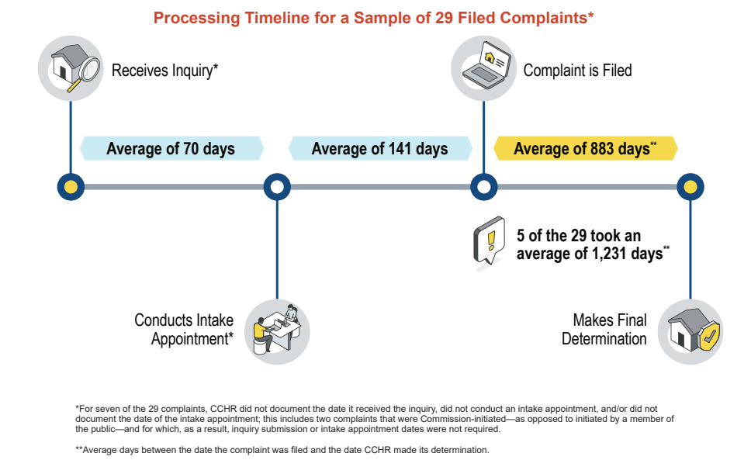
The above chart is replicated from the Comptroller’s Audit at p. 9.
CCHR and the Comptroller both agreed that inadequate and declining staffing levels contributed to these dysfunctions. During the span of the audit, CCHR dropped from a high of 42 staff attorneys down to a low of 8, and revised its internal guidance for how long an average housing case should take to resolve up from one year to two years, partially as a reflection of staffing shortages. The Comptroller further observed that inadequate documentation or analysis of case files has prevented CCHR from identifying or addressing the causes of delay, and recommended that CCHR impose and monitor compliance with clear timeframes for each step of intake, complaint filing, and investigation; analyze internal data to identify bottlenecks; create a procedure to prioritize attorney reassignments; and ensure staff document case supervision and activities.
CCHR generally agreed with the recommendations and described actions it will take, but disagreed with several findings: it argued that the audit mischaracterizes its workflow and ignores the pre-complaint intervention process. Nevertheless, the Comptroller largely retained the audit’s original findings.

American History, Race, and Prison, Vera Institute. See: https://www.vera.org/reimagining-prison-web-report/american-history-race-and-prison
American History, Race, and Prison, Vera Institute. See: https://www.vera.org/reimagining-prison-web-report/american-history-race-and-prison
Travis, Jeremy, et. al, The Growth of Incarceration in the United States, National Research Council of the National Academy of Sciences. (2014) Available at: https://www.vera.org/reimagining-prison-web-report/american-history-race-and-prison
Prison Industrial Complex is a term used to describe the overlapping interests of government and industry that use surveillance, policing, and imprisonment as solutions to economic, social, and political problems. See: https://criticalresistance.org/mission-vision/not-so-common-language/
American History, Race, and Prison, Vera Institute. See: https://www.vera.org/reimagining-prison-web-report/american-history-race-and-prison
Cullen, James, The History of Mass Incarceration, Brennan Center for Justice. (July 20, 2018). Available at: https://www.brennancenter.org/our-work/analysis-opinion/history-mass-incarceration
Cullen, James, The History of Mass Incarceration, Brennan Center for Justice. (July 20, 2018). Available at: https://www.brennancenter.org/our-work/analysis-opinion/history-mass-incarceration
Cullen, James, The History of Mass Incarceration, Brennan Center for Justice. (July 20, 2018). Available at: https://www.brennancenter.org/our-work/analysis-opinion/history-mass-incarceration
Farley, Robert, Bill Clinton and the 1994 Crime Bill, FactCheck.org. (Apr 12, 2016) Available at: https://www.factcheck.org/2016/04/bill-clinton-and-the-1994-crime-bill/
Nazgol Ghandnoosh and Sabrina Pearce, America’s Incarceration Crossroads: Reversing Progress Amid Record-Low Crime Rates, The Sentencing Project. (Nov 12, 2025) Available at: https://www.sentencingproject.org/policy-brief/americas-incarceration-crossroads-reversing-progress-amid-record-low-crime-rates/
Bureau of Justice Statistics, Prisoners in 2023–Statistical tables (Sept. 2025), https://bjs.ojp.gov/library/publications/prisoners-2023-statistical-tables.
Highest to Lowest-Prison population total, World Prison Brief. See: https://www.prisonstudies.org/world-prison-data/highest-lowest/highest-lowest-prison-population-total?field_region_taxonomy_tid=All
Fair Chance Ordinances - An Advocate's Toolkit, National Housing Law Project. Available at https://www.nhlp.org/wp-content/uploads/021320_NHLP_FairChance_Final.pdf.
Racial and ethnic disparities, Prison Policy Initiative. (2025) See: https://www.prisonpolicy.org/research/racial_and_ethnic_disparities/
Racial and ethnic disparities, Prison Policy Initiative. (2025) See: https://www.prisonpolicy.org/research/racial_and_ethnic_disparities/
Racial and ethnic disparities, Prison Policy Initiative. (2025) See: https://www.prisonpolicy.org/research/racial_and_ethnic_disparities/
Americans with Criminal Records, The Sentencing Project. (Aug 2022). Available at: https://www.sentencingproject.org/app/uploads/2022/08/Americans-with-Criminal-Records-Poverty-and-Opportunity-Profile.pdf
New York Profile - Prison Policy Initiative. Available at https://www.prisonpolicy.org/profiles/NY.html.
New York Profile - Prison Policy Initiative. Available at https://www.prisonpolicy.org/profiles/NY.html.
Americans with Criminal Records, The Sentencing Project. (Aug 2022). Available at: https://www.sentencingproject.org/app/uploads/2022/08/Americans-with-Criminal-Records-Poverty-and-Opportunity-Profile.pdf
Ames Grawert and Noah Kim, New data on Poverty and Criminal Records in New York State, Brennan Center for Justice. (May 25, 2023) Available at: https://www.brennancenter.org/our-work/analysis-opinion/new-data-poverty-and-criminal-records-new-york-state
Zaveri, Mihir. Criminal Background Checks May Be Banned in N.Y.C. Housing Application, The New York Times. (Aug. 9, 2022) Available at https://www.nytimes.com/2022/08/09/nyregion/criminal-background-checks-nyc-housing.html.
Jones, John. It's Time to Ban the Box on Housing, Medium, TechEquity Collaborative. (Jan. 14, 2019) Available at https://www.medium.com/techequity-collaborative/its-time-to-ban-the-box-on-housing-a20889159e69.
Metraux, S., & Culhane, D. P. Recent Incarceration History Among a Sheltered Homeless Population. (2006) Available at https://repository.upenn.edu/spp_papers/61.
Sandhya Kajeepta, Barred from Housing: The Discriminatory Impacts of Criminal History Restrictions in Tenant Screening, Thurgood Marshall Institute (April 2025), https://tminstituteldf.org/criminal-background-checks-housing-barrier/.
Saneta deVuono-powell, Chris Schweidler, Alicia Walters, and Azadeh Zohrabi. Who Pays? The True Cost of Incarceration on Families. Oakland, CA: Ella Baker Center, Forward Together, Research Action Design. (2015) Available at https://whopaysreport.org/wp-content/uploads/2015/09/Who-Pays-FINAL.pdf.
Surveyed individuals were between the ages of 25 and 44. Ferguson Melhorn, Stephanie, et al, The Workforce Impact of Second Chance Hiring, U.S. Chamber of Commerce (Sept. 18 2024) Available at: https://www.uschamber.com/workforce/data-deep-dive-the-workforce-impact-of-second-chance-hiring-3
Grant Duwe and Makada Henry-Nickie, A better path forward for criminal justice: training and employment for correctional populations, The Brookings Institution. (Apr 2021) Available at: https://www.brookings.edu/articles/a-better-path-forward-for-criminal-justice-training-and-employment-for-correctional-populations/
Ferguson Melhorn, Stephanie, et al, The Workforce Impact of Second Chance Hiring, U.S. Chamber of Commerce (Sept. 18 2024) Available at: https://www.uschamber.com/workforce/data-deep-dive-the-workforce-impact-of-second-chance-hiring-3
Fontaine, Jocelyn. Cityscape: A Journal of Policy Development and Research, Vol. 15, Num. 3. U.S. Dept. of Housing and Urban Dev., Office of Policy Dev. and Research. (2013) Available at https://www.huduser.gov/portal/periodicals/cityscpe/vol15num3/ch3.pdf.
Nelson, Marta, et al., The First Month Out – Post Incarceration Experiences in New York City, Vera Institute. (Sept 1999) Available at https://www.vera.org/downloads/Publications/the-first-month-out-post-incarceration-experiences-in-new-york-city/legacy_downloads/first_month_out.pdf.
Admin. Code §§ 8-102, 8-107(10); CCHR, “Fair Chance Act in Employment,” https://www.nyc.gov/site/cchr/media/fair-chance-act-campaign.page (visited April 22, 2026).
Admin. Code §§ 8-102, 8-107(5)(o); CCHR, “Fair Chance Act in Housing,” https://www.nyc.gov/site/cchr/media/fair-chance-housing-campaign.page (visited April 22, 2026).
N.Y. COR Chpt. 43, Art. 23-A; NYHRL § 296.16.
See, e.g., N.Y. Dept. of Labor, Justice Involvement and Finding Employment (explaining additional requirements that apply only in New York City), https://dol.ny.gov/individuals-who-are-justice-involved (visited April 22, 2026).
See U.S. Equal Employment Opportunity Comm’n, Arrest and Conviction Records: Resources for Job Seekers, Workers and Employers, https://www.eeoc.gov/arrestandconviction (accessed April 22, 2026); Fair Housing Act of 1968 (Title VIII of 1968 Civil Right Act), Pub. L. No. 90-284, 82 Stat. 81 (codified as amended at 42 U.S.C. §§ 3601–3619, 3631). See generally Sandhya Kajeepta, Barred from Housing: The Discriminatory Impacts of Criminal History Restrictions in Tenant Screening, Thurgood Marshall Institute (April 2025), https://tminstituteldf.org/criminal-background-checks-housing-barrier/.
See Sandhya Kajeepta, Barred from Housing: The Discriminatory Impacts of Criminal History Restrictions in Tenant Screening, Thurgood Marshall Institute (April 2025), https://tminstituteldf.org/criminal-background-checks-housing-barrier/#part4; Julian Mark, Trump officials start dismantling civil rights offices, as part of DOGE’s secret plan, Wash. Post, Feb. 28, 2025, https://www.washingtonpost.com/nation/2025/02/28/doge-trump-civil-rights-office-closing-eeoc/.
This is because human rights law violations are most often inflicted on already-marginalized individuals and groups who frequently lack the resources to enforce their rights through private action. C.f. Sandya Venugopal, State and Local Responses to the Gutting of Federal Health Agencies: Impacts on Public Health, Human Rights, and Social Justice, Am. Bar Assoc. (Nov 05, 2025), https://www.americanbar.org/groups/crsj/resources/human-rights/2025-october/state-local-responses-health-agencies/.
See Gaines at 553; See Sam Atherton, Katie Elder, Katie Fallon, & Kelly Walsh, Fair Chance Housing Laws Implementation Lessons and Perceived Impact, Urban Institute (July 2025), https://www.urban.org/sites/default/files/2025-07/Final_Fair%20Chance%20Housing%20Laws%20brief.pdf..
Such states include California, Illinois, Massachusetts, and New Jersey. See Caitlin T. Gaines, Keeping Fair Chance Laws Fair: Implications for Employers and Employees Given the Expansion and Variety of Fair Chance Laws in the United States, 72 Catholic Univ. L. R. 535, 540 (2023), https://scholarship.law.edu/lawreview/vol72/iss4/9/.
Id. at 541–542.
See Beth Avery & Han Lu, Ban the Box: U.S. Cities, Counties, and States Adopt Fair Hiring Policies. National Employment Law Project. Available at https://www.nelp.org/insights-research/ban-the-box-fair-chance-hiring-state-and-local-guide/#Chart_of_Local_Fair_Chance_Policies.
Many, like New York City, limit the application of these laws to employers of a minimum size. For example, the California Fair Chance Act applies to employers with five or more employees, and New Mexico’s private sector fair chance law applies to those with four or more employees. See Gaines at 541–542, 544; Admin. Code § 8-102 (defining “employer” for the purposes of the Fair Chance provisions as applying only to businesses with four or more employees).
For example, since the City of San Francisco implemented fair chance employment policies in 2013 for public sector hiring, including a requirement for a careful individualized assessment, the city government reported disqualifying only 0.731 percent of candidates in fiscal year 2022–2023. See National Employment Law Center, Research Supports Fair Chance Policies, at 6 (April 2024). Available at https://www.nelp.org/app/uploads/2024/04/Research-Supports-Fair-Chance-Policies-Apr.2024.pdf.
See Gaines at 544.
See N.Y. Dept. of Labor, Justice Involvement and Finding Employment, https://dol.ny.gov/individuals-who-are-justice-involved (visited April 22, 2026).
Office of Policy Development and Research. Tenant Screening With Criminal Background Checks: Predictions And Perceptions Are Not Causality. Dept. of Housing and Urban Development (May 17, 2022), https://www.huduser.gov/portal/pdredge/pdr-edge-frm-asst-sec-051722.html; Ban the Box and Beyond: How to Comply with State Laws and Local Ordinances. Rent Manager (Sept 25. 2019), https://www.rentmanager.com/ban-the-box-and-beyond-how-to-comply-with-state-laws-and-local-ordinances/.
Fair Chance in Housing Act. N.J.S.A. §§ 46:8-52 to 46:8-54. Available at https://www.njoag.gov/wp-content/uploads/2021/12/Fair-Chance-in-Housing-Act_NJSA-46-8-52-et-seq.pdf; see also Klazema, Michael. Colorado Enacts New Restrictions on Tenant Background Checks. BackgroundChecks.com. (May 9, 2019) Available at https://www.backgroundchecks.com/blog/colorado-enacts-new-restrictions-on-tenant-background-checks.
See Sam Atherton, Katie Elder, Katie Fallon, & Kelly Walsh, Fair Chance Housing Laws Implementation Lessons and Perceived Impact, Urban Institute (July 2025), https://www.urban.org/sites/default/files/2025-07/Final_Fair%20Chance%20Housing%20Laws%20brief.pdf.
Sam Atherton, Katie Elder, Katie Fallon, & Kelly Walsh, Fair Chance Housing Laws Implementation Lessons and Perceived Impact, Urban Institute (July 2025), https://www.urban.org/sites/default/files/2025-07/Final_Fair%20Chance%20Housing%20Laws%20brief.pdf; Kelsie Chesnut et al., Fair Chance Housing: Lessons in Implementation, Vera Inst. for Justice (Jan. 2025), https://vera-institute.files.svdcdn.com/production/downloads/publications/Fair-Chance-Housing-Lessons-in-Implementation.pdf?dm=1736531593.
Sam Atherton, Katie Elder, Katie Fallon, & Kelly Walsh, Fair Chance Housing Laws Implementation Lessons and Perceived Impact, Urban Institute (July 2025), https://www.urban.org/sites/default/files/2025-07/Final_Fair%20Chance%20Housing%20Laws%20brief.pdf.
Sam Atherton, Katie Elder, Katie Fallon, & Kelly Walsh, Fair Chance Housing Laws Implementation Lessons and Perceived Impact, Urban Institute (July 2025), https://www.urban.org/sites/default/files/2025-07/Final_Fair%20Chance%20Housing%20Laws%20brief.pdf; Kelsie Chesnut et al., Fair Chance Housing: Lessons in Implementation, Vera Inst. for Justice (Jan. 2025), https://vera-institute.files.svdcdn.com/production/downloads/publications/Fair-Chance-Housing-Lessons-in-Implementation.pdf?dm=1736531593.
Sam Atherton, Katie Elder, Katie Fallon, & Kelly Walsh, Fair Chance Housing Laws Implementation Lessons and Perceived Impact, Urban Institute (July 2025), https://www.urban.org/sites/default/files/2025-07/Final_Fair%20Chance%20Housing%20Laws%20brief.pdf.
Kelsie Chesnut et al., Fair Chance Housing: Lessons in Implementation, Vera Inst. for Justice (Jan. 2025), https://vera-institute.files.svdcdn.com/production/downloads/publications/Fair-Chance-Housing-Lessons-in-Implementation.pdf?dm=1736531593.
Kelsie Chesnut et al., Fair Chance Housing: Lessons in Implementation, Vera Inst. for Justice (Jan. 2025), https://vera-institute.files.svdcdn.com/production/downloads/publications/Fair-Chance-Housing-Lessons-in-Implementation.pdf?dm=1736531593.
These included the Deputy Commissioner, Assistant Commissioner and Managing Attorney for the bureau; 4 Supervising Attorneys; 25 Agency Attorneys; 4 Attorney Internes, 7 Administrative Staff; 1 Testing Coordinator; 2 Testers; and 5 Infoline Staff. CCHR Annual Report for 2016, https://www.nyc.gov/assets/cchr/downloads/pdf/publications/AnnualReport2016FINAL.pdf.
Testimony of Dana Sussman Deputy Commissioner for Policy and Intergovernmental Affairs New York City Commission on Human Rights Before the Committee on Civil and Human Rights (Jan. 22, 2020), available at https://perma.cc/P3J9-BZ4E.
These are recorded in Annual Reports as discrimination relating to arrest or conviction record.
In addition, the following year, CCHR filed 51 complaints alleging discrimination on the basis of arrest record and 65 on the basis of conviction record. CCHR Annual Report for 2016, https://www.nyc.gov/assets/cchr/downloads/pdf/publications/AnnualReport2016FINAL.pdf; CCHR Annual Report for 2017, https://www.nyc.gov/assets/cchr/downloads/pdf/publications/2017YearEndReviewFINAL.pdf.
CCHR Annual Report for 2016 (reporting that 190 out of 426 total investigations, or 45 percent of all investigations, were for discrimination based on conviction record), https://www.nyc.gov/assets/cchr/downloads/pdf/publications/AnnualReport2016FINAL.pdf.
Id.
CCHR also conducted 16 tests for credit history discrimination, of which all 16 (100 percent) uncovered unlawful discriminatory practices. CCHR Annual Report for 2016, https://www.nyc.gov/assets/cchr/downloads/pdf/publications/AnnualReport2016FINAL.pdf.
Representing 6 percent of all inquiries where a protected class was identified. See id.
CCHR Annual Report for 2016, https://www.nyc.gov/assets/cchr/downloads/pdf/publications/AnnualReport2016FINAL.pdf.
CCHR Annual Report for 2016, https://www.nyc.gov/assets/cchr/downloads/pdf/publications/AnnualReport2016FINAL.pdf.
Testimony of Dana Sussman Deputy Commissioner for Policy and Intergovernmental Affairs New York City Commission on Human Rights Before the Committee on Civil and Human Rights (Jan. 22, 2020), available at https://perma.cc/P3J9-BZ4E.
Testimony of Dana Sussman Deputy Commissioner for Policy and Intergovernmental Affairs New York City Commission on Human Rights Before the Committee on Civil and Human Rights (Jan. 22, 2020), available at https://perma.cc/P3J9-BZ4E.
Sadeq Khan, NYC Employers: Ensure compliance with the Fair Chance Act (Jan. 8, 2018), https://www.certiphi.com/resource-center/compliance-services/nyc-employers-ensure-compliance-with-the-fair-chance-act/.
See generally Committee Report for the Committee on Civil and Human Rights, Dec. 8, 2022 (describing the common use of criminal background checks in housing application processes, and the steps required under L.L. 24 of 2024), https://legistar.council.nyc.gov/LegislationDetail.aspx?ID=5755059&GUID=1081D9A0-5626-4DE4-BB6A-142AB373A4AF&Options=&Search=; Committee Report for the Committee on Civil and Human Rights, Dec. 8, 2022 (describing the common use of criminal background checks in the employment context, and the steps required under L.L. 63 of 2015), https://legistar.council.nyc.gov/LegislationDetail.aspx?ID=1739365&GUID=EF70B69C-074A-4B8E-9D36-187C76BB1098&Options=ID|Text|&Search=63.
Testimony of Dana Sussman Deputy Commissioner for Policy and Intergovernmental Affairs New York City Commission on Human Rights Before the Committee on Civil and Human Rights (Jan. 22, 2020), available at https://perma.cc/P3J9-BZ4E.
The rules also specify when and which aspects of arrest or conviction records may be considered by an employer under the Human Rights Law, the effect of inadvertent disclosures of criminal history, the required process for assessing and documenting the relevance of a job candidate’s prior criminal history under the Fair Chance Employment law, and procedures for enforcement. See, e.g., N.Y.C.R.R. § 2-04(e) (explaining the steps for determining whether prior criminal history has either a “direct relationship” to job responsibilities that cannot be mitigated, or presents an “unreasonable risk” to persons or property pursuant to Admin. Code §§ 8-107(10)–8-107(11-a)).
N.Y.C.R.R. § 2-04(e)(2)(ii)(A).
N.Y.C.R.R. §§ 2-04(a), 2-04(i)(2).
See, e.g., CCHR Annual Report for 2016 (trainings offered in Spanish and other languages as needed), https://www.nyc.gov/assets/cchr/downloads/pdf/publications/AnnualReport2016FINAL.pdf.
Testimony of Dana Sussman Deputy Commissioner for Policy and Intergovernmental Affairs New York City Commission on Human Rights Before the Committee on Civil and Human Rights (Jan. 22, 2020), available at https://perma.cc/P3J9-BZ4E. As of April 2026, consumer credit checks for employment purposes are also prohibited under State law, except where such check is required by law. Gen. Bus. Law § 380 et seq. (known as the N.Y. State Fair Credit Reporting Act) (outlining narrow exceptions for, e.g., law enforcement officers, fiduciary roles, or positions requiring a federal or state security clearance).
CCHR Annual Report for 2016, https://www.nyc.gov/assets/cchr/downloads/pdf/publications/AnnualReport2016FINAL.pdf.
CCHR Annual Report for 2017, https://www.nyc.gov/assets/cchr/downloads/pdf/publications/2017YearEndReviewFINAL.pdf.
Testimony of Dana Sussman Deputy Commissioner for Policy and Intergovernmental Affairs New York City Commission on Human Rights Before the Committee on Civil and Human Rights (Jan. 22, 2020), available at https://perma.cc/P3J9-BZ4E.
Id.
Allison Que, Two Years of New York City’s Fair Chance Act: From Robust Legislation to Effective Enforcement, Nat’l Emp. L. Project (Nov. 7, 2017), https://www.nelp.org/blog/two-years-of-new-york-citys-fair-chance-act-fromrobust-legislation-to-effective-enforcement/.
See id.; Gurjot Kaur & Dana Sussman, Unlocking the Power and Possibility of Local Enforcement of Human and Civil Rights: Lessons Learned From the NYC Commission on Human Rights, Columbia Human Rts. L. Rev. 51.2 at 629–30 (Feb. 2020), https://hrlr.law.columbia.edu/files/2020/02/51.2.3-Kaur-and-Sussman.pdf.
CCHR Annual Report for 2016, https://www.nyc.gov/assets/cchr/downloads/pdf/publications/AnnualReport2016FINAL.pdf; CCHR Annual Report for 2017, https://www.nyc.gov/assets/cchr/downloads/pdf/publications/2017YearEndReviewFINAL.pdf.
This total includes Commission-initiated complaints. CCHR Annual Report for 2024, https://www.nyc.gov/assets/cchr/downloads/pdf/publications/AnnualReport2024.pdf; CCHR Annual Report for 2025, https://www.nyc.gov/assets/cchr/downloads/pdf/publications/AnnualReport2025.pdf. CCHR also recorded 54 and 55 inquiries linked to FCA Employment discrimination in those years, representing, respectively, 2 and 3 percent of all inquiries where a protected class was identified (less than half, proportionally, compared to the number of FCA Employment inquiries in 2016). CCHR Annual Report for 2024, https://www.nyc.gov/assets/cchr/downloads/pdf/publications/AnnualReport2024.pdf; CCHR Annual Report for 2025, https://www.nyc.gov/assets/cchr/downloads/pdf/publications/AnnualReport2025.pdf; CCHR Annual Report for 2016, available at https://www.nyc.gov/site/cchr/media/reports/annual-reports.page.
See, e.g., CCHR Annual Report for 2016, available at https://www.nyc.gov/site/cchr/media/reports/annual-reports.page. Pre-complaint interventions have historically been carried out primarily by the Community Relations Bureau, but the Law Enforcement Bureau has handled dozens of these matters as well. Id.
See CCHR Annual Reports for the years 2016–2021, available at https://www.nyc.gov/site/cchr/media/reports/annual-reports.page.
Id.
See id.
In FY 2024 and 2025, 54 and 58 percent of all inquiries under the Fair Chance law in those years were converted to claims, representing 5 percent of total claims filed as complaints in both years. A single complaint can include multiple claims of discrimination; in FY’24 and ‘25, CCHR brought 366 and 396 complaints, respectively, that encompassed 601 and 626 claims, respectively. In FY 2016, this percentage was even higher, with 69 percent of all Fair Chance inquiries leading to a claim filed. CCHR Annual Reports for the years 2016, 2024, and 2025, available at https://www.nyc.gov/site/cchr/media/reports/annual-reports.page.
NYS Comptroller Thomas DiNapoli, DiNapoli: Housing Discrimination Complaints Languish at NYC Commission on Human Rights (Dec. 4, 2025), https://www.osc.ny.gov/press/releases/2025/12/dinapoli-housing-discrimination-complaints-languish-nyc-commission-human-rights.
See CCHR Annual Reports for the years 2016, 2017, 2023, and 2025, available at https://www.nyc.gov/site/cchr/media/reports/annual-reports.page.
Id.; NYC Comptroller Agency Staffing Dashboard (showing only 98 employees at the agency’s staffing nadir in August 2025), https://comptroller.nyc.gov/services/for-the-public/nyc-agency-staffing-dashboard/authorized-vs-actual-staffing-with-vacancy-rates/.
See CCHR Annual Reports for the years 2016 and 2025 (showing an increase from 8330 inquiries in FY 2016 to 15,507 in FY 2025) (reporting in the CCHR 2016 Annual Report that 9 Human Rights Specialists staff the Infoline), available at https://www.nyc.gov/site/cchr/media/reports/annual-reports.page; CCHR reported to Committee staff in early 2026 that CCHR has 8 staff members that run the Infoline.
CCHR Annual Report for 2016, available at https://www.nyc.gov/site/cchr/media/reports/annual-reports.page; CCHR reported to Committee staff in early 2026 that CCHR has 8 staff members that run the Infoline.
See generally Christopher Herring & Sandra Susan Smith, The Limits of Ban-the-Box Legislation, Inst. for Research on Labor & Employment (IRLE) (March 14, 2022) (documenting ), https://irle.berkeley.edu/wp-content/uploads/2022/03/The-Limits-of-Ban-the-Box-Legislation-1.pdf.
In FY 2023, CCHR reported that 390 tests were conducted for discrimination based on arrest record, and 389 were conducted for discrimination based on conviction record, representing 63 percent of all 1,242 tests conducted that fiscal year. CCHR Annual Report for 2023, https://www.nyc.gov/assets/cchr/downloads/pdf/publications/AnnualReport2023.pdf. Historically, the most frequent type of employment discrimination in CCHR-initiated investigations has been for Fair Chance violations. See, e.g., Testimony of Carmelyn P. Malalis before the Committee on Civil and Human Rights, March 16, 2018, https://www.nyc.gov/assets/cchr/downloads/pdf/20180326_CCHR_Testimony.pdf.
CCHR Annual Report for 2024, https://www.nyc.gov/assets/cchr/downloads/pdf/publications/AnnualReport2024.pdf.
CCHR Annual Report for 2025, https://www.nyc.gov/assets/cchr/downloads/pdf/publications/AnnualReport2025.pdf.
Fair Chance in Employment complaints initiated by CCHR comprised 4 out of 85 total Commission-initiated complaints in FY 24 and 13 out of 85 Commission-initiated complaints in FY 2025 (representing 5 percent and 15 percent of CCHR-initiated complaints for each year, respectively). CCHR Annual Report for 2024, https://www.nyc.gov/assets/cchr/downloads/pdf/publications/AnnualReport2024.pdf; CCHR Annual Report for 2025, https://www.nyc.gov/assets/cchr/downloads/pdf/publications/AnnualReport2025.pdf.
CCHR Annual Report for 2024, https://www.nyc.gov/assets/cchr/downloads/pdf/publications/AnnualReport2024.pdf; NYC CCHR, “2024 Settlement Highlights,” https://www.nyc.gov/site/cchr/enforcement/2024-settlements.page (accessed April 21, 2026).
NYC CCHR, “2025 Settlement Highlights,” https://www.nyc.gov/site/cchr/enforcement/2025-settlements.page (accessed April 21, 2026).
See Testimony of Annabel Palma to the Committee on Civil and Human Rights on Int. 632 (Dec. 8, 2022), available at https://legistar.council.nyc.gov/LegislationDetail.aspx?ID=5755059&GUID=1081D9A0-5626-4DE4-BB6A-142AB373A4AF&Options=&Search=.
CCHR Annual Report for 2025, https://www.nyc.gov/assets/cchr/downloads/pdf/publications/AnnualReport2025.pdf.
Partner organizations included CAMBA, Asian Americans for Equality, Harlem Development Corporation, and Northfield Economic Development Corp. CCHR Annual Report for 2025, https://www.nyc.gov/assets/cchr/downloads/pdf/publications/AnnualReport2025.pdf.
CCHR Annual Report for 2025, https://www.nyc.gov/assets/cchr/downloads/pdf/publications/AnnualReport2025.pdf.
See Testimony of Dana Sussman Deputy Commissioner for Policy and Intergovernmental Affairs New York City Commission on Human Rights Before the Committee on Civil and Human Rights (Jan. 22, 2020), available at https://perma.cc/P3J9-BZ4E.
Available at https://www.nyc.gov/assets/cchr/downloads/pdf/publications/FairChanceHousing-Notice.pdf.
Available at https://www.nyc.gov/site/cchr/media/posters.page.
These include user-friendly visualizations and FAQs, listed as flyers and fact sheets on CCHR’s website. Available at https://www.nyc.gov/site/cchr/media/publications.page and https://www.nyc.gov/site/cchr/media/materials.page.
CCHR Annual Report for 2025, https://www.nyc.gov/assets/cchr/downloads/pdf/publications/AnnualReport2025.pdf.
See Comm’n on Human Rights CAPA Regulatory Agenda FY 2026, https://rules.cityofnewyork.us/wp-content/uploads/2025/07/FY-26-CCHR-Regulatory-Agenda.pdf; Mayor’s Office of Operations, Agency Regulatory Agendas for the Coming Fiscal Year (showing that FY 2026 is the most recent published regulatory agenda for CCHR), https://rules.cityofnewyork.us/view-agency-regulatory-agendas/ (visited April 22, 2026).
See CCHR Annual Report for 2025, https://www.nyc.gov/assets/cchr/downloads/pdf/publications/AnnualReport2025.pdf.
Testimony of Britny McKenzie, Policy Director to the Committee on Civil and Human Rights (March 13, 2026), available at https://legistar.council.nyc.gov/LegislationDetail.aspx?ID=7929723&GUID=AE7506FD-531C-468B-A7CC-EC5446E34DD0&Options=&Search=.
See Fiscal Impact Statement for Int. 632-2022 (L.L. 24 of 2024), available at https://legistar.council.nyc.gov/LegislationDetail.aspx?ID=5755059&GUID=1081D9A0-5626-4DE4-BB6A-142AB373A4AF&Options=&Search=.
NYC Fair Chance for Housing, NYC Fair Chance for Housing Act: Frequently Asked Questions (last updated 2020), https://static1.squarespace.com/static/585adef937c5817d231b7de1/t/646d332f762c0b04be46b523/1684878147357/Fair+Chance+for+Housing+Act+Info+Sheet.pdf.
NYC Comptroller Agency Staffing Dashboard, https://comptroller.nyc.gov/services/for-the-public/nyc-agency-staffing-dashboard/authorized-vs-actual-staffing-with-vacancy-rates/ (visited April 22, 2026).
NYC Office of Management and Budget, Preliminary Budget Fiscal Years 2026–2030, https://www.nyc.gov/content/omb/pages/publications/fy2026-2030-preliminary-budget (visited April 22, 2026).
NYS Comptroller Thomas DiNapoli, DiNapoli: Housing Discrimination Complaints Languish at NYC Commission on Human Rights (Dec. 4, 2025) (recommending improved oversight), https://www.osc.ny.gov/press/releases/2025/12/dinapoli-housing-discrimination-complaints-languish-nyc-commission-human-rights.
For a sample of 29 inquiries, more than two years (883 days) passed, on average, for a determination to be reached after filing a complaint; five cases closed for "Administrative Convenience" averaged over three years (1,231 days) from filing. For 18 inquiries with documented submission dates, decisions took an average of more than three years (1,175 days), including one that took over seven years (2,574 days). Id. at pp. 9–10.
In accordance with NYC Executive Order 115 of 2008, https://www.nyc.gov/assets/records/pdf/executive_orders/2008EO115.pdf.
NYS Comptroller Thomas DiNapoli, DiNapoli: Housing Discrimination Complaints Languish at NYC Commission on Human Rights (Dec. 4, 2025), https://www.osc.ny.gov/press/releases/2025/12/dinapoli-housing-discrimination-complaints-languish-nyc-commission-human-rights.
Id. at 11.
Id. at 2, 12.
Id. at 1–2, 13.
Id. at 15.
Id. at 2, 16.
Of 36 sampled inquiries assigned to an attorney, 26 of the 28 that were closed or transferred were missing the required file maintenance checklist. Id. at 2, 18.
After receiving an initial inquiry from a member of the public about potential unlawful discrimination, CCHR schedules an intake appointment with an attorney, following which the attorney must make a determination as to whether the facts support filing a claim. Id. at 7.
Id. at 9–10.
Id.
Id. at 8.
The estimate of 2 years for a simple housing case assumed full staffing levels up to CCHR’s budgeted headcount. CCHR has never been staffed up to its full budgeted headcount and in recent years has suffered one of the highest vacancy rates due to attrition and hiring freezes. See id. at 10; NYC Comptroller Agency Staffing Dashboard, https://comptroller.nyc.gov/services/for-the-public/nyc-agency-staffing-dashboard/authorized-vs-actual-staffing-with-vacancy-rates/ (visited April 22, 2026). NYS Comptroller Thomas DiNapoli, DiNapoli: Housing Discrimination Complaints Languish at NYC Commission on Human Rights at p. 10 (Dec. 4, 2025), https://www.osc.ny.gov/press/releases/2025/12/dinapoli-housing-discrimination-complaints-languish-nyc-commission-human-rights.
Id. at 2–3, 18.
Id. at 20, 23–25.
Id.

