THE COUNCIL OF THE CITY OF NEW YORK
RESOLUTION NO.

Resolution approving with modifications the decision of the City Planning Commission on ULURP No. N 260049 ZRK, for a Zoning Text amendment (L.U. No. 53).

By Council Members Riley and Louis

WHEREAS, 9201 LLC, filed an application pursuant to Section 201 of the New York City Charter for an amendment of the Zoning Resolution of the City of New York, amending APPENDIX F for the purpose of establishing a Mandatory Inclusionary Housing area. (ULURP No. N 260049 ZRK) (the "Application");
WHEREAS, the City Planning Commission filed with the Council on April 10, 2026 its decision dated April 1, 2026 (the "Decision") on the Application;

WHEREAS, the Application is related to application C 260048 ZMK (L.U. No. 52), a zoning map amendment changing from a C8-2 zoning district to a C4-4D zoning district;
WHEREAS, the Decision is subject to review and action by the Council pursuant to Section 197-d of the City Charter;
WHEREAS, upon due notice, the Council held a public hearing on the Decision and Application on April 14, 2026;

WHEREAS, the Council has considered the land use and other policy issues relating to the Decision and Application; and

WHEREAS, the Council has considered the relevant environmental issues, including the Negative Declaration issued on November 14, 2025 (CEQR No. 25DCP078K), which includes an (E) designation (E- 873) related to hazardous materials, air quality, and noise to avoid the potential for significant adverse impacts (the “Negative Declaration”).

RESOLVED:
The Council finds that the action described herein will have no significant impact on the environment as set forth in the Negative Declaration.
Pursuant to Sections 197-d and 200 of the New York City Charter and based on the Decision and Application, the environmental determination and consideration described in the report, N 260049 ZRK, incorporated by reference herein, and the record before the Council, the Council approves the Decision of the City Planning Commission, with the following modification:
Matter underlined is new, to be added;
Matter struck out is to be deleted;
Matter double-underlined is new, added by Council;
Matter double-struck out is old, deleted by Council;
Matter within # # is defined in Section 12-10 or 101-01;
* * * indicates where unchanged text appears in the Zoning Resolution.

* * *

APPENDIX F
Mandatory Inclusionary Housing Areas and former Inclusionary Housing Designated Areas

* * *

BROOKLYN

* * *

Brooklyn Community District 10

* * *

Map 1 – [date of adoption]

[EXISTING MAP]

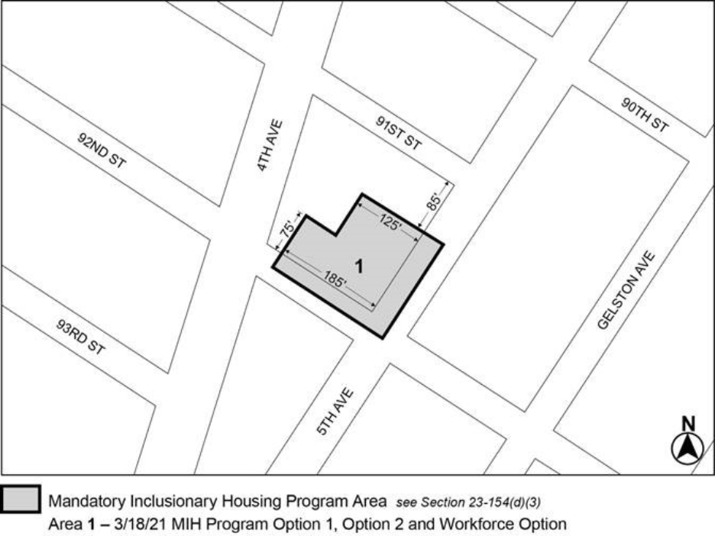
[PROPOSED MAP]
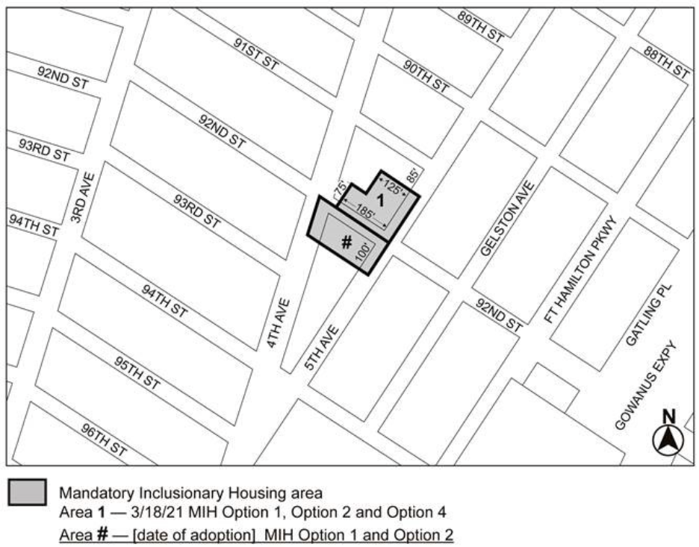
[PROPOSED MAP – MODIFIED BY CITY COUNCIL]
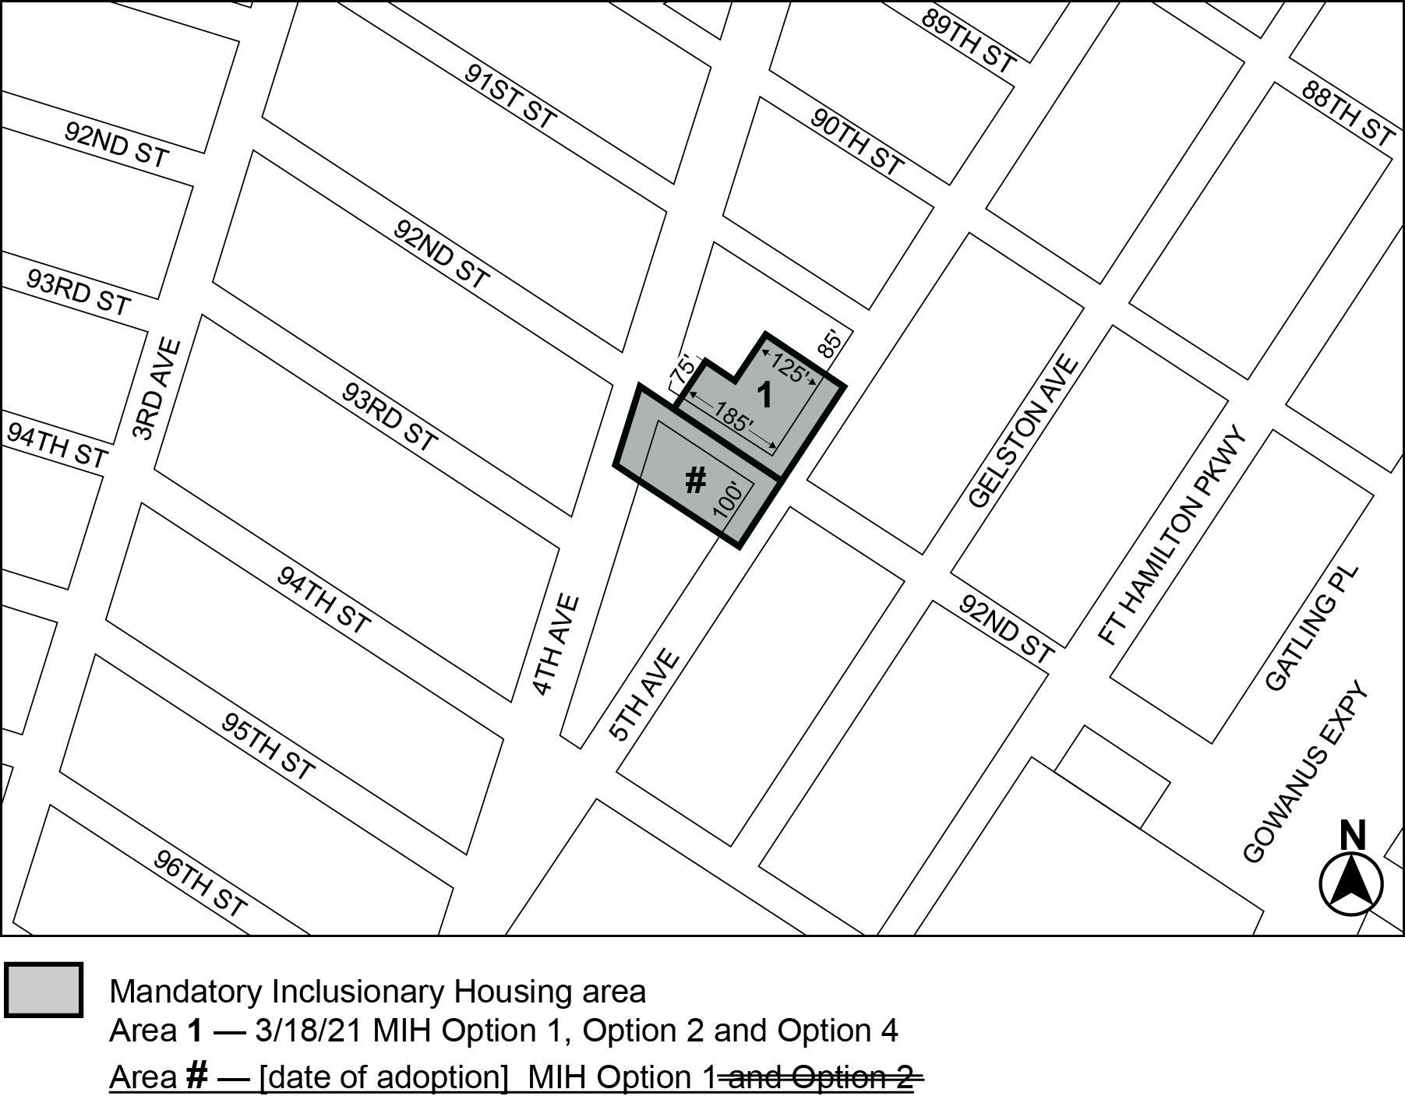
Portion of Community District 10, Brooklyn

* * *

Adopted.

Office of the City Clerk, }
The City of New York, } ss.:

I hereby certify that the foregoing is a true copy of a Resolution passed by The Council of The City of New York on __________, 2026, on file in this office.

.....................................................
City Clerk, Clerk of The Council

